

**SCIT**

**School of Computing and Information Technology Faculty of Engineering & Information Science**

**CSIT314 - Software Development Methodologies**

**Group: Makan Club**

|  |  |  |
| --- | --- | --- |
| **Report** | | |
| **Student Name** | **UOW Student ID** | **Email** |
| Chong Hui Wen | 7311436 | hwc890@uowmail.edu.au |
| Kendrick Kee | 7366814 | kk135@uowmail.edu.au |
| Lee Yu Xian | 7233164 | yxl563@uowmail.edu.au |
| Bryan Choo | 7060452 | xgbc617@uowmail.edu.au |
| Li Jin | 6650181 | jl870@uowmail.edu.au |
| Kaycee Tan Wan Ching | 7311540 | kwct409@uowmail.edu.au |
| Soh Wei Liang | 7083294 | wls998@uowmail.edu.au |

Youtube Link for demo: <https://youtu.be/9Bhzayjm2Mo>

# Members’ Contribution

The Team arrived at a consensus that the workload was evenly distributed, and every single team member is satisfied with the contribution and description stated below.

|  |  |  |  |  |
| --- | --- | --- | --- | --- |
| **Student Name** | **UOW Student ID** | **Contribution** | **Description** | **Signature** |
| Chong Hui Wen | 7311436 | 100% | User Stories  Use Case Diagram  Use Case Description  BCE Class Diagram  BCE Sequence Diagram  Ethical Considerations  Data-Driven Development |  |
| Kendrick Kee | 7366814 | 100% | Test Cases  Database  TDD  CI/CD  Front-End  Back-End |  |
| Lee Yu Xian | 7233164 | 100% | BCE Sequence Diagram  Use Case Description  Front-End  Back-End |  |
| Bryan Choo | 7060452 | 100% | Database  Use Case Description  Back-End  Wireframing |  |
| Li Jin | 6650181 | 100% | Wireframing  BCE Class Diagram  BCE Sequence Diagram  Data-Driven Development |  |
| Kaycee Tan Wan Ching | 7311540 | 100% | Use Case Description  Front-End  Back-End  User Stories |  |
| Soh Wei Liang | 7083294 | 100% | Front-End  Back-End  Database  Test Cases |  |

**Table of Contents**

Members’ Contribution 1

1. User Stories and Tasks 6

1.1 Guest 6

1.2 Member 9

1.3 Restaurant Staff 13

1.4 Restaurant Manager 15

1.5 Restaurant Owner 18

2. Gantt Chart 20

3. Use Case Diagrams 26

3.1 Guest/Member 26

3.2 Restaurant Staff 27

3.3 Restaurant Manager 28

3.4 Restaurant Owner 29

4. Use Case Description 30

4.1 All actors except Guest 30

4.2 Guest 32

4.3 Guest and Member 33

4.4 Member 41

4.5 Restaurant Staff 44

4.6 Restaurant Manager 46

4.7 Restaurant Owner 51

5. BCE Class Diagram 54

5.1 Guest 54

5.2 Member 55

5.3 Restaurant Staff 56

5.4 Restaurant Manager 57

5.5 Restaurant Owner 59

6. BCE Sequence Diagram 60

6.1 Guest 60

6.1.1 Sign up as member 60

6.2 Guest/Member 61

6.2.1 View Menu 61

6.2.2 Place Order 61

6.2.3 View Cart 62

6.2.4 Add Food Item to Cart 62

6.2.5 Edit Quantity 63

6.2.8 Make Payment 64

6.3 Member 65

6.3.1 Login 65

6.3.2 Logout 65

6.3.3 Insert Coupon Code 66

6.4 Restaurant Staff 67

6.4.1 Login 67

6.4.2 View Order Status 67

6.4.3 Mark Order as Completed 68

6.4.4 Logout 68

6.5 Restaurant Manager 69

6.5.1 Login 69

6.5.2 Add Food Item 69

6.5.3 Hide Food Item 70

6.5.4 Create Coupon Code 71

6.5.5 Update Coupon Code 72

6.5.6 Logout 72

6.6 Restaurant Owner 73

6.6.1 Login 73

6.6.3 Logout 74

7. Sprints 75

7.1 Sprint 1 75

7.1.1 Wireframe 75

7.1.1.1 Customer 75

7.1.1.2 Restaurant Staff 83

7.1.1.3 Restaurant Manager 83

7.1.1.4 Restaurant Owner 83

7.1.2 Test Cases 86

7.1.3 Taiga 86

7.1.4 Test Driven Development (TDD) 89

7.2 Sprint 2 103

7.2.1 Wireframe 103

7.2.1.1 Customer 103

7.2.1.2 Restaurant Staff 104

7.2.1.3 Restaurant Manager 105

7.2.1.4 Restaurant Owner 107

7.2.2 Test Cases 109

7.2.3 Taiga 110

7.3 Sprint 3 112

7.3.1 Wireframing 112

7.3.1.1 Customer 112

7.3.1.2 Restaurant Staff 117

7.3.1.3 Restaurant Manager 121

7.3.1.4 Restaurant Owner 121

7.3.2 Test Cases 128

7.3.3 Taiga 129

7.4 Sprint 4 132

7.4.1 Wireframing 132

7.4.1.1 Customer 132

7.4.1.2 Restaurant Staff 133

7.4.1.3 Restaurant Manager 134

7.4.1.4 Restaurant Owner 137

7.4.2 Test Cases 141

7.4.3 Taiga 142

7.5 Sprint 5 144

7.5.1 Wireframing 144

7.5.1 Customer 144

7.5.2 Restaurant Staff 145

7.5.3 Restaurant Manager 146

7.5.4 Restaurant Owner 147

7.5.2 Test Cases 152

7.5.3 Taiga 153

8. CI/CD Development 155

9. Ethical Consideration and Discussions 156

9.1 Public 156

9.2 Product 156

9.3 Profession 156

9.4 Colleagues 156

9.5 Client and Employer 157

9.6 Self 157

10. Data-driven Development 158

10.1 Model Requirements 158

10.2 Data Collection 158

10.3 Data Cleaning 159

10.4 Data Labeling 159

10.5 Feature Engineering 159

10.6 Model Training 159

10.7 Model Evaluation 160

10.8 Model Deployment 160

10.9 Model Monitoring 160

11. Meeting Minutes 161

# User Stories and Tasks

## 1.1 Guest

1.1.1 As a Guest, I want to be able to view the menu by entering the unique code displayed on the table so that I can order food.

Tasks:

1. Develop Use Case Diagram for View Menu
2. Develop Use Case Description for View Menu
3. Develop BCE Class Diagram for Customer
4. Develop BCE Sequence Diagram for Customer
5. Develop Front End for View Menu
6. Develop Back End for View Menu
7. Wireframing for View Menu
8. Testing for View Menu

1.1.2 As a Guest, I want to be able to create an account to sign up as a member.

Tasks:

1. Develop Use Case Diagram to sign up as member
2. Develop Use Case Description to sign up as member
3. Develop BCE Class Diagram to sign up as member
4. Develop BCE Sequence Diagram to sign up as member
5. Develop Front End to sign up as member
6. Develop Back End to sign up as member
7. Wireframing to sign up as member
8. Testing to sign up as member

1.1.3 As a Guest, I want to be able to add food items into cart so that I can specify what I want to eat.

Tasks:

1. Develop Use Case Diagram for add food item into cart
2. Develop Use Case Description for add food item into cart
3. Develop BCE Class Diagram for add food item into cart
4. Develop BCE Sequence Diagram for add food item into cart
5. Develop Front End for add food item into cart
6. Develop Back End for add food item into cart
7. Wireframing for add food item into cart
8. Testing for add food item into cart

1.1.4 As a Guest, I want to be able to view my cart as a summary of the food items I have ordered so that I know what I have ordered.

Tasks:

1. Develop Use Case Diagram for view cart summary
2. Develop Use Case Description for view cart summary
3. Develop BCE Class Diagram for view cart summary
4. Develop BCE Sequence Diagram for view cart summary
5. Develop Front End for view cart summary
6. Develop Back End for view cart summary
7. Wireframing for view cart summary
8. Testing for view cart summary

1.1.5 As a Guest, I want to be able to delete food item from cart so that i will not order food items I do not wish to eat.

Tasks:

1. Develop Use Case Diagram for delete food item from cart
2. Develop Use Case Description for delete food item from cart
3. Develop BCE Class Diagram for delete food item from cart
4. Develop BCE Sequence Diagram for delete food item from cart
5. Develop Front End for delete food item from cart
6. Develop Back End for delete food item from cart
7. Wireframing for delete food item from cart
8. Testing for delete food item from cart

1.1.6 As a Guest, I want to be able to edit the quantity of food items in the cart so that I can amend the number of the same dish i want to order.

Tasks:

1. Develop Use Case Diagram for edit quantity of food item in cart
2. Develop Use Case Description for edit quantity of food item in cart
3. Develop BCE Class Diagram for edit quantity of food item in cart
4. Develop BCE Sequence Diagram for edit quantity of food item in cart
5. Develop Front End for edit quantity of food item in cart
6. Develop Back End for edit quantity of food item in cart
7. Wireframing for edit quantity of food item in cart
8. Testing for edit quantity of food item in cart

1.1.7 As a Guest, I want to be able to make payment so that I can get my order processed.

Tasks:

1. Develop Use Case Diagram for make payment
2. Develop Use Case Description for make payment
3. Develop BCE Class Diagram for make payment
4. Develop BCE Sequence Diagram for make payment
5. Develop Front End for make payment
6. Develop Back End for make payment
7. Wireframing for make payment
8. Testing for make payment

1.1.8 As a Guest, I want to be able to view my order summary so I know what I have ordered

Tasks:

1. Develop Use Case Diagram for view order summary
2. Develop Use Case Description for view order summary
3. Develop BCE Class Diagram for view order summary
4. Develop BCE Sequence Diagram for view order summary
5. Develop Front End for view order summary
6. Develop Back End for view order summary
7. Wireframing for view order summary
8. Testing for view order summary

## 

## 1.2 Member

1.2.1 As a Member, I want to be able to view the menu by entering the unique code displayed on the table so that I can order food.

Tasks:

1. Develop Use Case Diagram for view menu
2. Develop Use Case Description for view menu
3. Develop BCE Class Diagram for view menu
4. Develop BCE Sequence Diagram for view menu
5. Develop Front End for view menu
6. Develop Back End for view menu
7. Wireframing for view menu
8. Testing for view menu

1.2.2 As a Member, I want to be able to log into my account to use the functionalities as a member.

Tasks:

1. Develop Use Case Diagram for log in/validate user
2. Develop Use Case Description for log in/validate user
3. Develop BCE Class Diagram for log in/validate user
4. Develop BCE Sequence Diagram for log in/validate user
5. Develop Front End for log in/validate user
6. Develop Back End for log in/validate user
7. Wireframing for log in/validate user
8. Testing for log in/validate user

1.2.3 As a Member, I want to be able to log out of my account so that I can terminate the session.

Tasks:

1. Develop Use Case Diagram for log out
2. Develop Use Case Description for log out
3. Develop BCE Class Diagram for log out
4. Develop BCE Sequence Diagram
5. Develop Front End for log out
6. Develop Back End for log out
7. Wireframing for log out
8. Testing for log out

1.2.4 As a Member, I want to be able to add food items into cart so that I can specify what I want to eat.

Tasks:

1. Develop Use Case Diagram for add food item into cart
2. Develop Use Case Description for add food item into cart
3. Develop BCE Class Diagram for add food item into cart
4. Develop BCE Sequence Diagram for add food item into cart
5. Develop Front End for add food item into cart
6. Develop Back End for add food item into cart
7. Wireframing for add food item into cart
8. Testing for add food item into cart

1.2.5 As a Member, I want to be able to view my cart as a summary of the food items I have ordered so that I know what I have ordered.

Tasks:

1. Develop Use Case Diagram for view order summary
2. Develop Use Case Description for view order summary
3. Develop BCE Class Diagram for view order summary
4. Develop BCE Sequence Diagram for view order summary
5. Develop Front End for view order summary
6. Develop Back End for view order summary
7. Wireframing for view order summary
8. Testing for view order summary

1.2.6 As a Member, I want to be able to delete food items from cart so that i will not order food items I do not wish to eat.

Tasks:

1. Develop Use Case Diagram for delete food item from cart
2. Develop Use Case Description for delete food item from cart
3. Develop BCE Class Diagram for delete food item from cart
4. Develop BCE Sequence Diagram for delete food item from cart
5. Develop Front End for delete food item from cart
6. Develop Back End for delete food item from cart
7. Wireframing for delete food item from cart
8. Testing for delete food item from cart

1.2.7 As a Member, I want to be able to edit the quantity of food items in the cart so that I can amend the number of the same dish i want to order.

Tasks:

1. Develop Use Case Diagram for edit quantity of food item in cart
2. Develop Use Case Description for edit quantity of food item in cart
3. Develop BCE Class Diagram for edit quantity of food item in cart
4. Develop BCE Sequence Diagram for edit quantity of food item in cart
5. Develop Front End for edit quantity of food item in cart
6. Develop Back End for edit quantity of food item in cart
7. Wireframing for edit quantity of food item in cart
8. Testing for edit quantity of food item in cart

1.2.8 As a Member, I want to be able to make payment so that I can get my order processed.

Tasks:

1. Develop Use Case Diagram for make payment
2. Develop Use Case Description for make payment
3. Develop BCE Class Diagram for make payment
4. Develop BCE Sequence Diagram for make payment
5. Develop Front End for make payment
6. Develop Back End for make payment
7. Wireframing for make payment
8. Testing for make payment

1.2.9 As a Member, I want to be able to insert coupon code to be used before making payment so that i can offset my total amount.

Tasks:

1. Develop Use Case Diagram for member to insert coupon code
2. Develop Use Case Description for member to insert coupon code
3. Develop BCE Class Diagram for member to insert coupon code
4. Develop BCE Sequence Diagram for member to insert coupon code
5. Develop Front End for member to insert coupon code
6. Develop Back End for member to insert coupon code
7. Wireframing for member to insert coupon code
8. Testing for member to insert coupon code

1.2.10 As a Member, I want to be able to remove coupon code before making payment so that I can utilize the correct coupon code or use the coupon code the next time.

Tasks:

1. Develop Use Case Diagram for member to remove coupon code
2. Develop Use Case Description for member to remove coupon code
3. Develop BCE Class Diagram for member to remove coupon code
4. Develop BCE Sequence Diagram for member to remove coupon code
5. Develop Front End for member to remove coupon code
6. Develop Back End for member to remove coupon code
7. Wireframing for member to remove coupon code
8. Testing for member to remove coupon code

1.2.11 As a Member, I want to be able to view my order summary so I know what I have ordered

Tasks:

1. Develop Use Case Diagram for view order summary
2. Develop Use Case Description for view order summary
3. Develop BCE Class Diagram for view order summary
4. Develop BCE Sequence Diagram for view order summary
5. Develop Front End for view order summary
6. Develop Back End for view order summary
7. Wireframing for view order summary
8. Testing for view order summary

1.2.12 As a Member, I want to be able to view my previous orders history so that it facilitates my decision while viewing the menu.

Tasks:

1. Develop Use Case Diagram for view order history
2. Develop Use Case Description for view order history
3. Develop BCE Class Diagram for view order history
4. Develop BCE Sequence Diagram for view order history
5. Develop Front End for view order history
6. Develop Back End for view order history
7. Wireframing for view order history
8. Testing for view order history

## 1.3 Restaurant Staff

1.3.1 As a Restaurant Staff, I want to be able to log into my account to use the functionalities.

Tasks:

1. Develop Use Case Diagram for log in/validate user
2. Develop Use Case Description for log in/validate user
3. Develop BCE Class Diagram for log in/validate user
4. Develop BCE Sequence Diagram for log in/validate user
5. Develop Front End for log in/validate user
6. Develop Back End for log in/validate user
7. Wireframing for log in/validate user
8. Testing for log in/validate user

1.3.2 As a Restaurant Staff, I want to be able to log out of my account so that I can terminate the session.

Tasks:

1. Develop Use Case Diagram for log out
2. Develop Use Case Description for log out
3. Develop BCE Class Diagram for log out
4. Develop BCE Sequence Diagram for log out
5. Develop Front End for log out
6. Develop Back End for log out
7. Wireframing for log out
8. Testing for log out

1.3.3 As a Restaurant Staff, I want to be able to view order status so that I can check on orders.

Tasks:

1. Develop Use Case Diagram for view order status
2. Develop Use Case Description for view order status
3. Develop BCE Class Diagram for view order status
4. Develop BCE Sequence Diagram for view order status
5. Develop Front End for view order status
6. Develop Back End for view order status
7. Wireframing for view order status
8. Testing for view order status

1.3.4 As a Restaurant Staff, I want to be able to mark orders as delivered so that I can be assured that customers have received their food items.

Tasks:

1. Develop Use Case Diagram to mark orders as delivered
2. Develop Use Case Description to mark orders as delivered
3. Develop BCE Class Diagram to mark orders as delivered
4. Develop BCE Sequence Diagram to mark orders as delivered
5. Develop Front End to mark orders as delivered
6. Develop Back End to mark orders as delivered
7. Wireframing to mark orders as delivered
8. Testing to mark orders as delivered

## 1.4 Restaurant Manager

1.4.1 As a Restaurant Manager, I want to be able to log into my account so that I can use the functionalities.

Tasks:

1. Develop Use Case Diagram for log in/validate user
2. Develop Use Case Description for log in/validate user
3. Develop BCE Class Diagram for log in/validate user
4. Develop BCE Sequence Diagram for log in/validate user
5. Develop Front End for log in/validate user
6. Develop Back End for log in/validate user
7. Wireframing for log in/validate user
8. Testing for log in/validate user

1.4.2 As a Restaurant Manager, I want to be able to log out of my account so that I can terminate the session.

Tasks:

1. Develop Use Case Diagram for log out
2. Develop Use Case Description for log out
3. Develop BCE Class Diagram for log out
4. Develop BCE Sequence Diagram for log out
5. Develop Front End for log out
6. Develop Back End for log out
7. Wireframing for log out
8. Testing for log out

1.4.3 As a Restaurant Manager, I want to be able to add food item into the menu so that guests/members can see new food items.

Tasks:

1. Develop Use Case Diagram to add new food item into menu
2. Develop Use Case Description to add new food item into menu
3. Develop BCE Class Diagram to add new food item into menu
4. Develop BCE Sequence Diagram to add new food item into menu
5. Develop Front End to add new food item into menu
6. Develop Back End to add new food item into menu
7. Wireframing to add new food item into menu
8. Testing to add new food item into menu

1.4.4 As a Restaurant Manager, I want to be able to hide food item from the menu so that to prevent customers from ordering food items that are no longer available.

Tasks:

1. Develop Use Case Diagram to hide food item into menu
2. Develop Use Case Description to hide food item into menu
3. Develop BCE Class Diagram to hide food item into menu
4. Develop BCE Sequence Diagram to hide food item into menu
5. Develop Front End to hide food item into menu
6. Develop Back End to hide food item into menu
7. Wireframing to hide food item into menu
8. Testing to hide food item into menu

1.4.5 As a Restaurant Manager, I want to be able to create coupon codes so that I can issue coupon codes to give customers.

Tasks:

1. Develop Use Case Diagram to create coupon code
2. Develop Use Case Description to create coupon code
3. Develop BCE Class Diagram to create coupon code
4. Develop BCE Sequence Diagram to create coupon code
5. Develop Front End to create coupon code
6. Develop Back End to create coupon code
7. Wireframing to create coupon code
8. Testing to create coupon code

1.4.6 As a Restaurant Manager, I want to be able to update food item so that I can amend details in the menu.

Tasks:

1. Develop Use Case Diagram to update food item
2. Develop Use Case Description to update food item
3. Develop BCE Class Diagram to update food item
4. Develop BCE Sequence Diagram to update food item
5. Develop Front End to update food item
6. Develop Back End to update food item
7. Wireframing to update food item
8. Testing to update food item

1.4.7 As a Restaurant Manager, I want to be able to update coupon code so that I can amend any coupons in the database

Tasks:

1. Develop Use Case Diagram to update coupon code
2. Develop Use Case Description to update coupon code
3. Develop BCE Class Diagram to update coupon code
4. Develop BCE Sequence Diagram to update coupon code
5. Develop Front End to update coupon code
6. Develop Back End to update coupon code
7. Wireframing to update coupon code
8. Testing to update coupon code

## 

## 1.5 Restaurant Owner

1.5.1 As a Restaurant Owner, I want to be able to log into my account so that I can use the functionalities.

Tasks:

1. Develop Use Case Diagram for log in/validate user
2. Develop Use Case Description for log in/validate user
3. Develop BCE Class Diagram for log in/validate user
4. Develop BCE Sequence Diagram for log in/validate user
5. Develop Front End for log in/validate user
6. Develop Back End for log in/validate user
7. Wireframing for log in/validate user
8. Testing for log in/validate user

1.5.2 As a Restaurant Owner, I want to be able to log out of my account so that I can terminate the session.

Tasks:

1. Develop Use Case Diagram for log out
2. Develop Use Case Description for log out
3. Develop BCE Class Diagram for log out
4. Develop BCE Sequence Diagram for log out
5. Develop Front End for log out
6. Develop Back End for log out
7. Wireframing for log out
8. Testing for log out

1.5.3 As a Restaurant Owner, I want to generate reports to view average spending per visit so that I can find ways to increase and find out if there is any issues.

Tasks:

1. Develop Use Case Diagram to view average spending per visit
2. Develop Use Case Description to view average spending per visit
3. Develop BCE Class Diagram to view average spending per visit
4. Develop BCE Sequence Diagram to view average spending per visit
5. Develop Front End to view average spending per visit
6. Develop Back End to view average spending per visit
7. Wireframing to view average spending per visit
8. Testing to view average spending per visit

1.5.4 As a Restaurant Owner, I want to generate reports to view average number of customers per day so that i can figure out ways to increase the number.

Tasks:

1. Develop Use Case Diagram to view average number of customers per day
2. Develop Use Case Description to view average number of customers per day
3. Develop BCE Class Diagram to view average number of customers per day
4. Develop BCE Sequence Diagram to view average number of customers per day
5. Develop Front End to view average number of customers per day
6. Develop Back End to view average number of customers per day
7. Wireframing to view average number of customers per day
8. Testing to view average number of customers per day

1.5.5 As a Restaurant Owner, I want to generate reports to view the top 3 food items so that I know what is popular in my restaurant.

Tasks:

1. Develop Use Case Diagram to view the top 3 food items
2. Develop Use Case Description to view the top 3 food items
3. Develop BCE Class Diagram to view the top 3 food items
4. Develop BCE Sequence Diagram to view the top 3 food items
5. Develop Front End to view the top 3 food items
6. Develop Back End to view the top 3 food items
7. Wireframing to view the top 3 food items
8. Testing to view the top 3 food items

# Gantt Chart

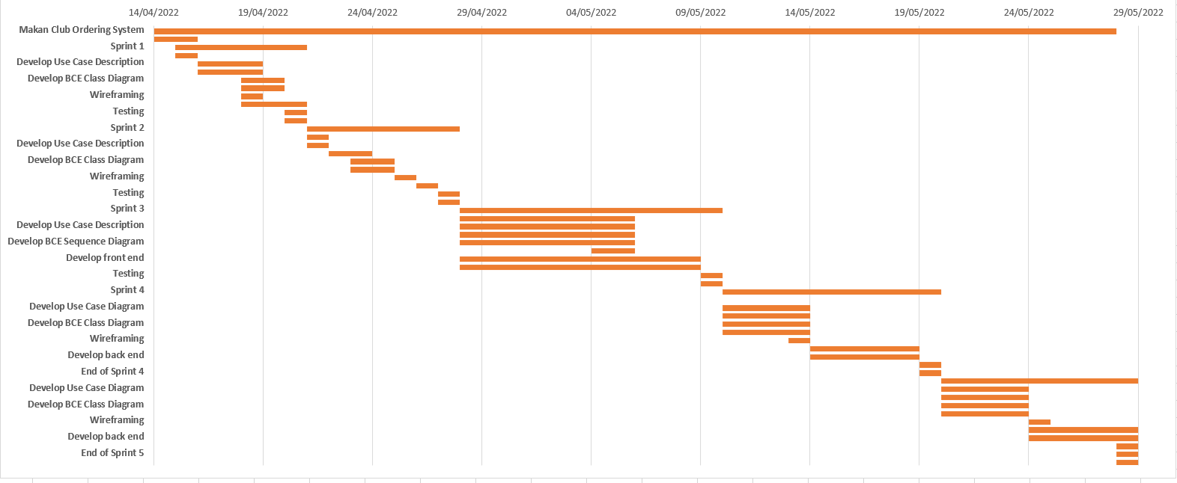

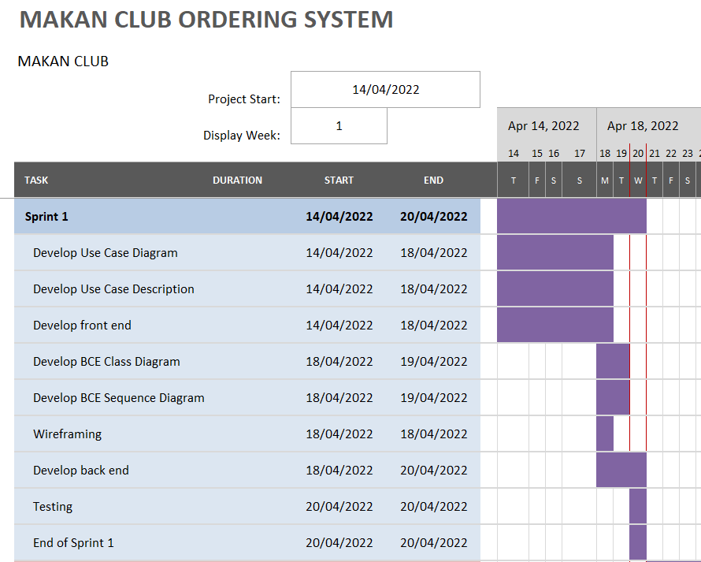

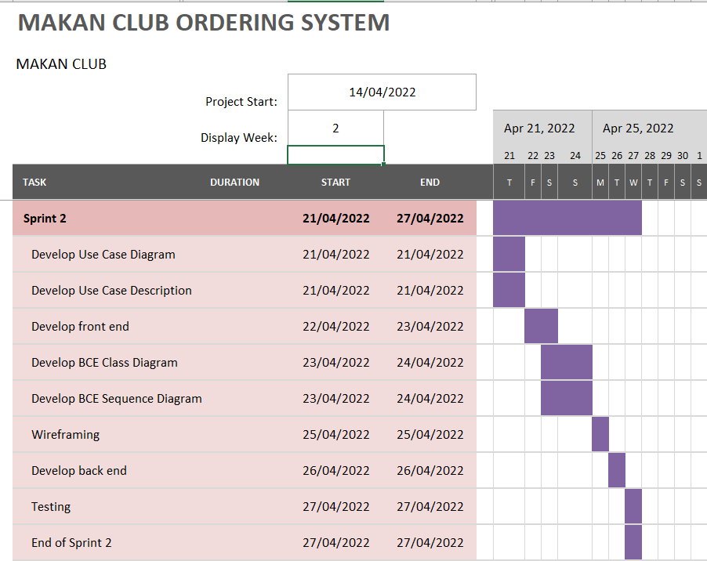

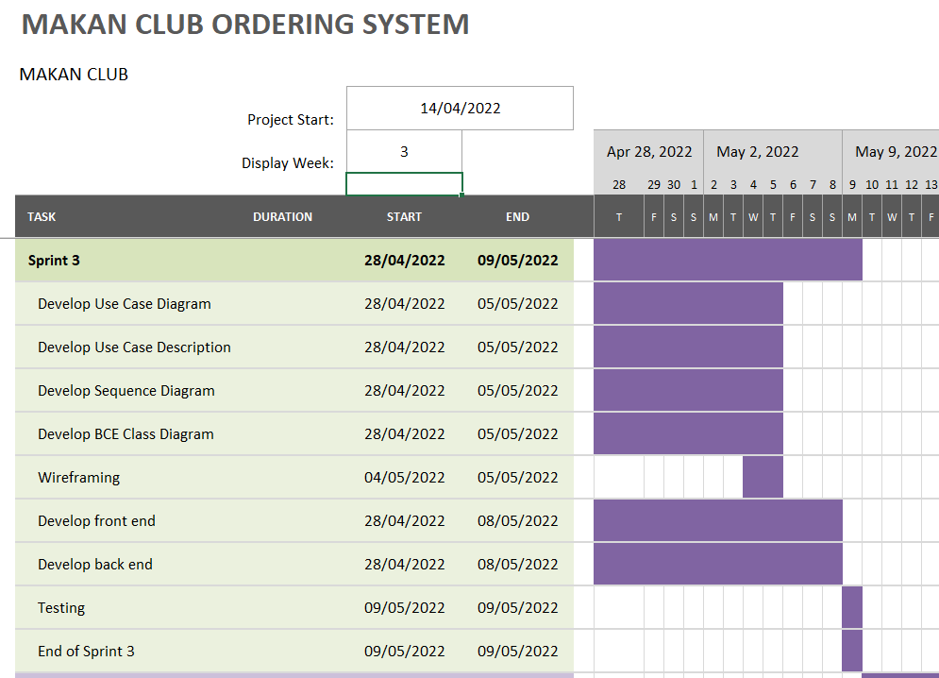

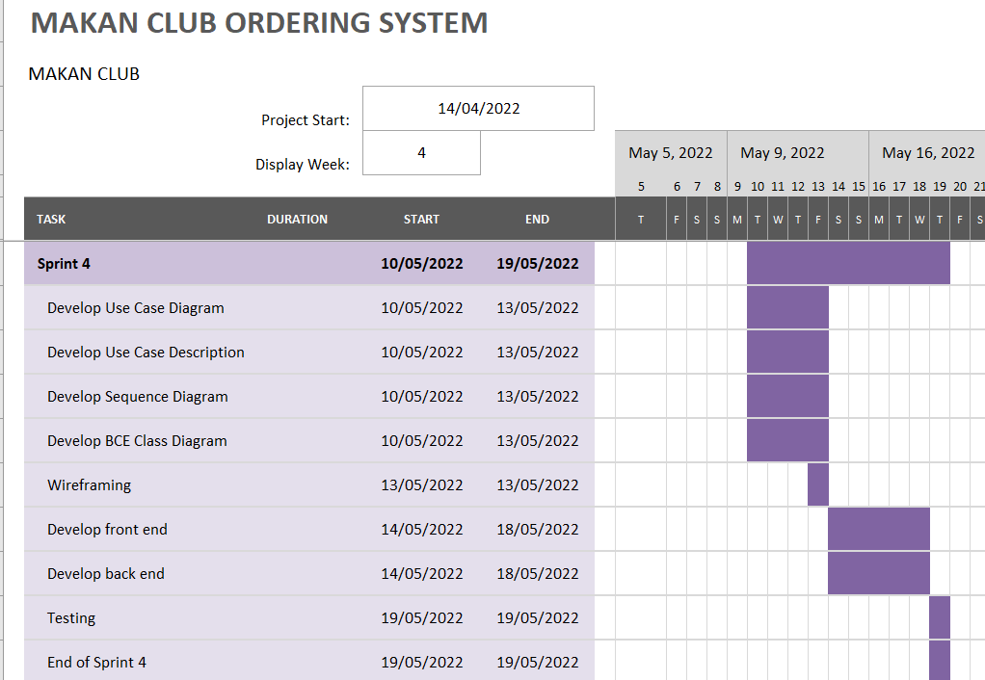

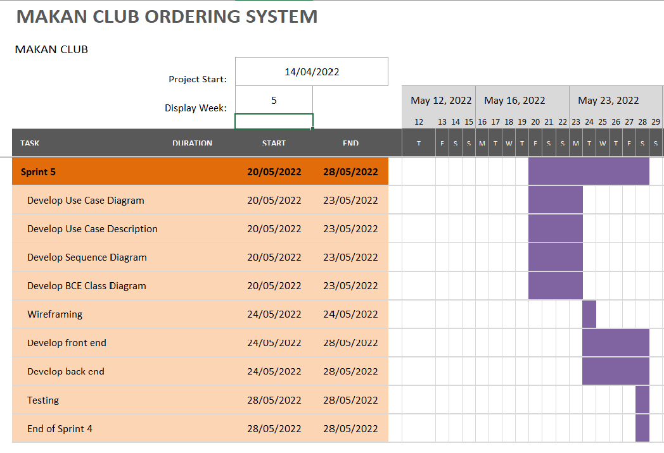

# Use Case Diagrams

### 3.1 Guest/Member

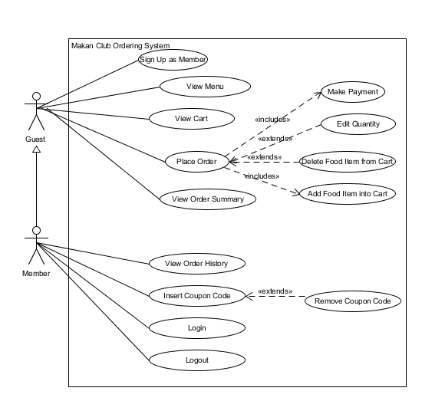

### 

### 3.2 Restaurant Staff

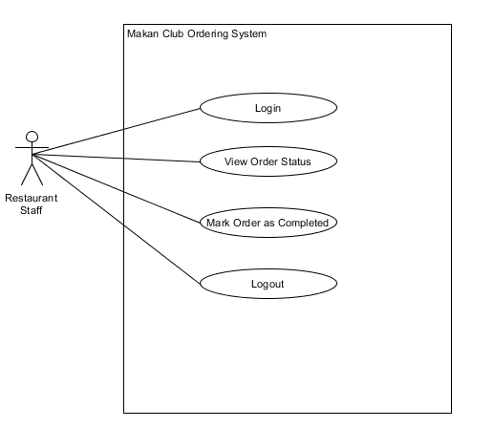

### 

### 3.3 Restaurant Manager

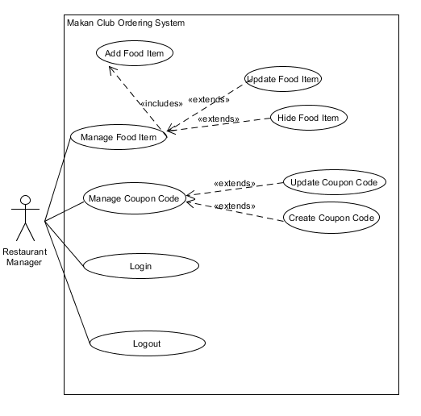

### 3.4 Restaurant Owner

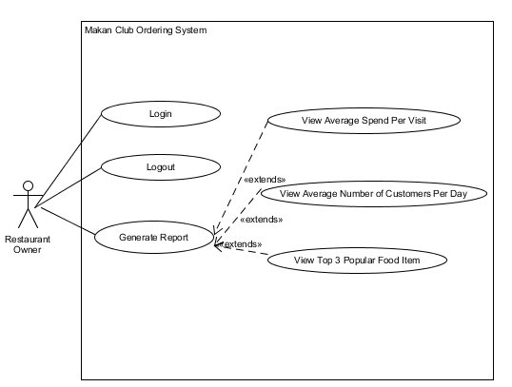

# Use Case Description

### 4.1 All actors except Guest

|  |  |
| --- | --- |
| **Name: Login** | **ID#:001** |
| **Stakeholders and Goals:** User - Wants to login to the application | |
| **Description:** Member, Restaurant Staff, Restaurant Manager, Restaurant Owner wants to login onto the application to utilize additional functions | |
| **Actors:** Member, Restaurant Staff, Restaurant Manager, Restaurant Owner | |
| **Pre-condition:** User must have a valid account in the database | |
| **Trigger:** The user selects login button on the application | |
| **Normal Flow:**   1. User taps on option to login 2. Application shows user a prompt to login 3. User enters login credentials and submits 4. Application checks if entered credentials is valid 5. If valid, Application displays a banner notifying user that login is successful 6. End | |
| **Sub-Flows:** None | |
| **Alternative/Exceptional Flows:**   1. Failed Login - Application to prompt error message: “Incorrect username/password” | |
| **Post-condition:** User is successfully logged into the application | |

|  |  |
| --- | --- |
| **Name: Logout** | **ID#:002** |
| **Stakeholders and Goals:** User- Wants to logout of the application | |
| **Description:** User wants to log out of the application and must be signed in. | |
| **Actors:** Members, Restaurant Staff, Restaurant Manager, Restaurant Owner, Developer | |
| **Trigger:** User selects logout on the application | |
| **Pre-condition:** User must be logged into the account to trigger termination of session | |
| **Normal Flow:**   1. User taps on option to logout 2. Application logs the user out and is redirected to login page. 3. End | |
| **Sub-Flows:**  None | |
| **Alternative/Exceptional Flows:** - | |
| **Post-condition:** User is successfully logged out of the application | |

### 

### 4.2 Guest

|  |  |
| --- | --- |
| **Name: Sign up as member** | **ID#:003** |
| **Stakeholders and Goals:** Guest - wants to sign up as a member | |
| **Description:** A guest wants to sign up for an account as a member | |
| **Actors:** Guest | |
| **Pre-condition:** The application must be loaded with the sign-up page active | |
| **Trigger:** When the guest wants to create a new account | |
| **Normal Flow:**   1. Guest visits the restaurant and enters the unique code provided on the table. 2. Guest taps on the sign-up button and fills in the required information. 3. Application validates and records the entry. 4. Application redirect to customer login page 5. End. | |
| **Sub-Flows:** None | |
| **Alternative/Exceptional Flows:**  3a. Application validation fails due to syntax error.  3b. Application fails to record due to database issue.  4a. Guest cannot register as email is taken. | |
| **Post-condition:** Guest is notified that they have been successfully registered as a Member | |

### 

### 4.3 Guest and Member

|  |  |
| --- | --- |
| **Name: View Menu** | **ID#:004** |
| **Stakeholders and Goals:** Guest, Member - Wants to find out what is available to eat | |
| **Description:** A Guest/Member can view the menu options that are available in the restaurant | |
| **Actors:** Guest, Member | |
| **Pre-condition:** The application must be loaded | |
| **Trigger:** The customer enters the unique code provided on the table to view the menu | |
| **Normal Flow:**   1. Guest/Member enters unique code provided on the table 2. Application queries database for available food options 3. Application populates page with options and displays the menu 4. Guest/Member is able to view the menu options 5. End | |
| **Sub-Flows:** None | |
| **Alternative/Exceptional Flows:** None | |
| **Post-condition:** - | |

# 

|  |  |
| --- | --- |
| **Name: View Cart** | **ID#:005** |
| **Stakeholders and Goals:** Guest, Member- Wants to find out what are the pending orders before placing the order. | |
| **Description:** Customer is able to view their pending food items | |
| **Actors:** Guest, Member | |
| **Pre-condition:** The application must be open with an active session. | |
| **Trigger:** The customer selects the cart option on the application | |
| **Normal Flow:**   1. Customer opens application and taps on cart 2. Application checks on current pending orders for the customer’s table 3. Application generates a dynamic page which contains the current pending order 4. End | |
| **Sub-Flows:** None | |
| **Alternative/Exceptional Flows:**  None | |
| **Post-condition:** - | |

# 

|  |  |
| --- | --- |
| **Name: Place Order** | **ID#:006** |
| **Stakeholders and Goals:** Guest, Member- Wants to order food after deciding on menu items | |
| **Description:** Guest/Member is able to send their order to the Application so that food preparation can begin | |
| **Actors:** Guest, Member | |
| **Pre-condition:** There must be existing items in the cart | |
| **Trigger:** The Guest/Member taps on place order | |
| **Normal Flow:**   1. Guest/Member views the menu and add food items to cart 2. Guest/Members opens cart and views current food items in cart 3. Guest/Members confirms order and taps on ‘Place Order’ 4. Application receives the order and sends it to the restaurant staff 5. Application displays a confirmation page to inform Guest/Member that their order is received 6. End | |
| **Sub-Flows:**  None | |
| **Alternative/Exceptional Flows:**  None | |
| **Post-condition:** Order is successful | |

# 

|  |  |
| --- | --- |
| **Name: Add Food Item into Cart** | **ID: ID#:007** |
| **Stakeholders and Goals:** Guest, Member - Wants to add food items to the cart | |
| **Description:** Guest/Member wants to be able to add food items to the cart | |
| **Actors:** Guest, Member | |
| **Pre-condition:** The application must be open with an active session. | |
| **Trigger:** Guest/Member taps on add food item to cart | |
| **Normal Flow:**   1. Guest/Member view available food items on the menu 2. Guest/Member adds a food item to cart 3. Application receives item and qty from Guest/Member and adds to Guest/Member’s cart 4. Application updates the page and reflects that item has been successfully added to cart 5. End | |
| **Sub-Flows:**  None | |
| **Alternative/Exceptional Flows:** None | |
| **Post-condition:** Food Item is successfully added into the cart | |

# 

|  |  |
| --- | --- |
| **Name: Delete Food Item from Cart** | **ID: ID#:008** |
| **Stakeholders and Goals:** Guest, Member - Wants to delete food item from cart | |
| **Description:** Guest/Member wants to be able to delete food item from cart | |
| **Actors:** Guest, Member | |
| **Pre-condition:** There must be existing food items in the cart | |
| **Trigger:** Guest/Member taps on the cross button to delete food item from cart | |
| **Normal Flow:**   1. Guest/Member view current cart items 2. Guest/Member removes food item from cart 3. Application receives the request and removes food item from cart 4. Application updates the page and reflects that food item has been successfully deleted from cart 5. End | |
| **Sub-Flows:**  None | |
| **Alternative/Exceptional Flows:** None | |
| **Post-condition:** Food Item is successfully deleted from the cart | |

|  |  |
| --- | --- |
| **Name: Edit Quantity** | **ID#:009** |
| **Stakeholders and Goals:** Guest, Member - Wants to alter the items that he has chosen | |
| **Description:** Guest/Member wants to be able to change the quantity of the food items that is in current cart | |
| **Actors:** Guest, Member | |
| **Pre-condition:** There must be a minimum quantity of 1 of the food item in the cart | |
| **Trigger:** Guest/Member views the cart and wants to modify the quantity that is in current cart | |
| **Normal Flow:**   1. Guest/Member views current cart and the selected food items 2. Guest/Member edits the quantity of the food in the cart 3. Application receives the customer’s input updates quantity into the database 4. Application reflects the quantity has been successfully updated 5. End | |
| **Sub-Flows:**  None | |
| **Alternative/Exceptional Flows:**  None | |
| **Post-condition:** Quantity of Individual Food Item is updated in the Cart | |

# 

|  |  |
| --- | --- |
| **Name: Make Payment** | **ID#:010** |
| **Stakeholders and Goals:** Guest, Member - Wants to make payment for their orders | |
| **Description:** Guest/Member wants to enter their credentials to make payment | |
| **Actors:** Guests, Member | |
| **Pre-condition:** There must be a minimum quantity of 1 of an individual food item in the cart | |
| **Trigger:** The Guest/Member select make payment option on the app | |
| **Normal Flow:**   1. Guest/Member selects the make payment option on the application 2. Application queries for the items ordered and tabulates the total 3. Application displays the total as well fields to enter payment details 4. Customer enters payment details 5. Application passes payment details to payment processor 6. Application receives an acknowledgement from payment processor 7. Application displays a success screen for payment received 8. End | |
| **Sub-Flows:**  None | |
| **Alternative/Exceptional Flows:**   1. Invalid Payment Details 2. Payment Rejected 3. Payment Timeout | |
| **Post-condition:** Payment is successful | |

# 

|  |  |
| --- | --- |
| **Name: View Order Summary** | **ID#:011** |
| **Stakeholders and Goals:** Guest/Member - wants to view Order summary | |
| **Description:** A Guest/Member can view the order summary of food items ordered | |
| **Actors:** Guest, Member | |
| **Pre-condition:** An order must have been made successfully and payment must have been made | |
| **Trigger:** When the Guest/Member wants to view the summary of the food items ordered | |
| **Normal Flow:**   1. Guest/Member wants to view the order list and taps on the summary. 2. Application shows the ordered list on display. 3. End. | |
| **Sub-Flows:** None | |
| **Alternative/Exceptional Flows:** None | |
| **Post-condition:** - | |

### 

### 4.4 Member

|  |  |
| --- | --- |
| **Name: Insert Coupon code** | **ID#:012** |
| **Stakeholders and Goals:** Member - Wants to utilize a coupon code | |
| **Description:** Member wants to enter a coupon code to receive benefits | |
| **Actors:** Member | |
| **Pre-condition:**   1. Member must be logged in 2. Coupon Code must be valid | |
| **Trigger:** Member selects insert coupon code | |
| **Normal Flow:**   1. Member taps on the option to insert coupon code 2. Application shows Member a prompt to enter code 3. Member enters code and submits 4. Application checks if entered code is valid 5. If code is valid, applies a promotion to the members’ order 6. Application displays a banner notifying Member that the coupon code has been accepted 7. End | |
| **Sub-Flows:**  None | |
| **Alternative/Exceptional Flows:**   1. Remove Code Use Case 2. Invalid Code (wrong code/expired) | |
| **Post-condition:** Coupon Code is successfully utilized | |

# 

|  |  |
| --- | --- |
| **Name: View Order History** | **ID#:013** |
| **Stakeholders and Goals:** Member - Wants to view previous order history | |
| **Description:** Member wants to be able to view back previous orders that he/she purchased | |
| **Actors:** Member | |
| **Pre-condition:** Member must be successfully logged in | |
| **Trigger:** Member selects view purchase history | |
| **Normal Flow:**   1. Member taps on option to view purchase history 2. Application retrieves information from database on member’s previous purchase history 3. Application displays information on purchase history for Member to browse 4. End | |
| **Sub-Flows:**  None | |
| **Alternative/Exceptional Flows:** None | |
| **Post-condition:** - | |

# 

|  |  |
| --- | --- |
| **Name: Remove Coupon Code** | **ID#:014** |
| **Stakeholders and Goals:** Member - Wants to remove coupon code | |
| **Description:** Member wants to remove the coupon code that they have previously entered | |
| **Actors:** Member | |
| **Pre-condition:**   1. Member must be logged in 2. Coupon Code must be successfully applied | |
| **Trigger:** Member wants to remove the coupon code applied for the order | |
| **Normal Flow:**   1. Member taps on the option to remove coupon code 2. Applications prompts user if confirm to remove 3. Application checks if entered code is valid 4. If code is valid, applies a promotion to the members’ order 5. Application displays a banner notifying Member that the coupon code has been accepted 6. End | |
| **Sub-Flows:**  None | |
| **Alternative/Exceptional Flows:** None | |
| **Post-condition:** Coupon Code have been removed | |

### 

### 4.5 Restaurant Staff

|  |  |
| --- | --- |
| **Name: View Order Status** | **ID#:015** |
| **Stakeholders and Goals:** Restaurant Staff - Wants to view the current status of orders | |
| **Description:** Restaurant Staff to view the orders’ status if pending or completed | |
| **Actors:** Restaurant Staff | |
| **Pre-condition:** - | |
| **Trigger:** When Restaurant Staff taps on view order status on the application | |
| **Normal Flow:**   1. Restaurant Staff taps on option to view orders 2. Application queries and displays the list of orders - both pending and completed 3. End | |
| **Sub-Flows:**  None | |
| **Alternative/Exceptional Flows:** None | |
| **Post-condition:** - | |

# 

|  |  |
| --- | --- |
| **Name: Mark Order Completed** | **ID#:016** |
| **Stakeholders and Goals:** Restaurant Staff - wants to mark order as completed | |
| **Description:** Restaurant Staff wants to be able to mark order as completed | |
| **Pre-condition:**   1. Restaurant Staff must be logged in 2. Order status must be ‘pending’ | |
| **Actors:** Restaurant Staff | |
| **Trigger:** When the Restaurant Staff taps on “Completed” | |
| **Normal Flow:**   1. Restaurant Staff taps on order item 2. Application shows order details 3. Restaurant Staff verifies that the order is correct 4. Restaurant Staff taps on “Complete Order” option on the app 5. Application updates status of order in the database and removes it from active orders 6. Application displays a banner to the Restaurant Staff to notify that action has been successful 7. End | |
| **Sub-Flows:**  None | |
| **Alternative/Exceptional Flows:**  None | |
| **Post-condition:** Order is completed | |

### 

### 

### 4.6 Restaurant Manager

|  |  |
| --- | --- |
| **Name: Add Food Item** | **ID#:017** |
| **Stakeholders and Goals:** Restaurant Manager - Wants to be able to add new menu items | |
| **Description:** Gives the restaurant manager a simple interface to add new food items | |
| **Actors:** Restaurant Manager | |
| **Pre-condition:**   1. Restaurant Manager must be successfully logged in 2. Food item must not already exist in the food menu | |
| **Trigger:** When the restaurant manager taps on the add food item option on the application | |
| **Normal Flow:**   1. Restaurant Manager taps on the option to add new food item 2. Application displays manage menu items page for the Restaurant Manager to add a new food item 3. Restaurant Manager enter details of menu item ( Price, Uploads Photo ) 4. Application adds a new entry to the database based on entered details 5. End | |
| **Sub-Flows:**  None | |
| **Alternative/Exceptional Flows:**  Empty entry validation | |
| **Post-condition:** Food Item is added successfully into the food menu | |

# 

|  |  |
| --- | --- |
| **Name: Update Food Item** | **ID#:018** |
| **Stakeholders and Goals:** Restaurant Manager - Wants to be able to edit existing food items on the menu | |
| **Description:** Gives the Restaurant Manager an interface to easily edit menu item details | |
| **Actors:** Restaurant Manager | |
| **Pre-condition:**   1. Restaurant Manager must be successfully logged in 2. Food item must exist in the food menu | |
| **Trigger:** When the restaurant manager taps on the edit food item option on the application | |
| **Normal Flow:**   1. Restaurant Manager taps on the option to update food item 2. Application queries for the details of the existing menu item, and populates it as placeholder values in a form 3. Restaurant Manager updates the details of menu item (Price, Photo, Name ) 4. Application updates entry to the database based on entered details 5. End | |
| **Sub-Flows:**  None | |
| **Alternative/Exceptional Flows:**  Empty entry validation | |
| **Post-condition:** Food item is updated and reflected in the food menu | |

|  |  |
| --- | --- |
| **Name: Hide Food Item** | **ID#:019** |
| **Stakeholders and Goals:** Restaurant Manager - Wants to be able to hide menu item | |
| **Description:** Restaurant Manager wants to hide a food item from the application because it is no longer available | |
| **Actors:** Restaurant Manager | |
| **Pre-condition:**   1. Restaurant Manager must be successfully logged in 2. Food item must exist in the food menu | |
| **Trigger:** When the restaurant manager taps on the hide food item option on the application | |
| **Pre-condition:** Restaurant Manager must have a valid account in the database | |
| **Normal Flow:**   1. Restaurant Manager taps on the option to hide food item 2. Restaurant Manager hides the food item 3. Applications updates backend to hide the food item 4. Application refresh the page to reflect the menu of updated list of food items with the food item hidden 5. End. | |
| **Sub-Flows:**  None | |
| **Alternative/Exceptional Flows:**  None | |
| **Post-condition:** Food Item is hidden from the food menu | |

# 

|  |  |
| --- | --- |
| **Name: Create Coupon Code** | **ID#:020** |
| **Stakeholders and Goals:** Restaurant Manager - Wants to create coupon code | |
| **Description:** Allows the Restaurant Manager to create coupon codes to give customers | |
| **Actors:** Restaurant Manager | |
| **Pre-condition:**   1. Restaurant Manager must be successfully logged in 2. Coupon Code must not exist | |
| **Trigger:** When the Restaurant Manager selects the option to create coupon code option | |
| **Normal Flow:**   1. Restaurant Manager taps on the option to create coupon code 2. Application displays manage coupon code page to create a coupon code 3. Restaurant Manager enters and submits the details of the coupon code ( code, value, validity period ) 4. Application receives the details and creates a new entry into the coupon code table 5. Application notify Restaurant Manager that the code has been created 6. End | |
| **Sub-Flows:**  None | |
| **Alternative/Exceptional Flows:** None | |
| **Post-condition:** Coupon Code is created successfully | |

# 

|  |  |
| --- | --- |
| **Name: Update Coupon Code** | **ID#:021** |
| **Stakeholders and Goals:** Restaurant Manager - Wants to update coupon code | |
| **Description:** Allows the Restaurant Manager to update coupon code | |
| **Actors:** Restaurant Manager | |
| **Pre-condition:**   1. Restaurant Manager must be successfully logged in 2. Coupon Code must not exist | |
| **Trigger:** When the Restaurant Manager selects the option to create coupon code option | |
| **Normal Flow:**   1. Restaurant Manager taps on the option to update coupon code 2. Application displays a form to update a coupon code 3. Restaurant Manager enters and submits the details of the coupon code ( code, value, validity period ) 4. Application receives the details and update the coupon code table 5. Application notify Restaurant Manager that the code has been updated 6. End | |
| **Sub-Flows:**  None | |
| **Alternative/Exceptional Flows:** None | |
| **Post-condition:** Coupon Code is created successfully | |

### 

### 4.7 Restaurant Owner

|  |  |
| --- | --- |
| **Name: View Average Spend Per Visit** | **ID#:022** |
| **Stakeholders and Goals:** Restaurant Owner - wants to know the average spending per visit | |
| **Description:** Restaurant Owner wants to generate a report to know the average spending in the restaurant | |
| **Actors:** Restaurant Owner | |
| **Pre-condition:** Restaurant Owner must be successfully logged in | |
| **Trigger:** Restaurant Owner wants to view report | |
| **Normal Flow:**   1. Restaurant Owner logs in 2. Application retrieves records from database and calculates backend the average spending per visit. 3. Application displays the result and visible to Restaurant Owner 4. End | |
| **Sub-Flows:**  None | |
| **Alternative/Exceptional Flows:** None | |
| **Post-condition:**  - | |

### 

|  |  |
| --- | --- |
| **Name: View Average Number of Customers Per Day** | **ID#:023** |
| **Stakeholders and Goals:** Restaurant Owner - wants to know how many customers patronizes the restaurant every day. | |
| **Description:** Restaurant Owner - wants to generate a report to find the average number of customers that orders daily | |
| **Actors:** Restaurant Owner | |
| **Pre-condition:**  Restaurant Owner must be successfully logged in | |
| **Trigger:** Restaurant Owner wants to view report | |
| **Normal Flow:**   1. Restaurant Owner logs in 2. Application retrieves records from database and calculates backend the average number of customers per day 3. Application displays the result and visible to Restaurant Owner 4. End | |
| **Sub-Flows:**  None | |
| **Alternative/Exceptional Flows:** None | |
| **Post-condition:** - | |

### 

|  |  |
| --- | --- |
| **Name: View Top 3 Popular Food Item** | **ID#:024** |
| **Stakeholders and Goals:** Restaurant Owner - Wants to view the top 3 popular food items. | |
| **Description:** To allow the restaurant owner to view the top 3 popular food item | |
| **Actors:** Restaurant Owner | |
| **Pre-condition:** Restaurant Owner must be successfully logged in | |
| **Trigger:** Restaurant Owner wants to view report | |
| **Normal Flow:**   1. Restaurant Owner taps on “Generate Report” button 2. Application retrieves records from database 3. Application displays the requested result and visible to Restaurant Owner 4. End | |
| **Sub-Flows:**  None | |
| **Alternative/Exceptional Flows:** None | |
| **Post-condition:** - | |

# 

# 

# BCE Class Diagram

### 5.1 Guest

Sign Up As Member:

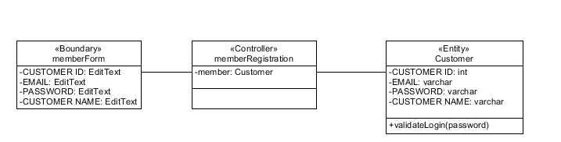

View Menu:

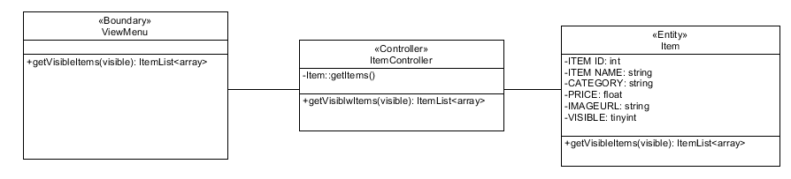

Checkout

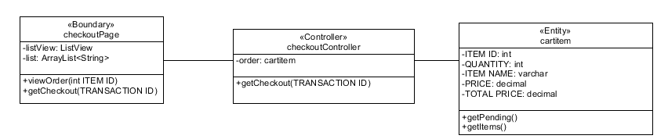

View Order Summary:

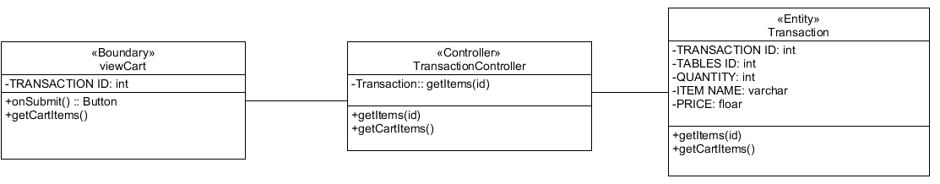

### 5.2 Member

Login:

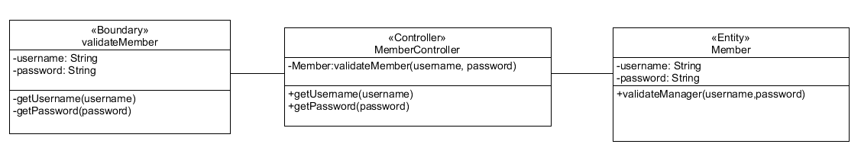

View Order History:

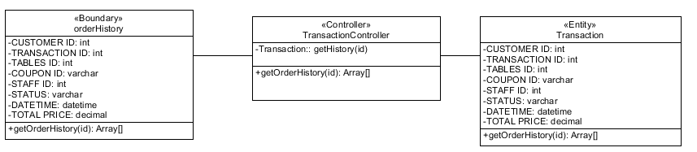

Insert Coupon Code:

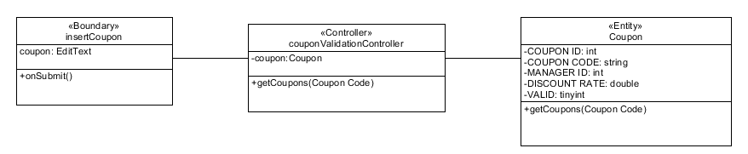

Logout

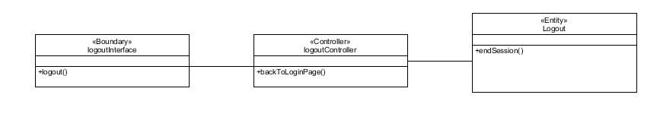

### 

### 5.3 Restaurant Staff

Login:

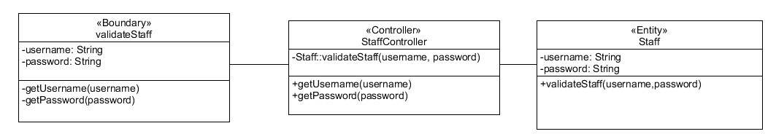

View Order Status:

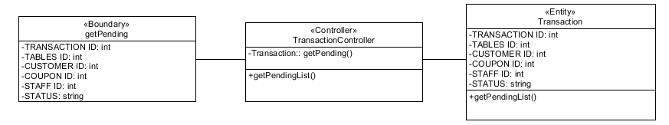

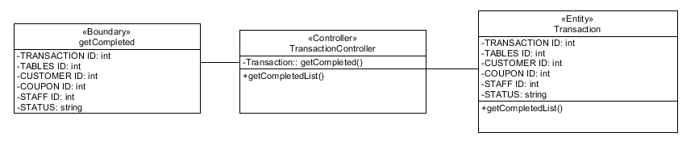

Mark Order Completed:

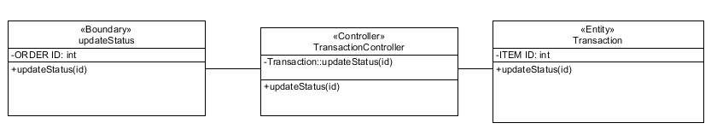

Logout



### 

### 5.4 Restaurant Manager

Login:

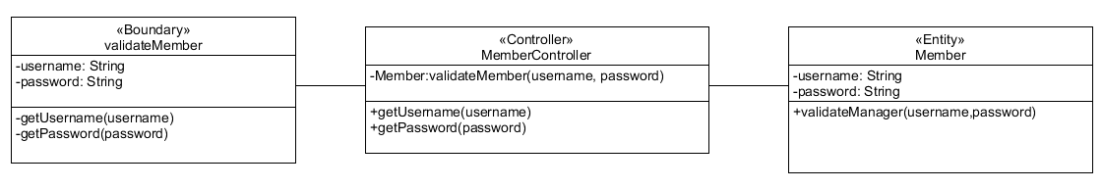

Add Food Item:

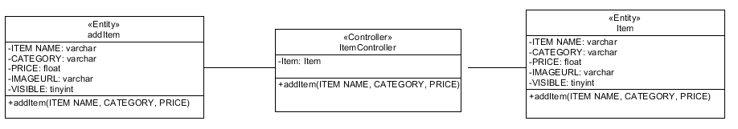

Edit Food Item:

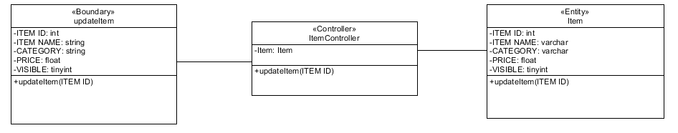

Create Coupon Code: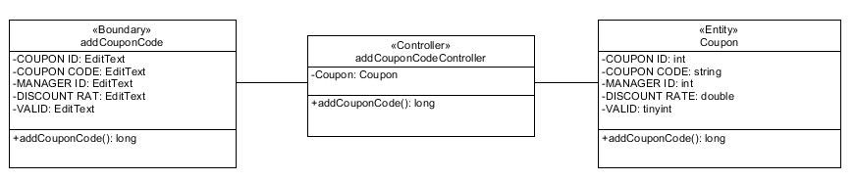

Update Coupon Code:

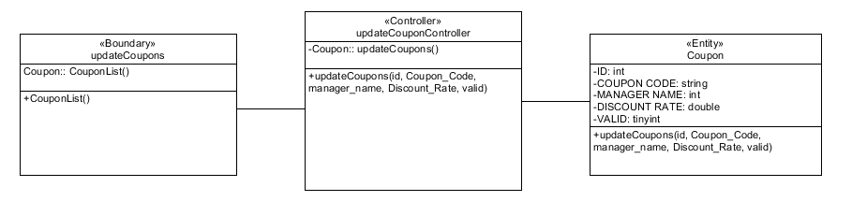

Logout



### 5.5 Restaurant Owner

Login

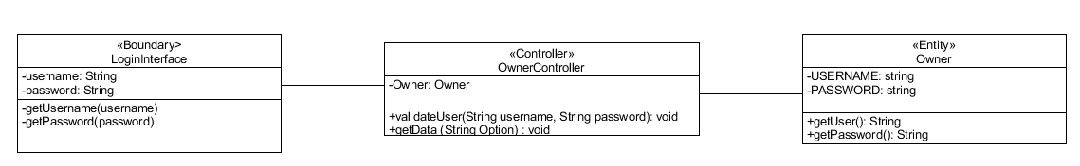

View Average Spend Per Visit, View Average Number of Customers Per Day, View Top 3 Popular Food Item

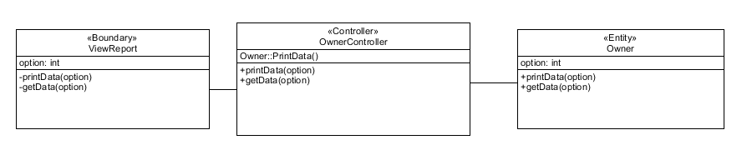

Logout



# BCE Sequence Diagram

### 6.1 Guest

#### 6.1.1 Sign up as member

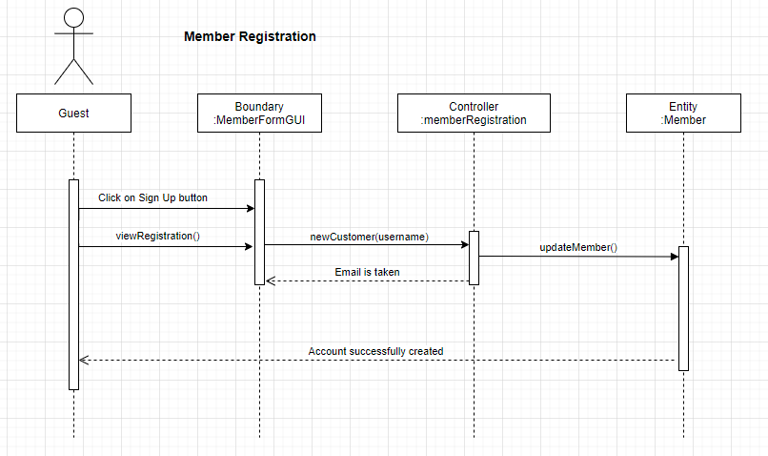

### 

### 6.2 Guest/Member

#### 6.2.1 View Menu

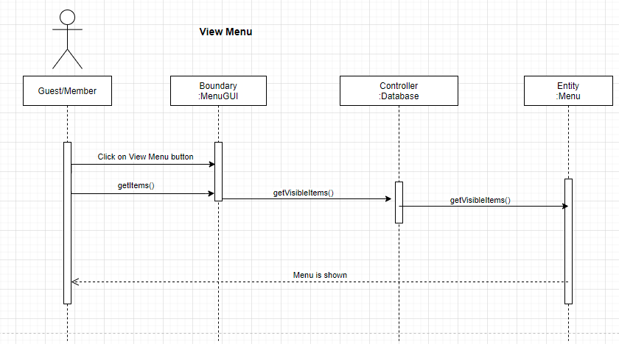

#### 6.2.2 Place Order

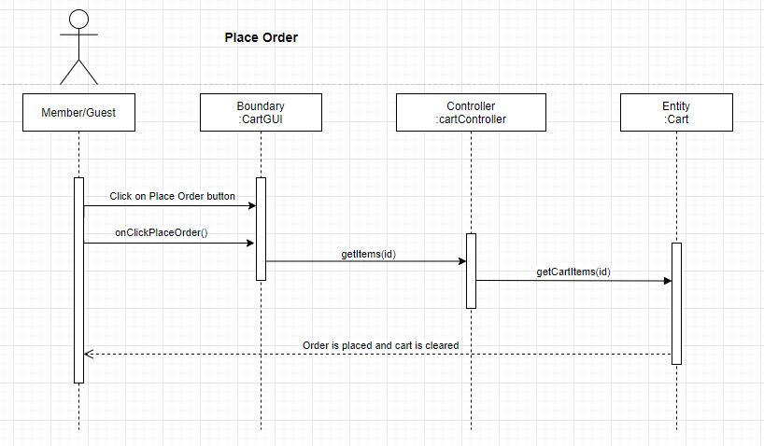

#### 6.2.3 View Cart

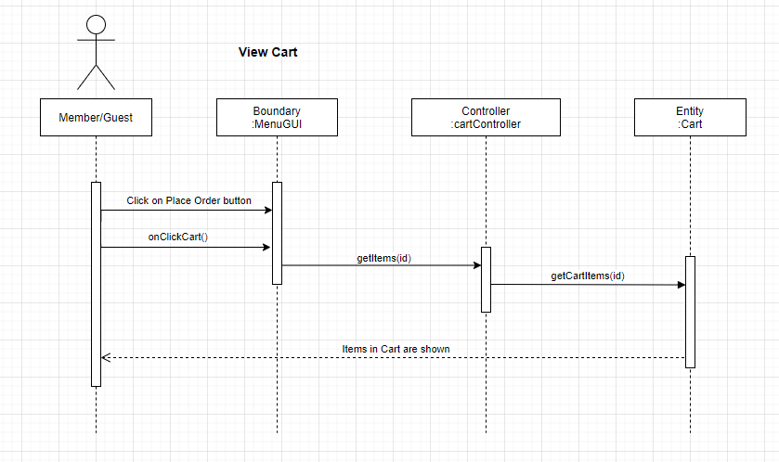

#### 6.2.4 Add Food Item to Cart

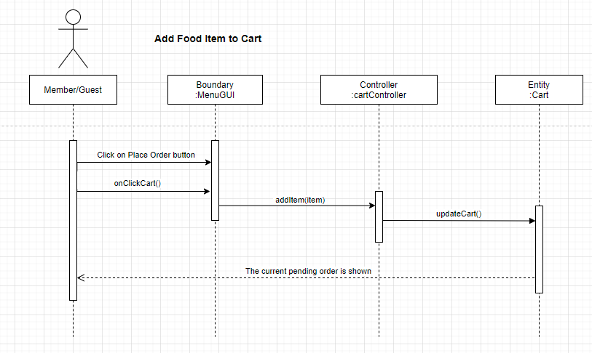

#### 6.2.5 Edit Quantity

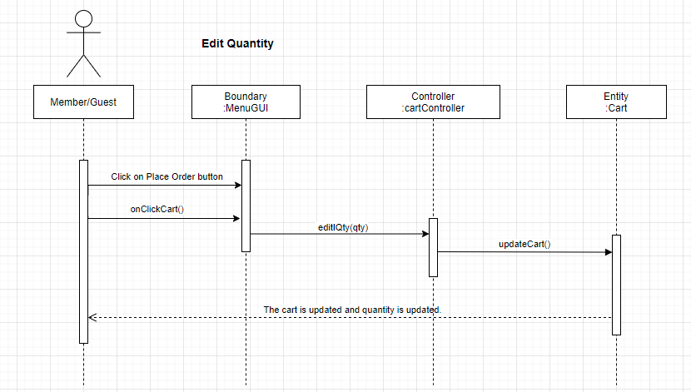6.2.6 Delete Food Item from Cart

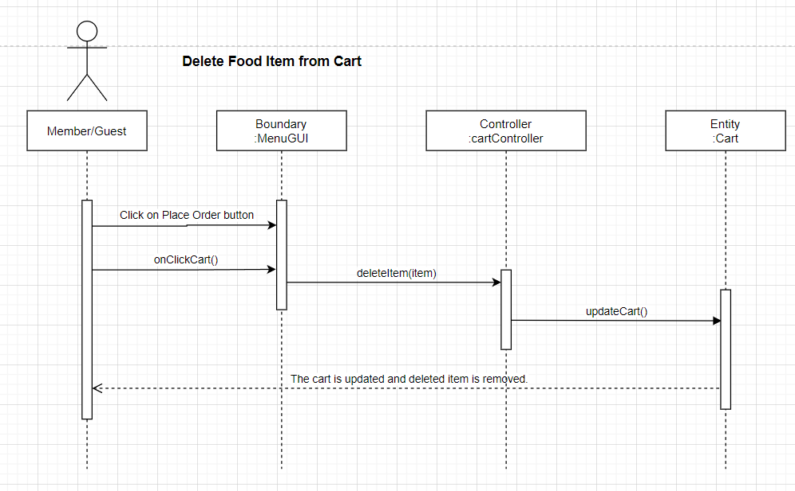

6.2.7 View Order Summary

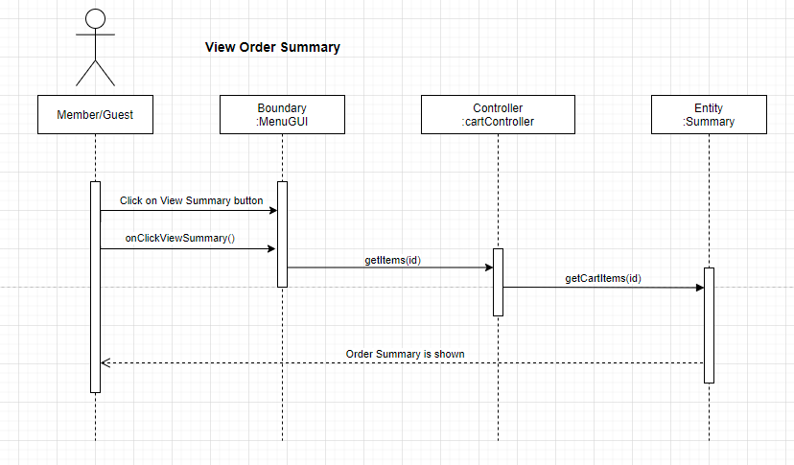

#### 6.2.8 Make Payment

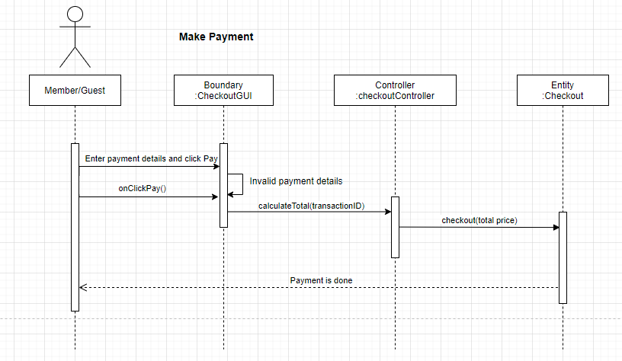

### 6.3 Member

#### 6.3.1 Login

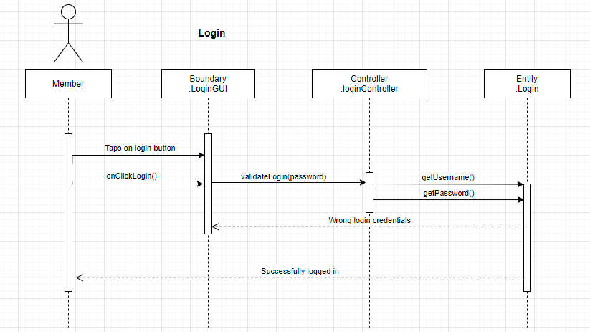

#### 6.3.2 Logout

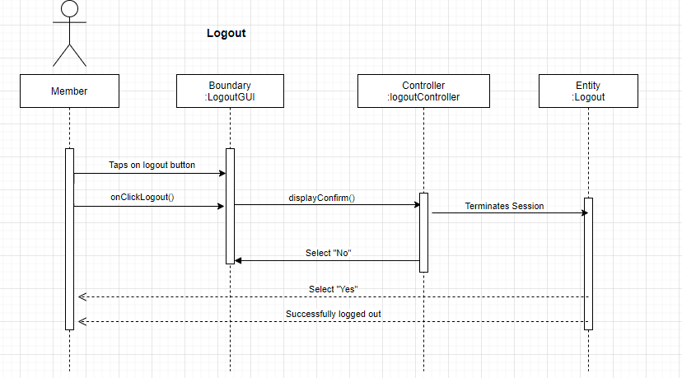

#### 6.3.3 Insert Coupon Code

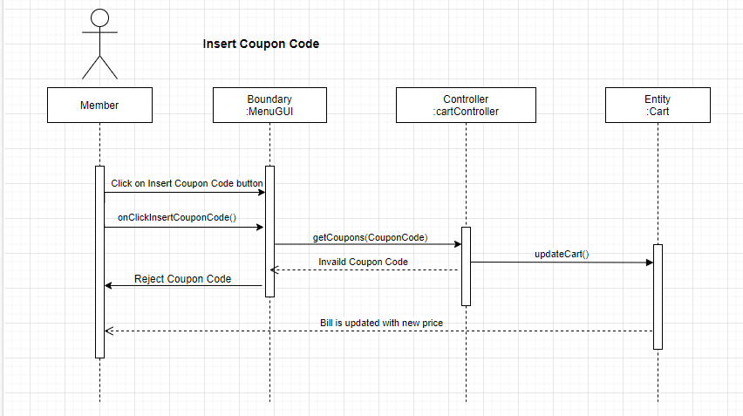

### 

### 6.4 Restaurant Staff

#### 6.4.1 Login

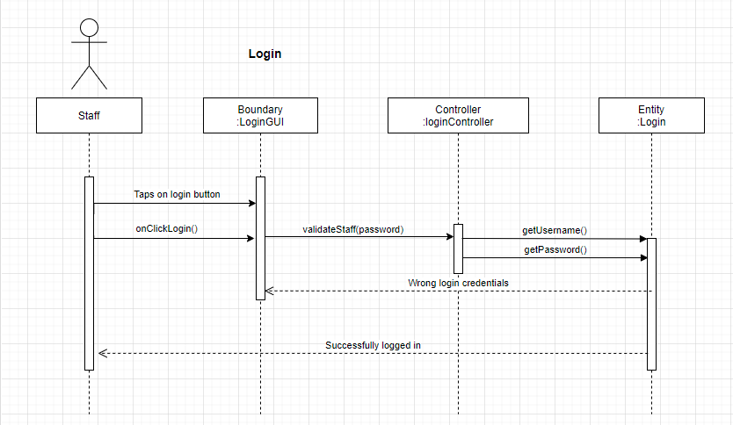

#### 6.4.2 View Order Status

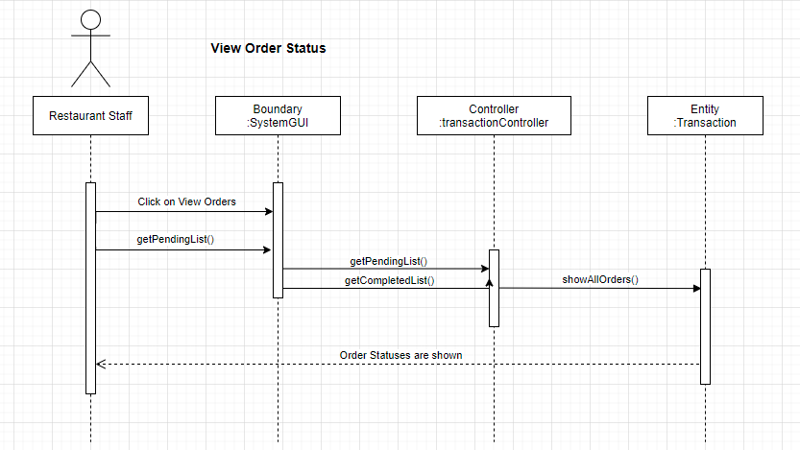

#### 6.4.3 Mark Order as Completed

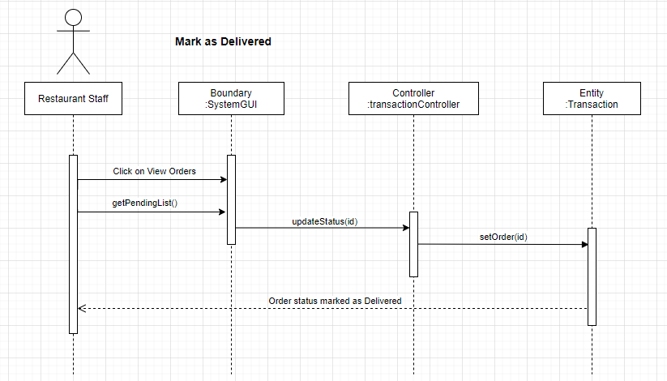

#### 6.4.4 Logout

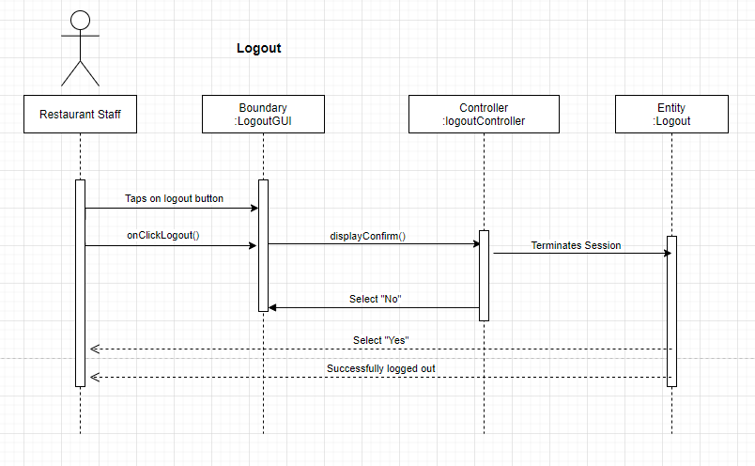

### 6.5 Restaurant Manager

#### 6.5.1 Login

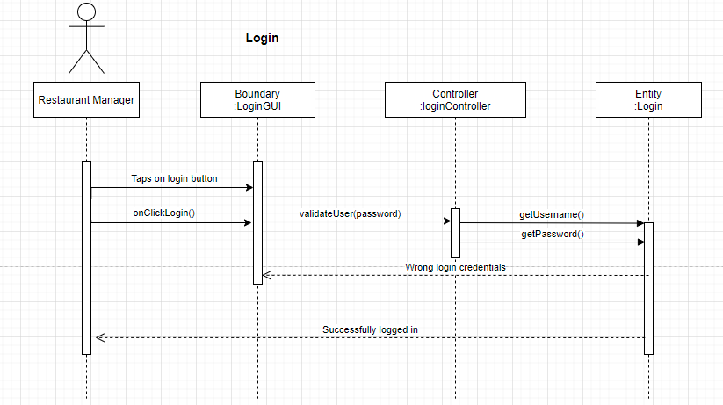

#### 6.5.2 Add Food Item

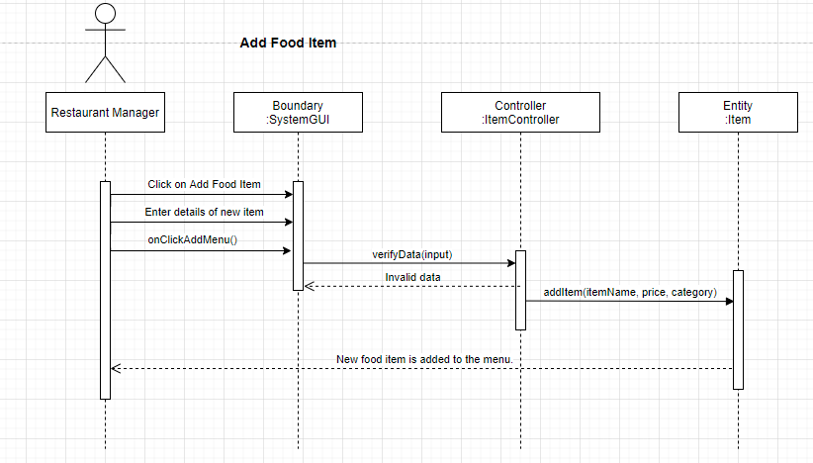

6.5.3 Edit Food Item

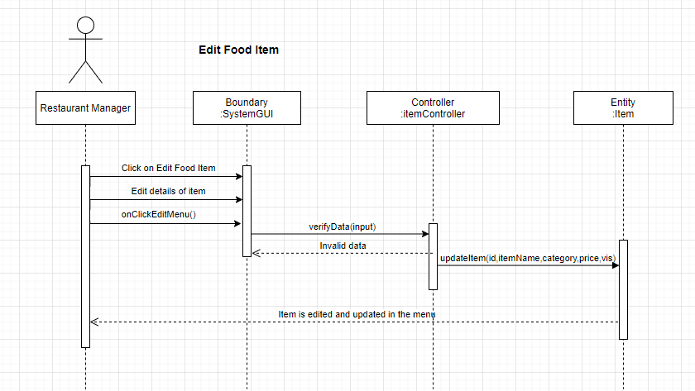

#### 6.5.3 Hide Food Item

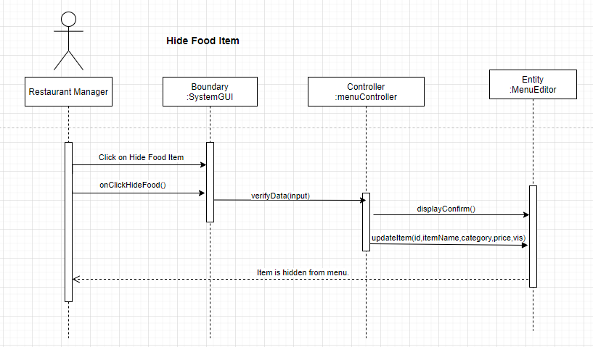

#### 6.5.4 Create Coupon Code

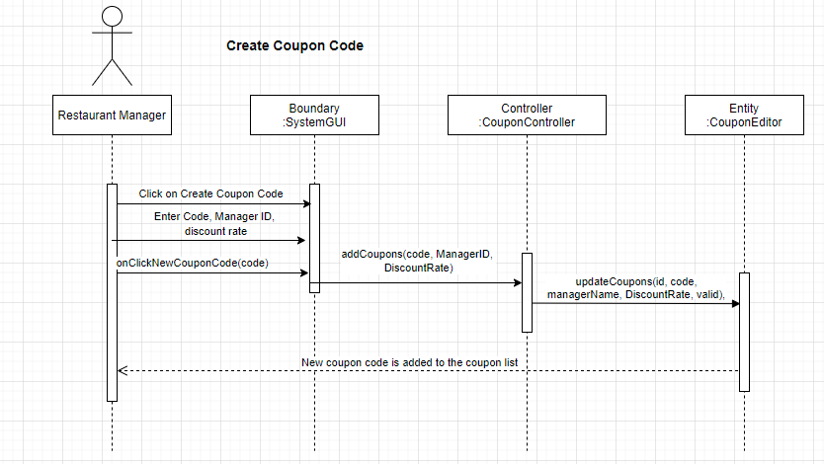

#### 6.5.5 Update Coupon Code

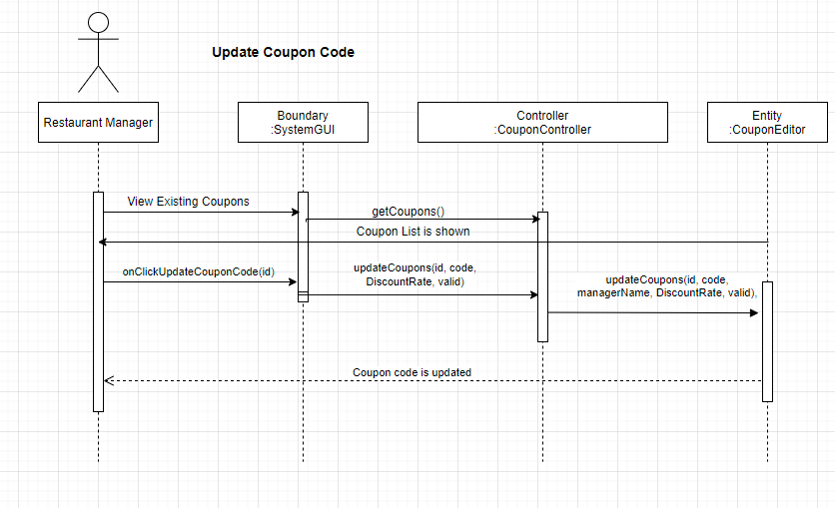

#### 6.5.6 Logout

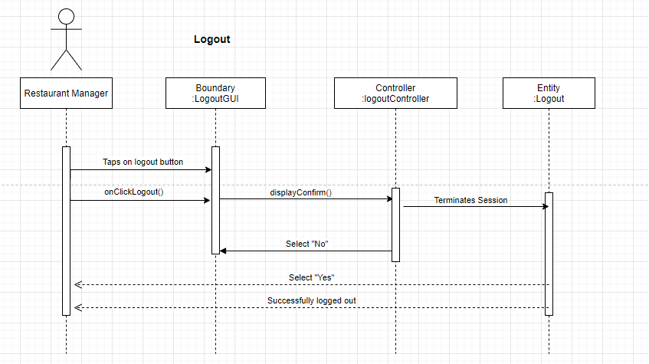

### 

### 6.6 Restaurant Owner

#### 6.6.1 Login

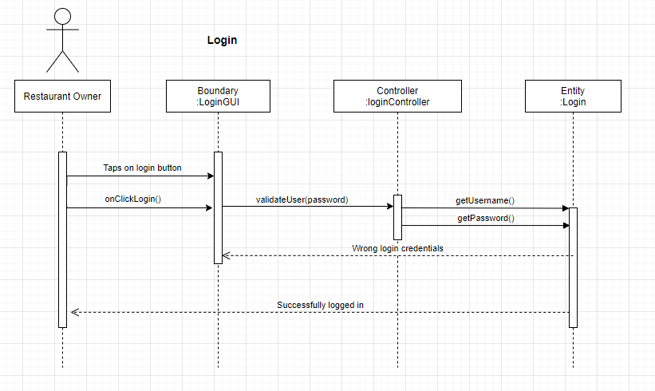6.6.2 View Report

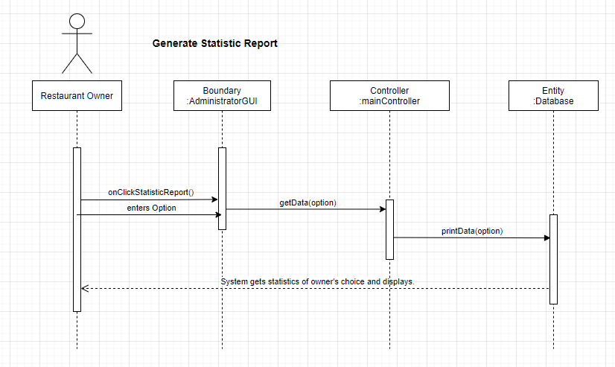

#### 6.6.3 Logout

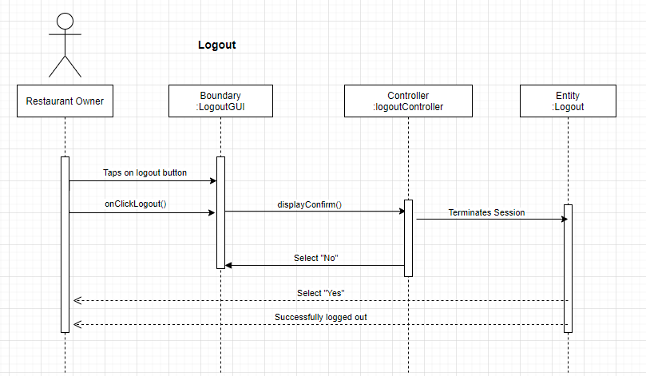

# 7. Sprints

## 7.1 Sprint 1

### 7.1.1 Wireframe

#### 7.1.1.1 Customer

**Guest:**

* View Menu

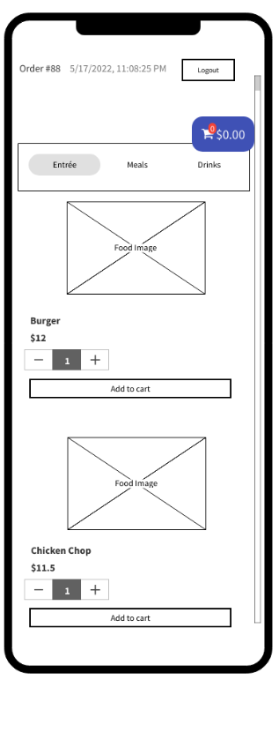

* Sign Up

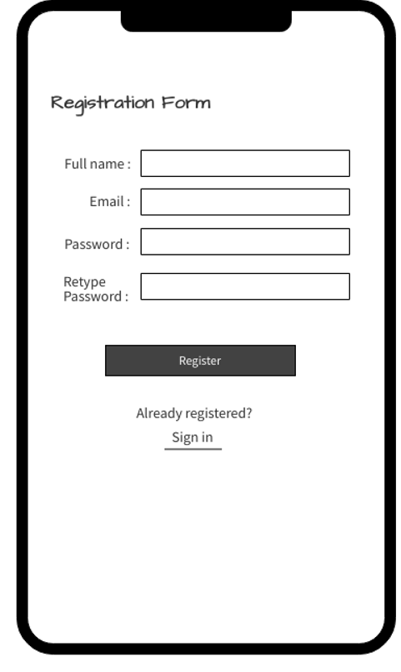

* Add Item to Cart

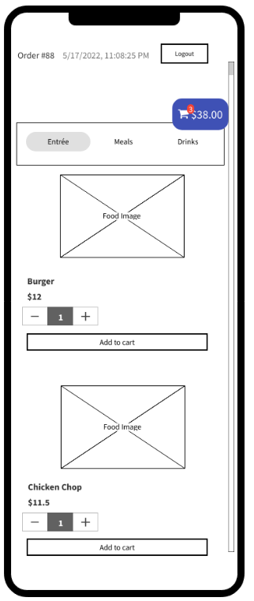

* View Cart Details

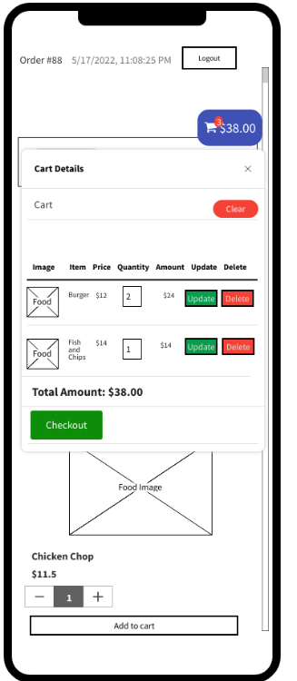

* Delete Item from Cart

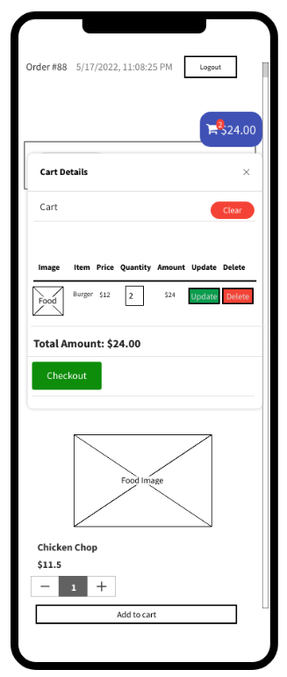

**Member:**

* View Menu

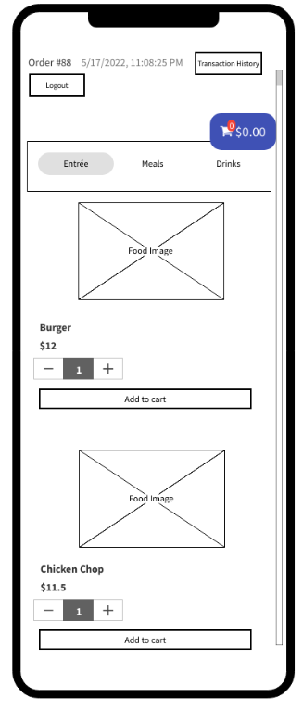

* Add Item to Cart

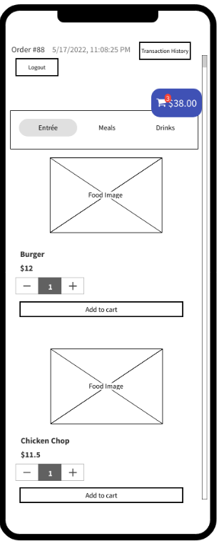

* View Cart Details

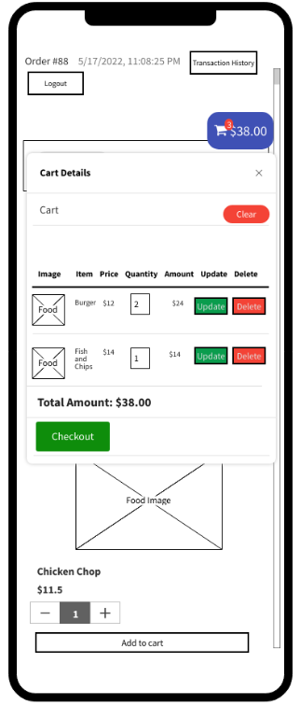

* Delete Item from Cart

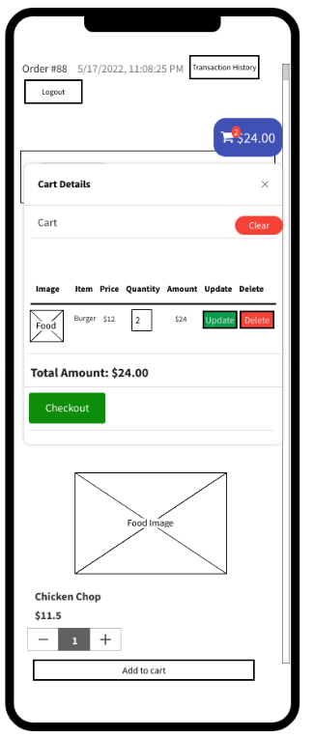

#### 7.1.1.2 Restaurant Staff

Nil

#### 7.1.1.3 Restaurant Manager

Nil

#### 7.1.1.4 Restaurant Owner

Nil

**Interface**

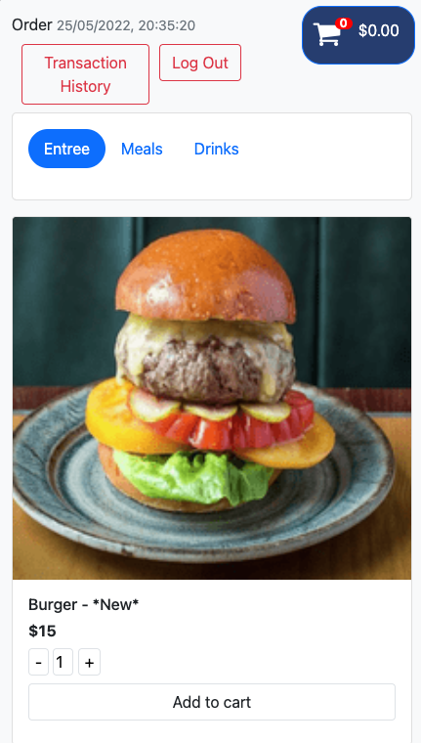

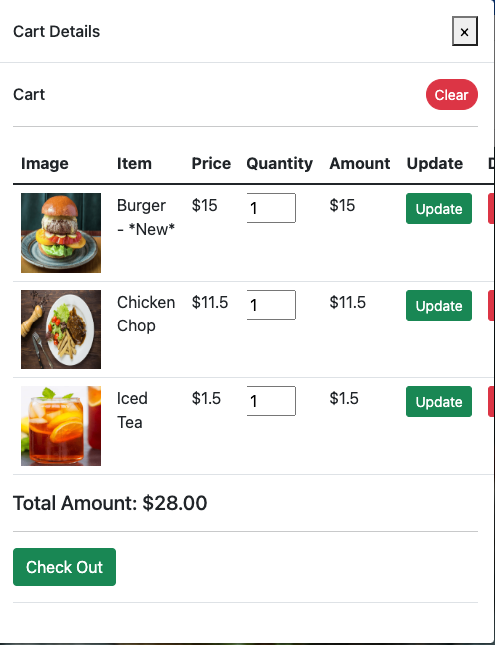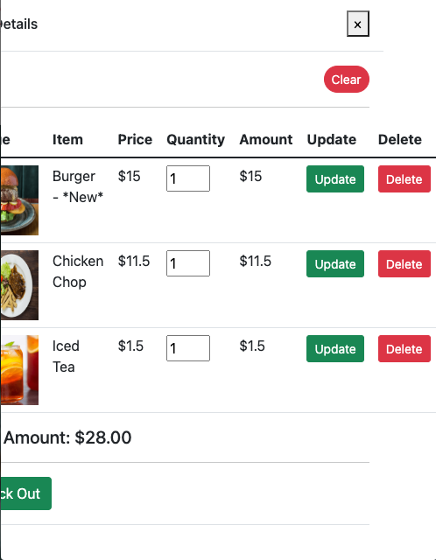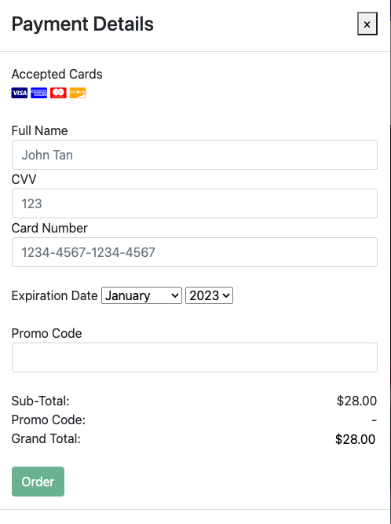

### 7.1.2 Test Cases

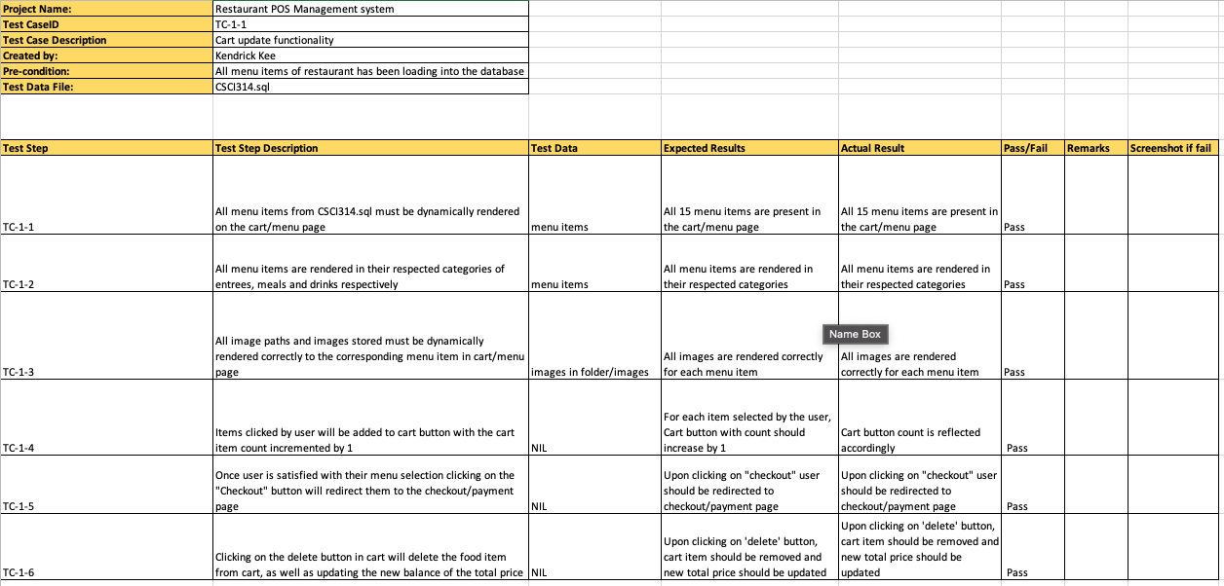

### 7.1.3 Taiga

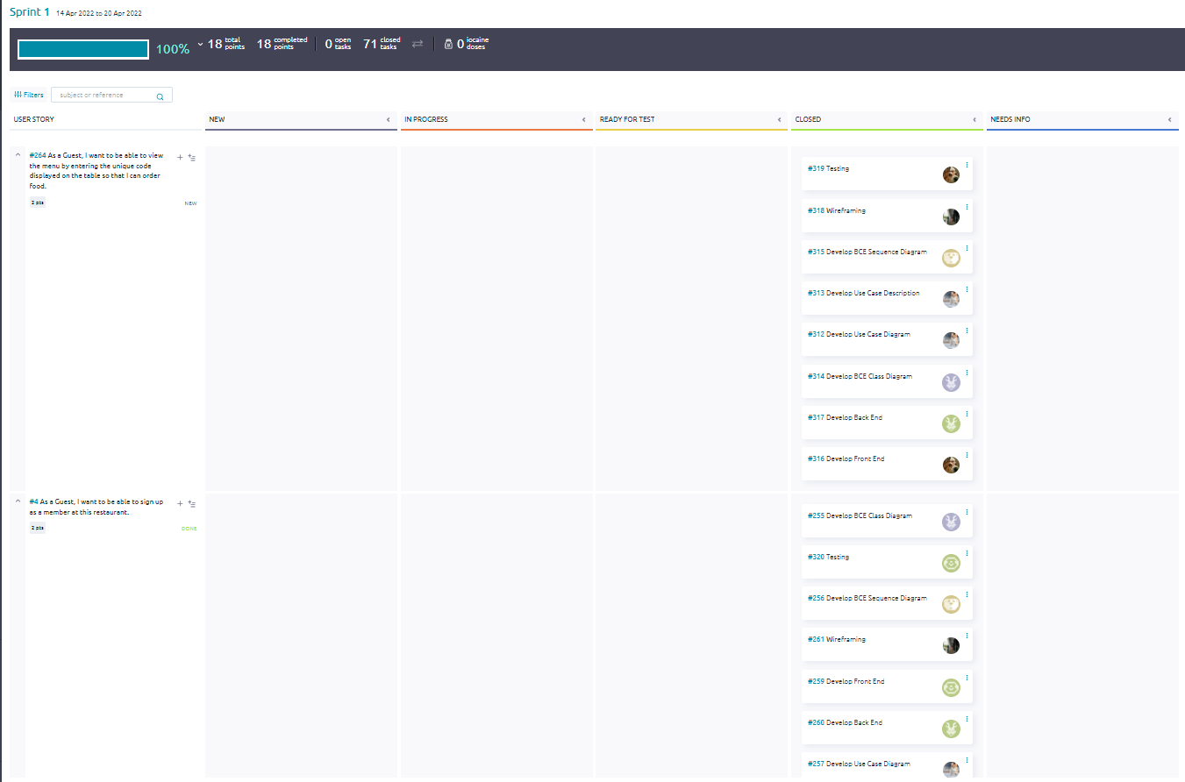

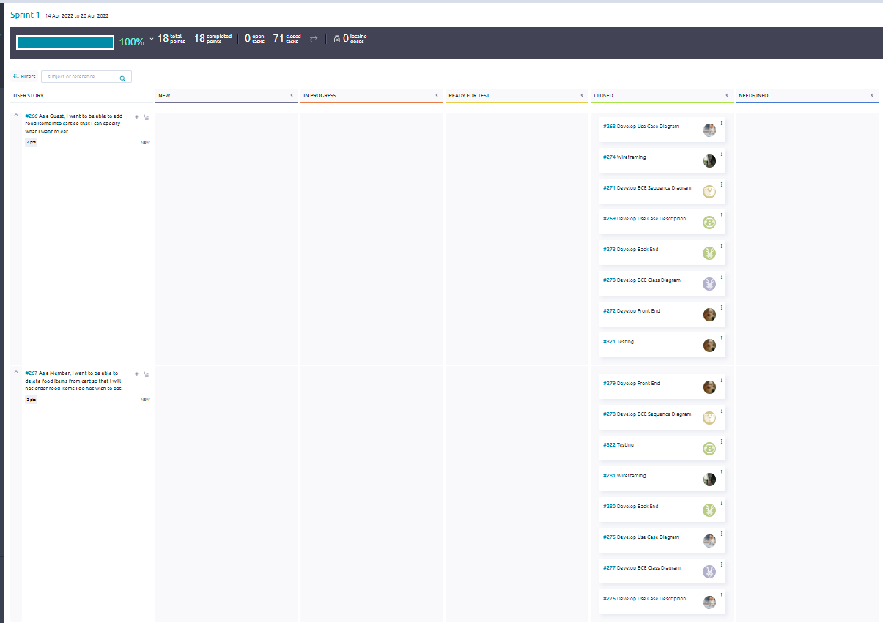

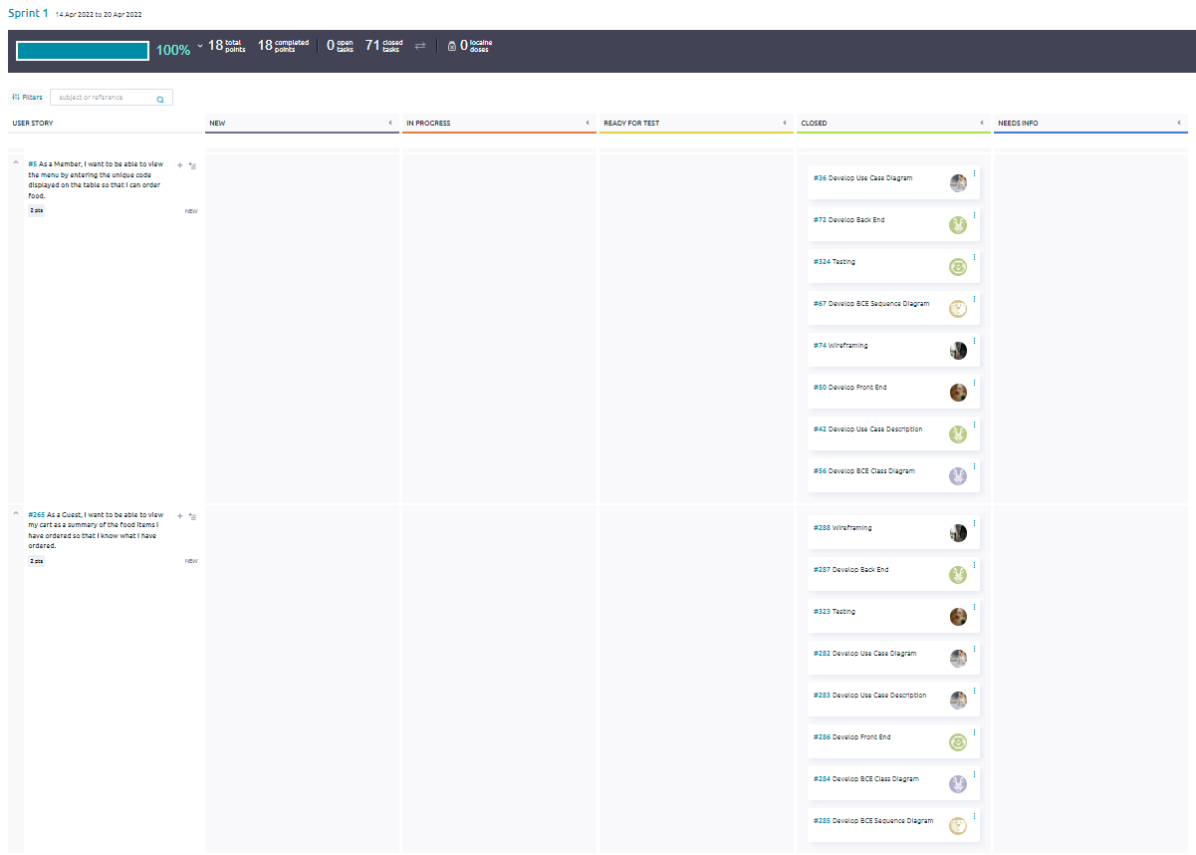

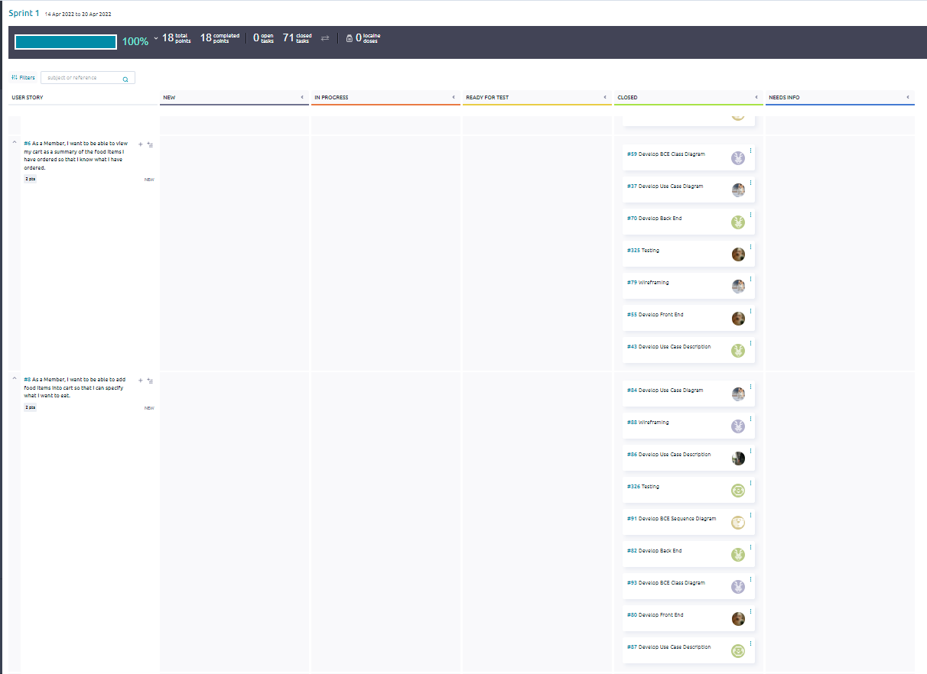

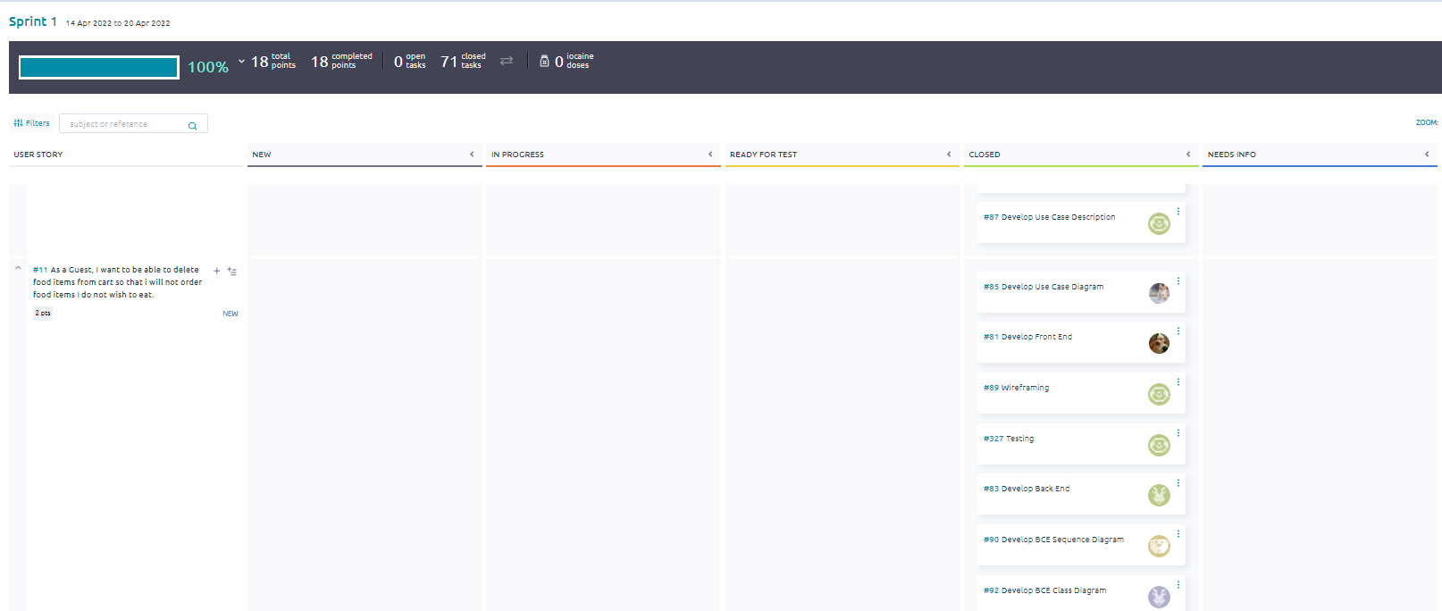

### 

### 7.1.4 Test Driven Development (TDD)

For the team, Test Driven Development (TDD) was done during sprint 1 where login and logout were implemented for all users.

Below is a screenshot of test cases, whereby the following conditions are created

In the first test case, the correct username and password is created and tested.

In the second test case, an incorrect username and password is created and tested which should return invalid login.

In the third test case, the correct username but wrong password is created and tested, which should return invalid login as well.

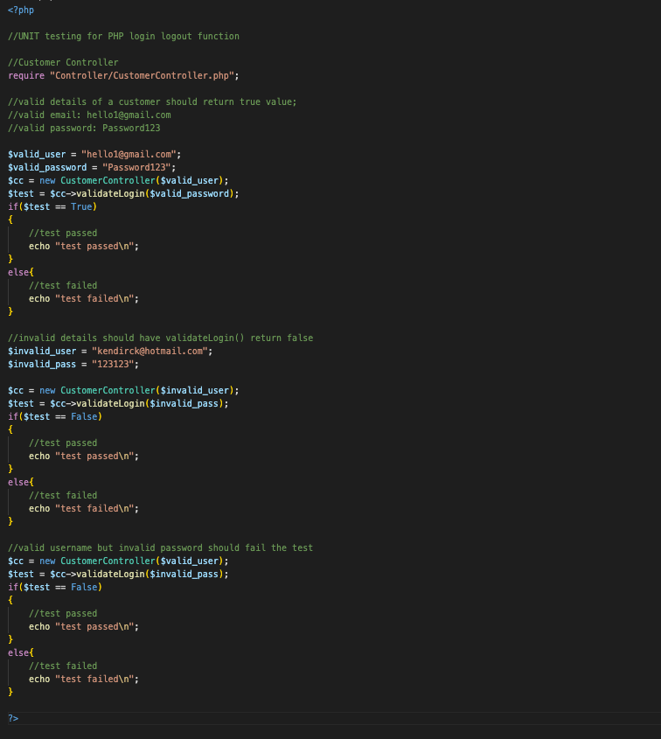

Below is a screenshot of the results for the 3 test cases created from the HTML rendered.

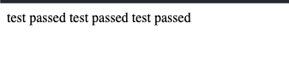

The following screenshots were taken during the test that reflects the login and logout of all the actors.

**Member:**

validateLogin()

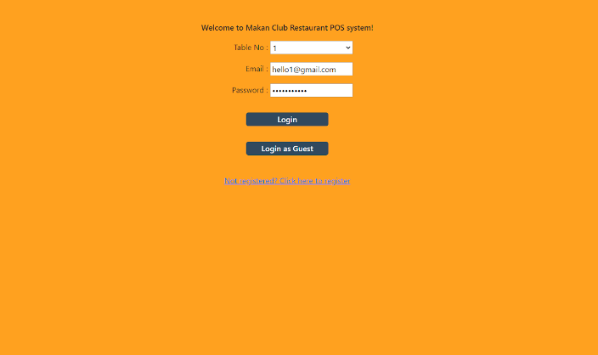

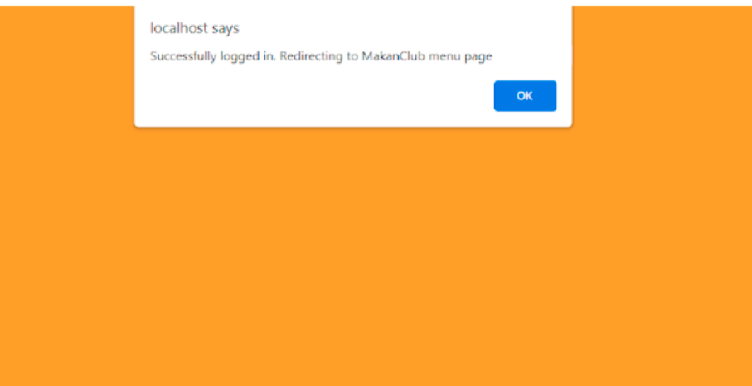

Invalid login 1 - Wrong username

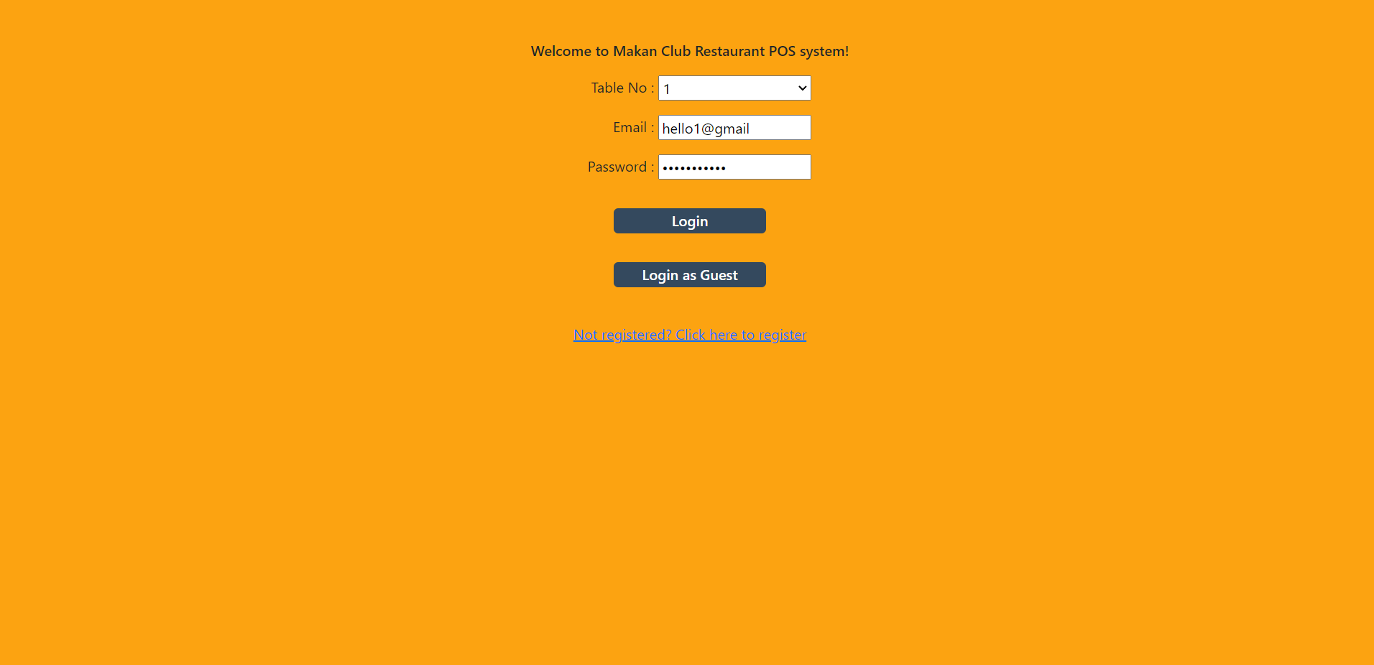



Invalid login 2 - Wrong password

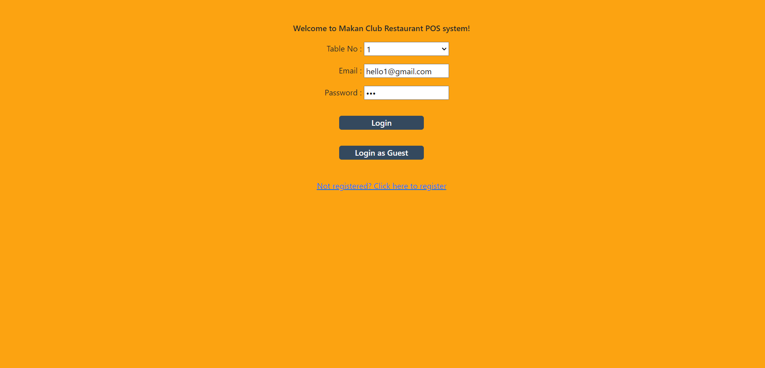



**Staff:**

Valid login

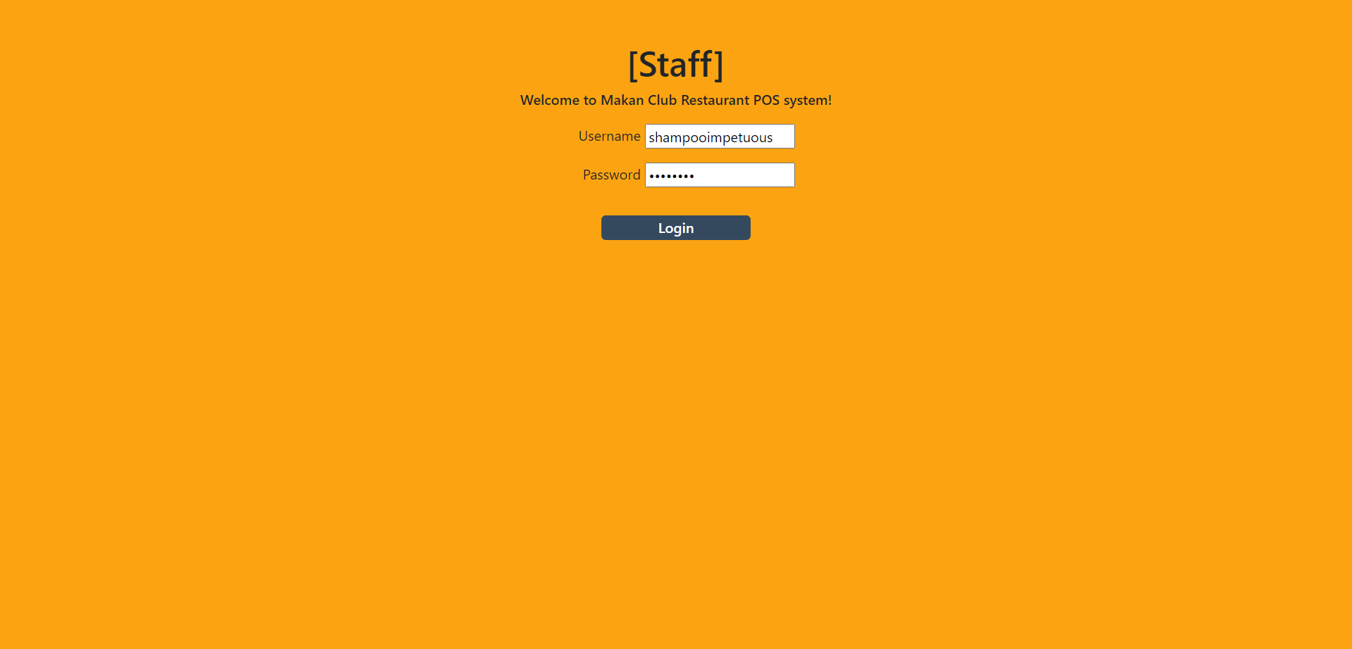

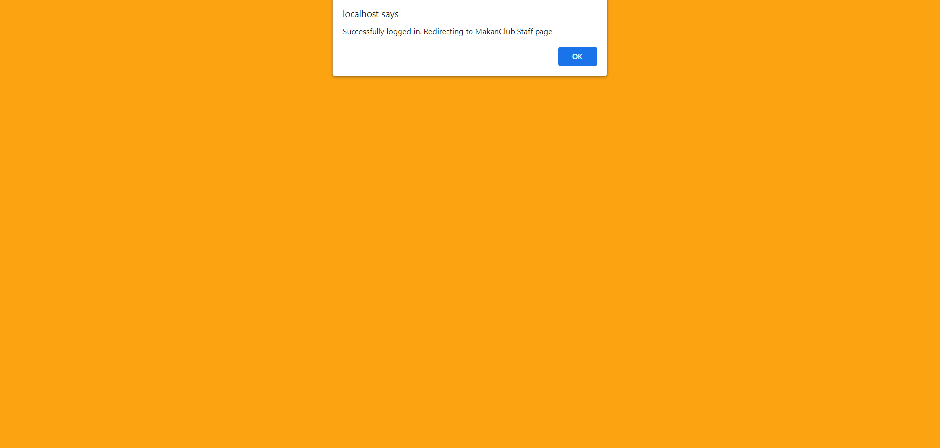

Invalid login 1 - Wrong username

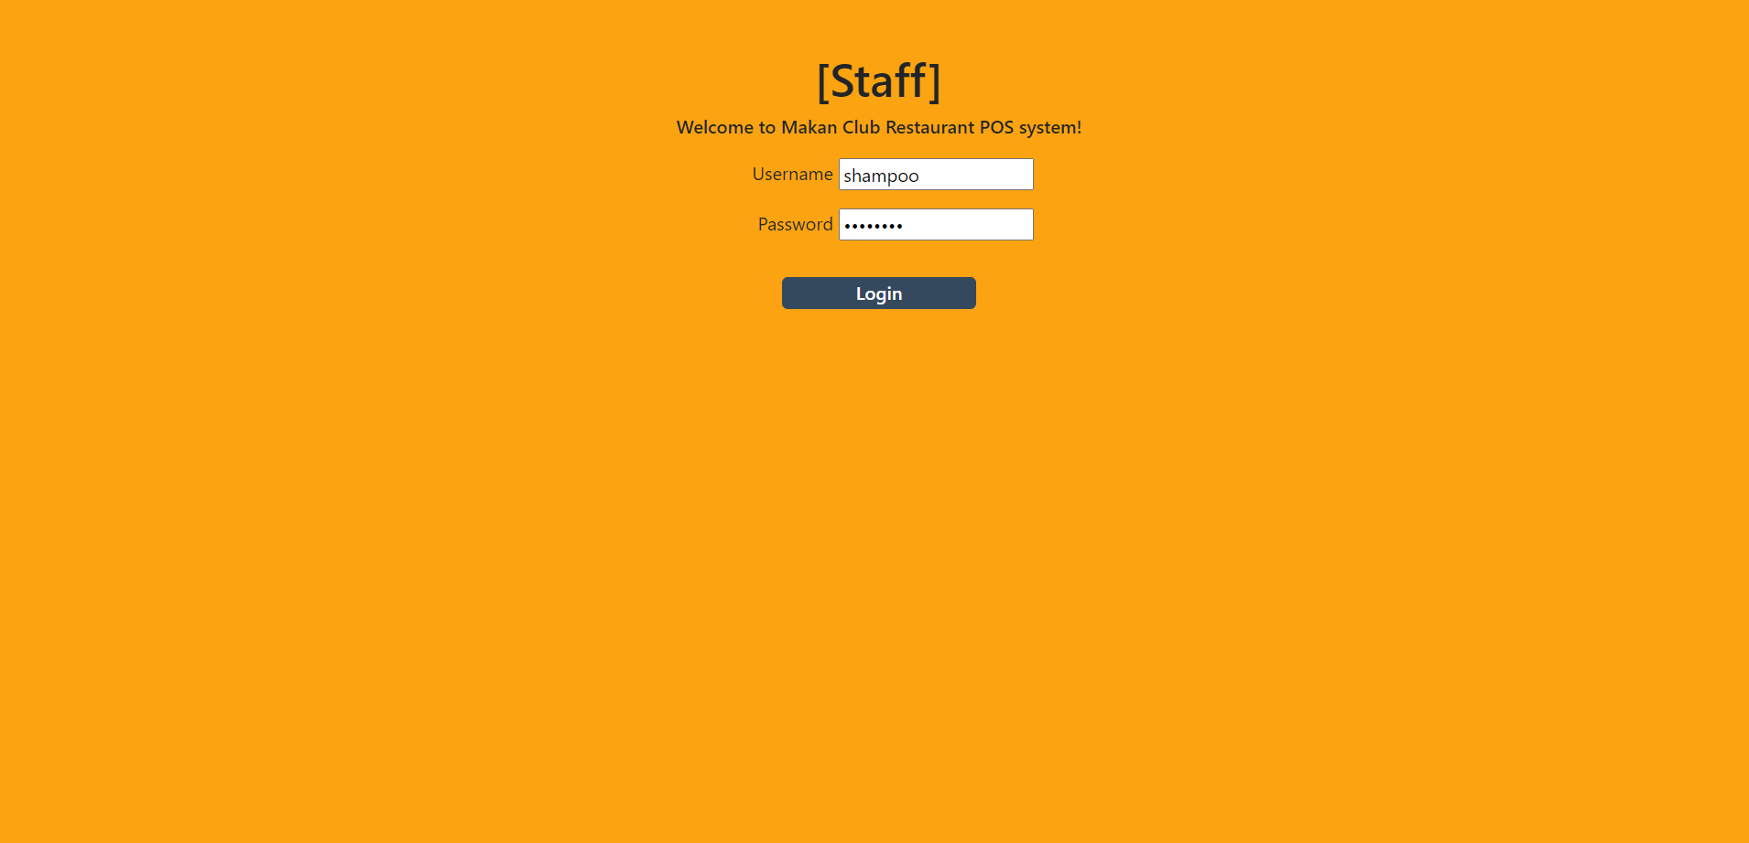



Invalid login 2 - Wrong password

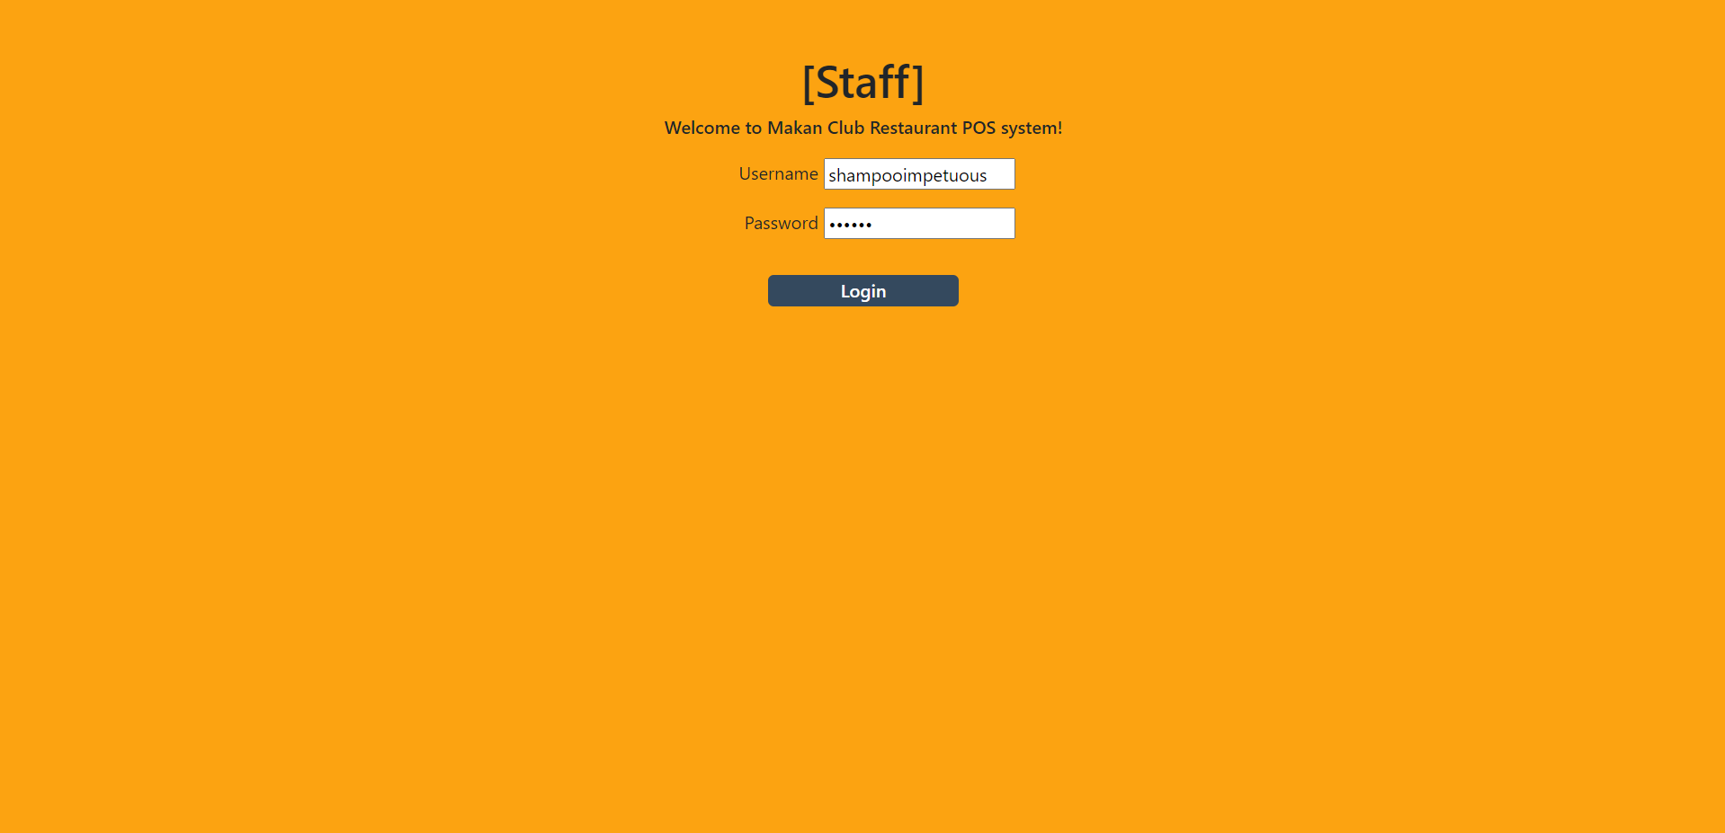



**Manager:**

Valid login

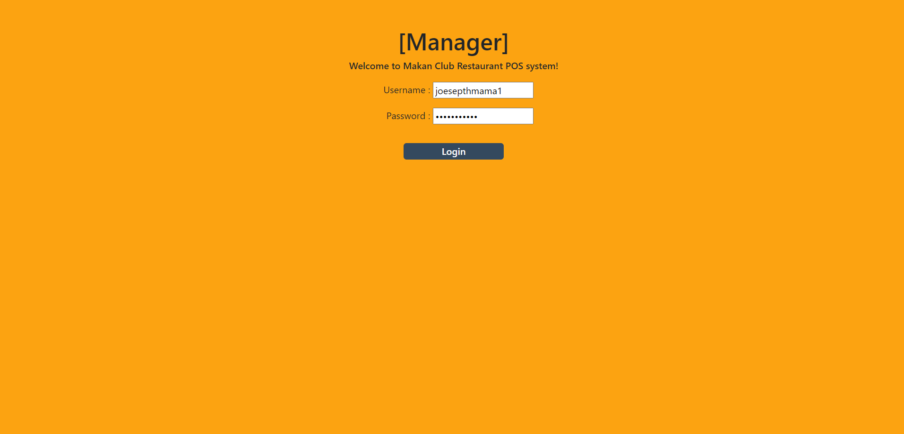

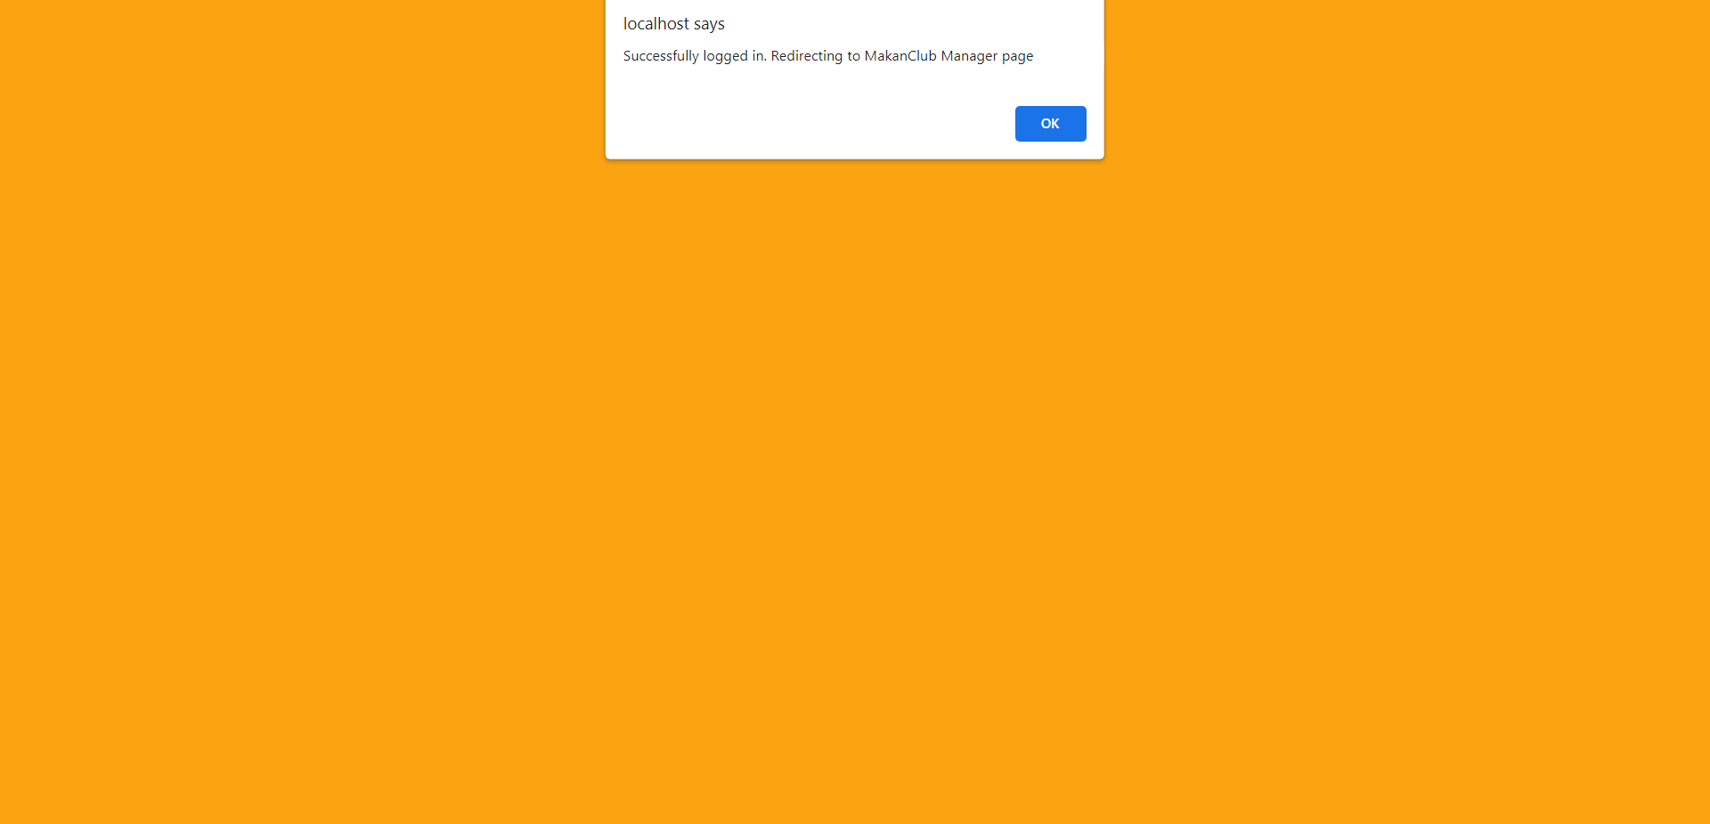

Invalid login 1 - Wrong username

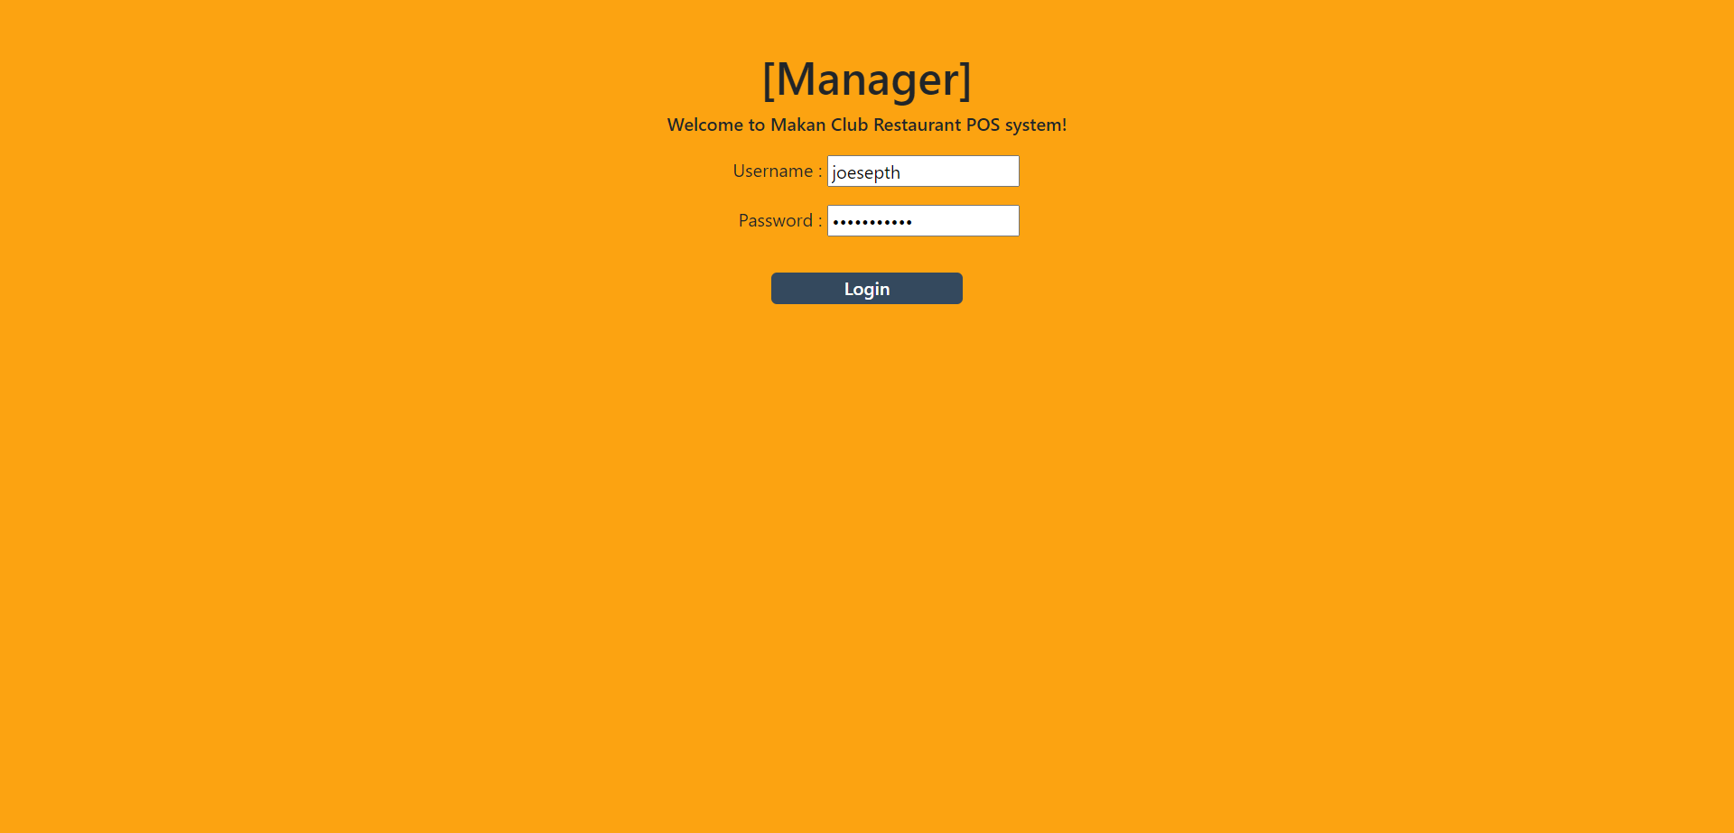



Invalid login 2 - Wrong password

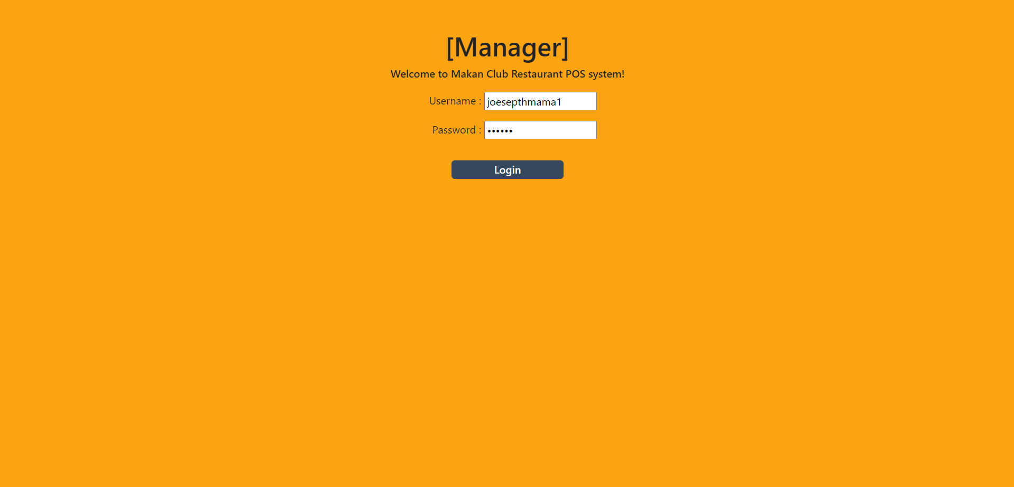



**Owner:**

Valid login

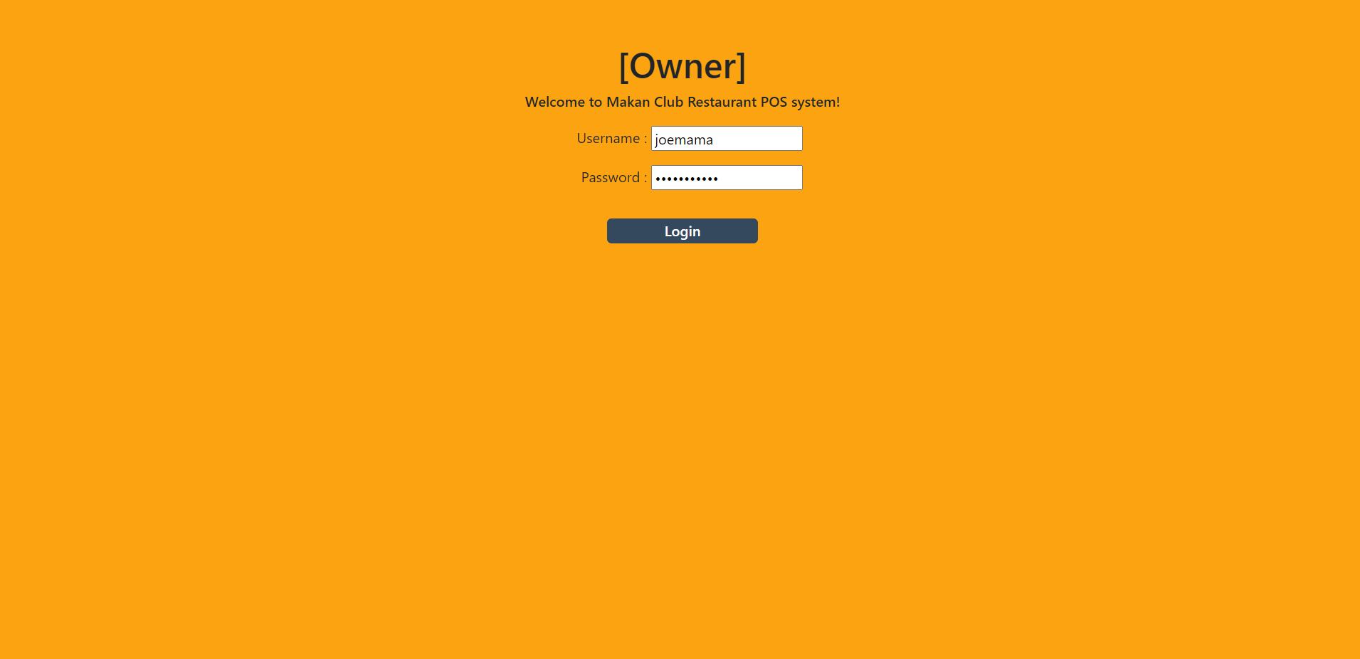

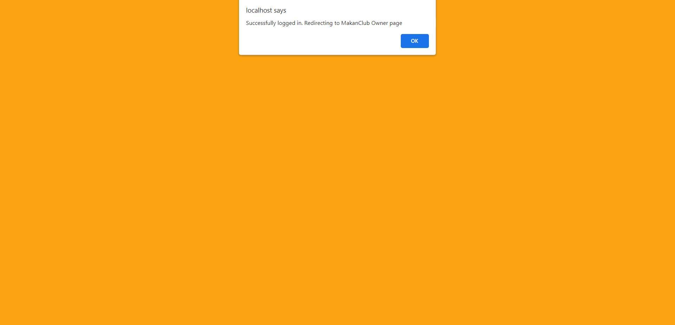

Invalid login 1 - Wrong username

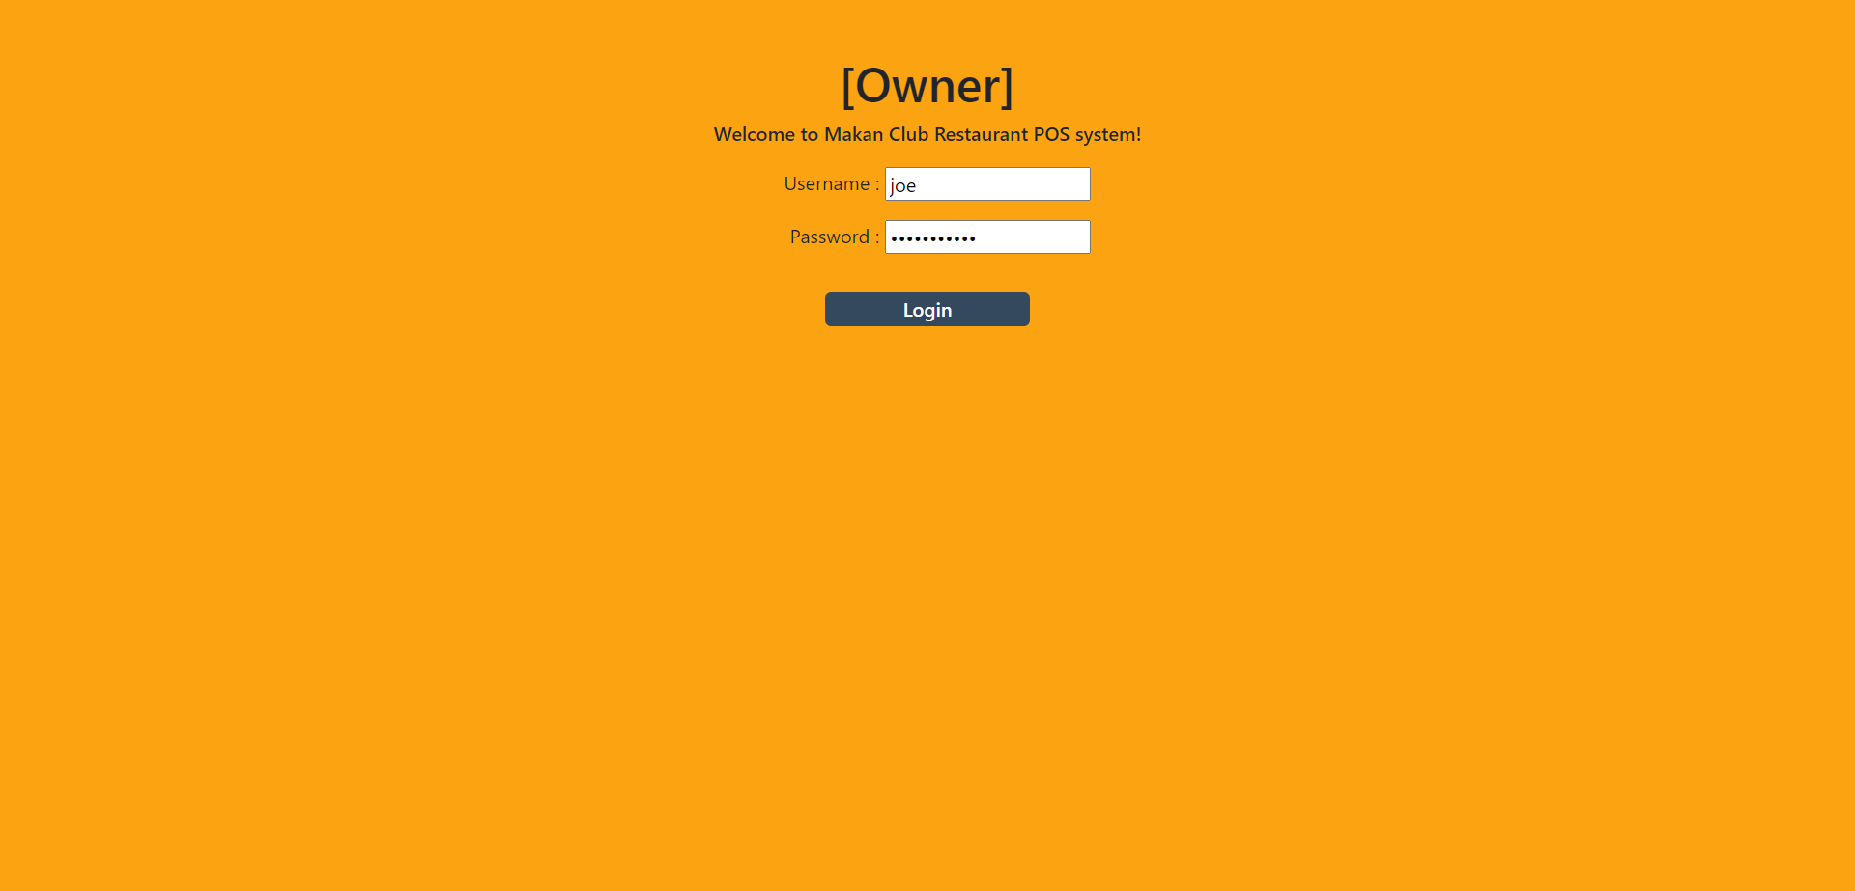

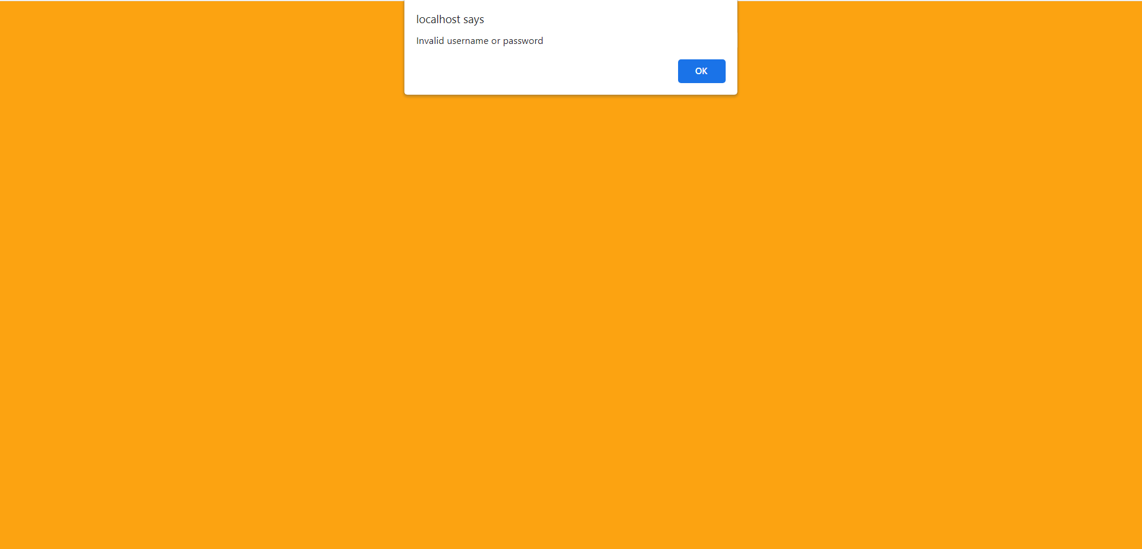

Invalid login 2 - Wrong password

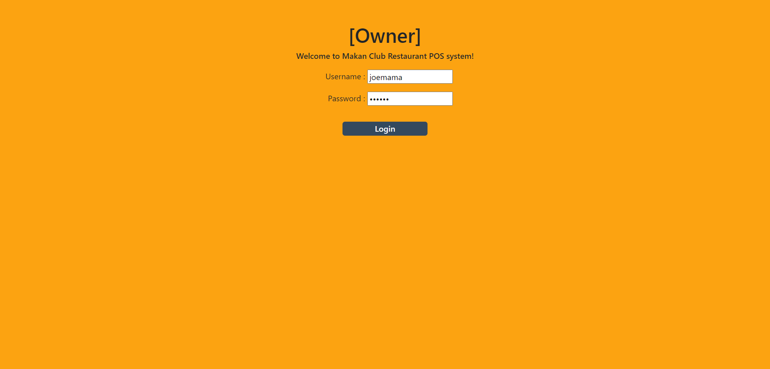

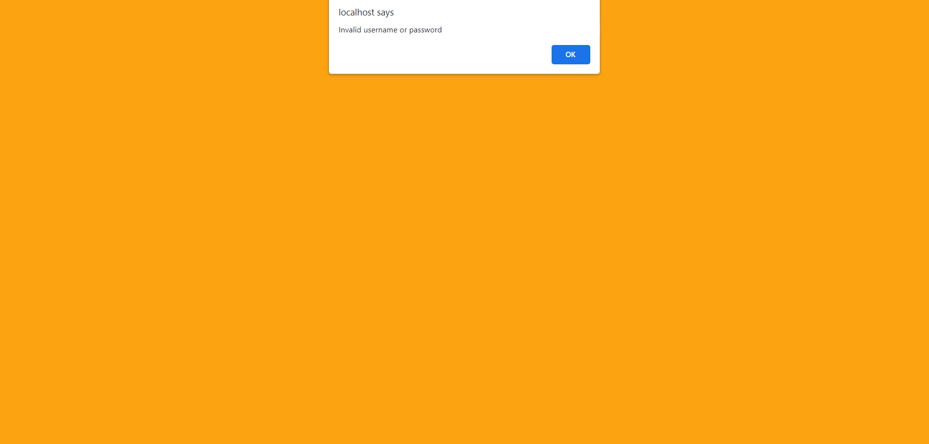

## 

## 7.2 Sprint 2

### 7.2.1 Wireframe

#### 7.2.1.1 Customer

Member:

* Login

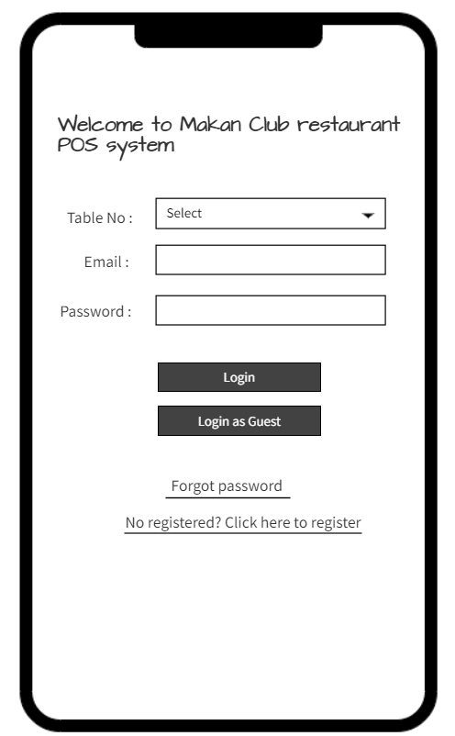

* Logout

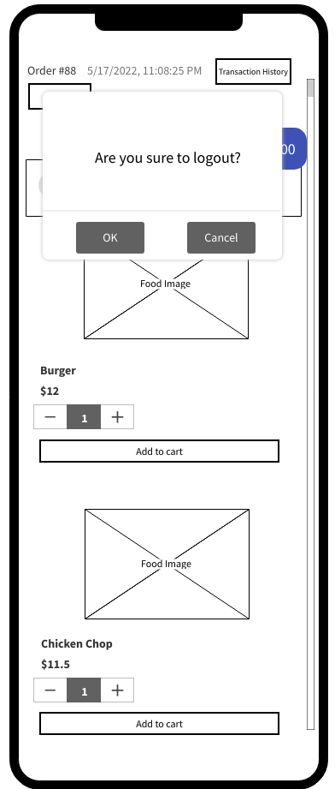

#### 7.2.1.2 Restaurant Staff

Nil

#### 7.2.1.3 Restaurant Manager

* Login

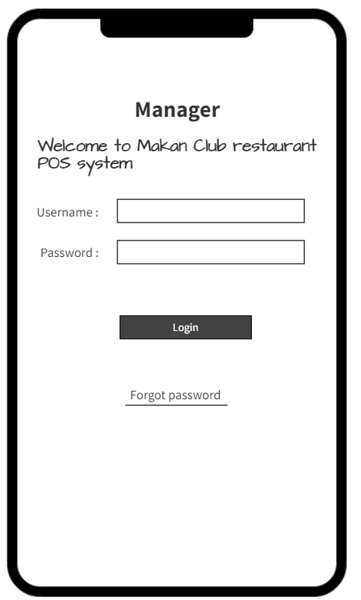

* Logout

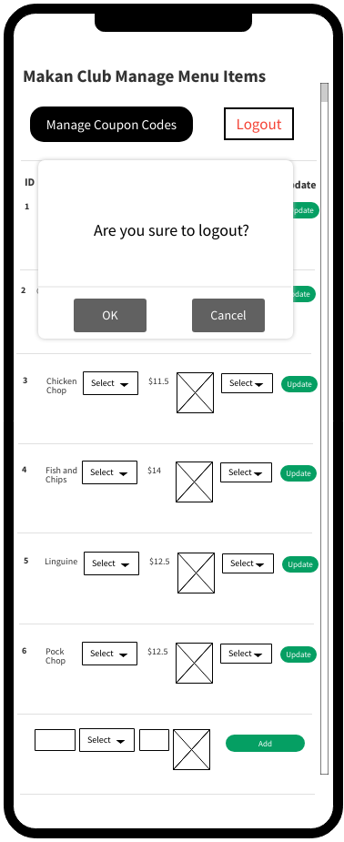

#### 

#### 7.2.1.4 Restaurant Owner

* Login

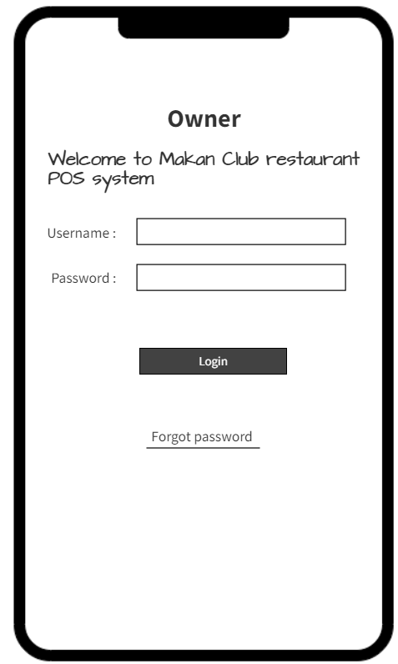

**Interface**

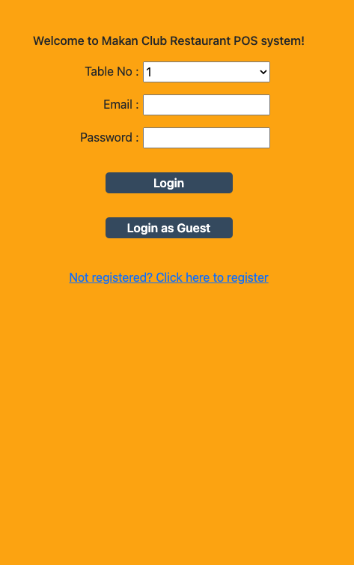

### 7.2.2 Test Cases

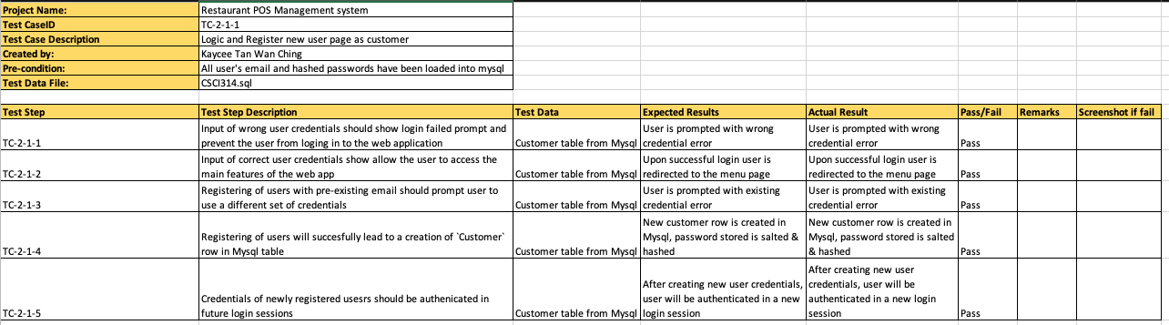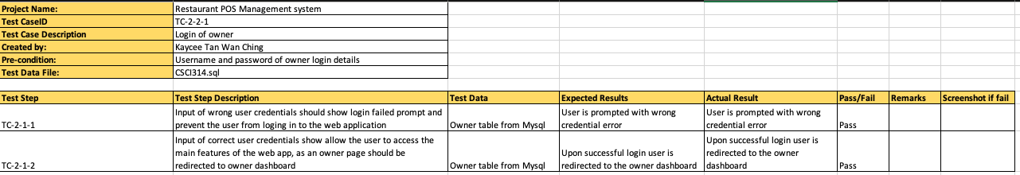

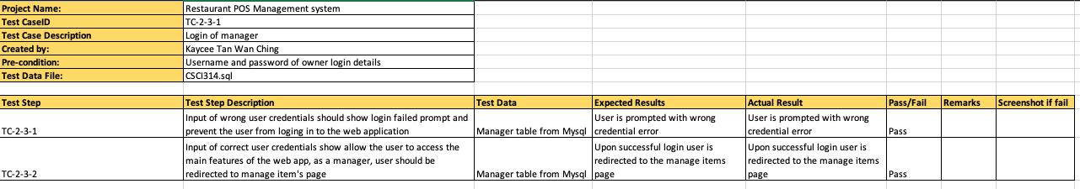

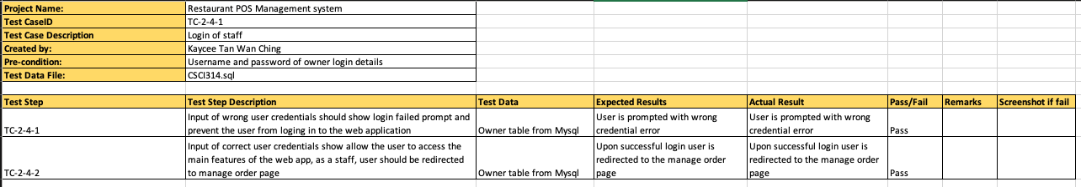

### 7.2.3 Taiga

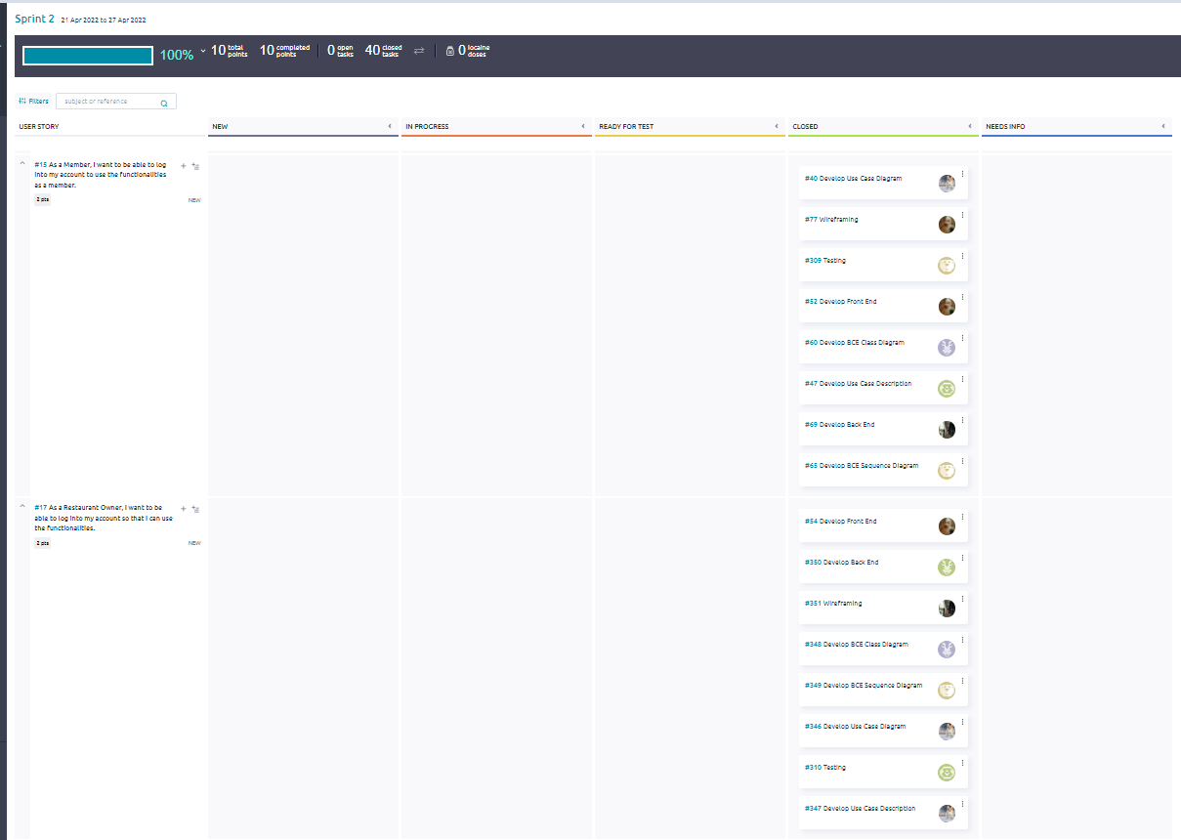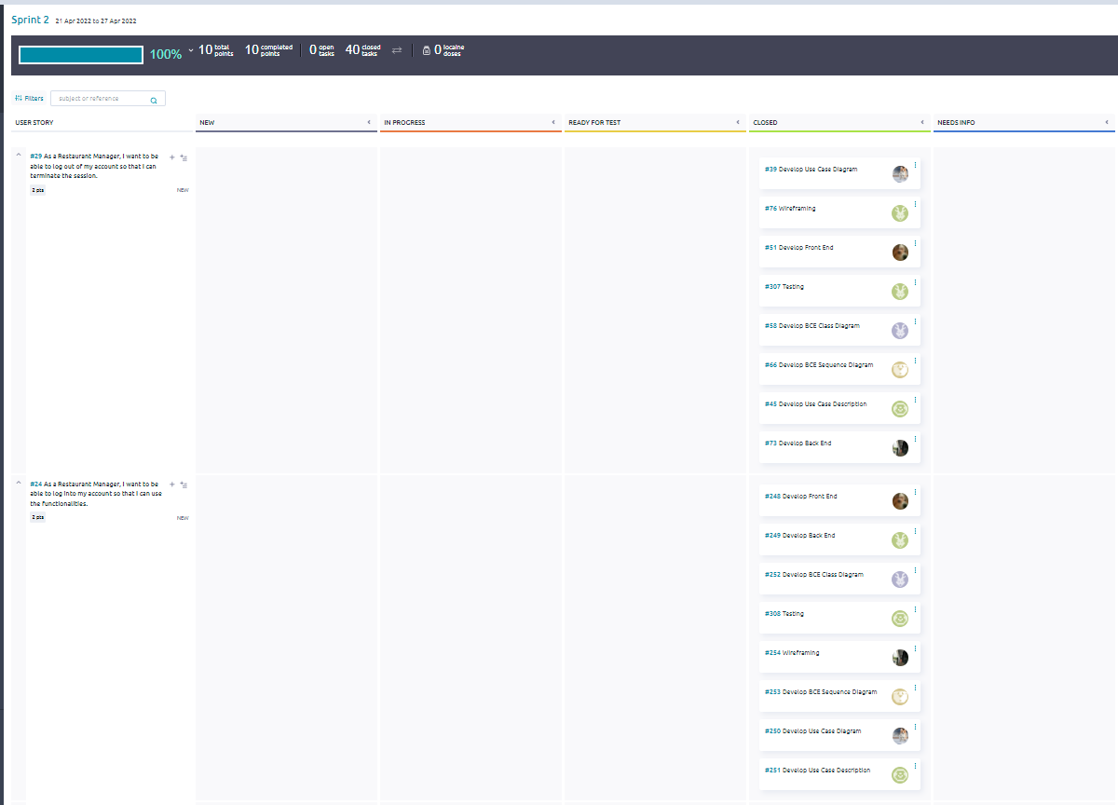

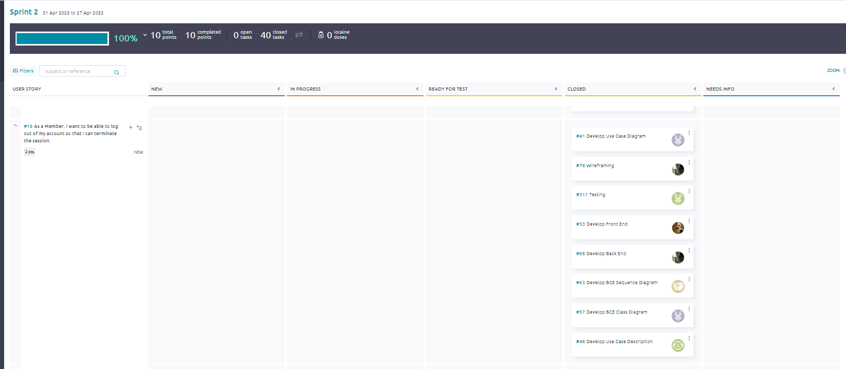

## 

## 7.3 Sprint 3

### 7.3.1 Wireframing

#### 7.3.1.1 Customer

**Guest:**

* Edit Quantity

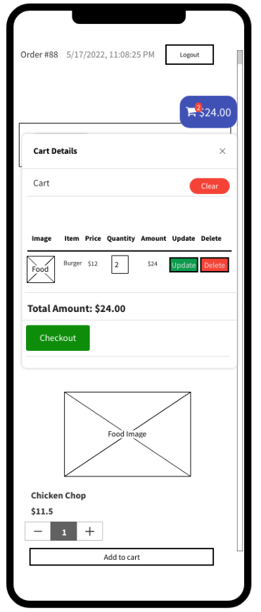

* View Order Summary

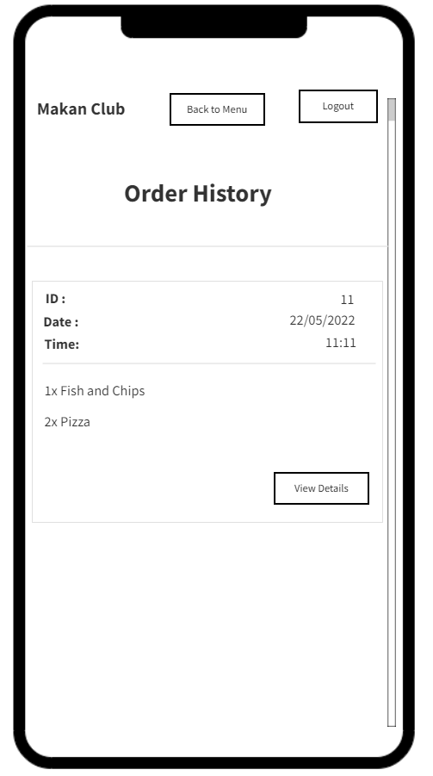

**Member:**

* Edit Quantity

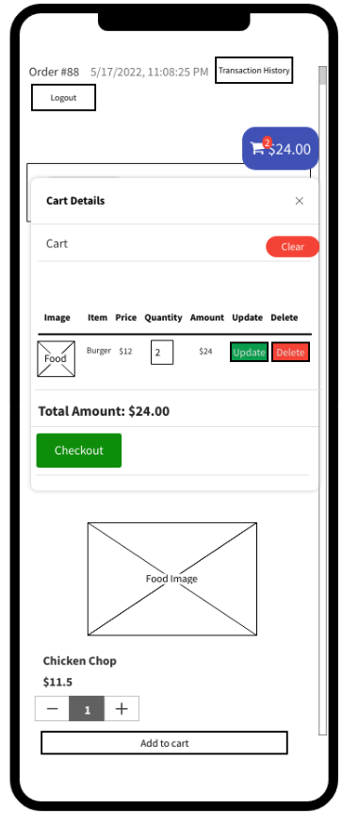

* View Order Summary

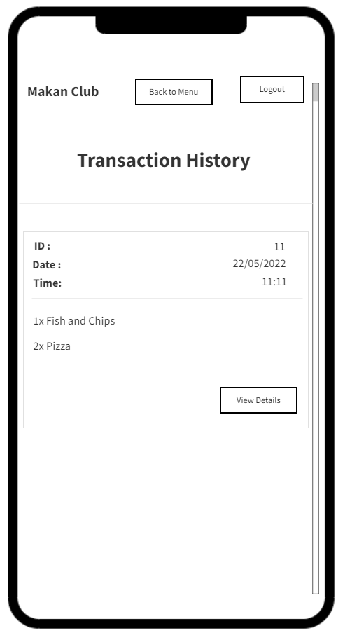

* View Transaction History



#### 

#### 7.3.1.2 Restaurant Staff

* Login

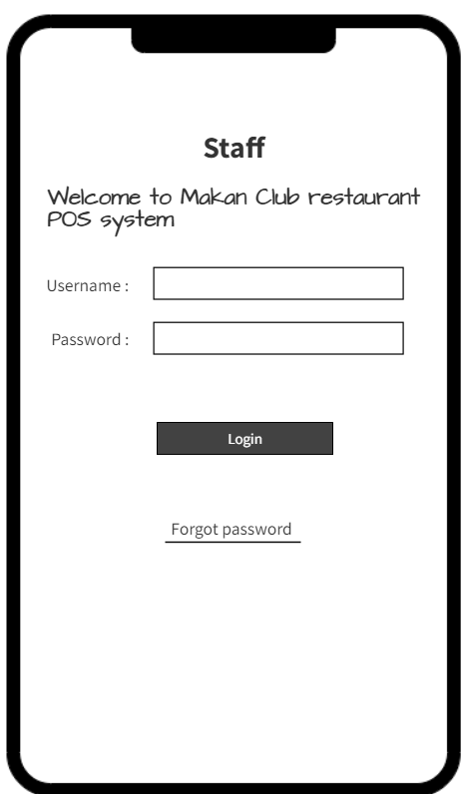

* Update Order Status

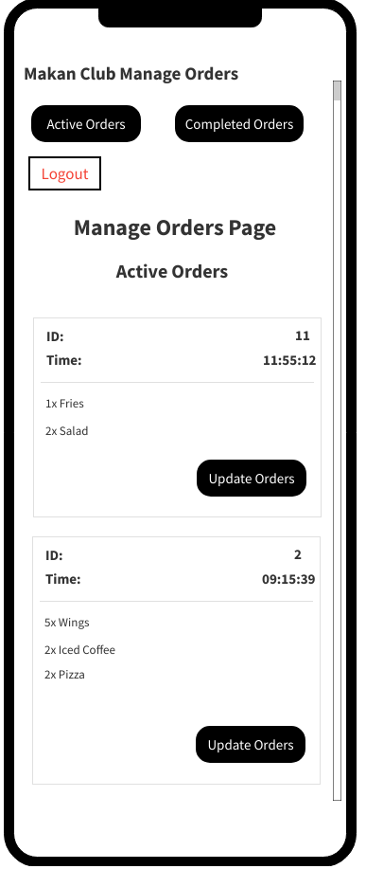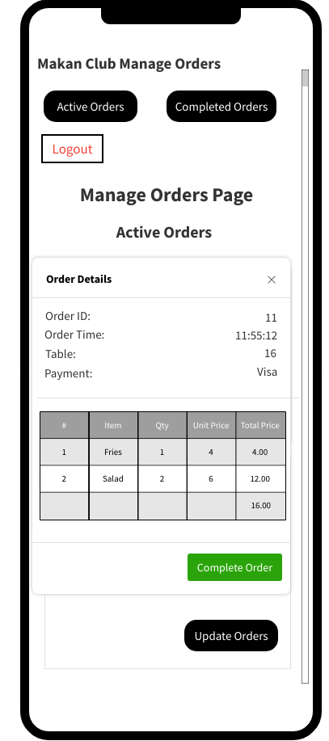

* View Order Status

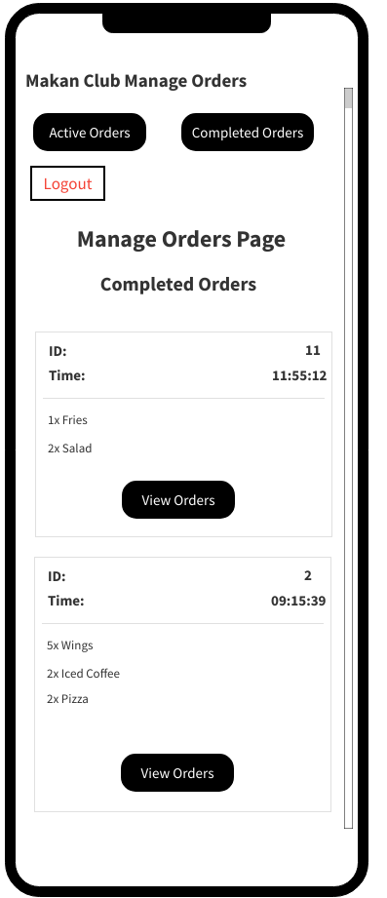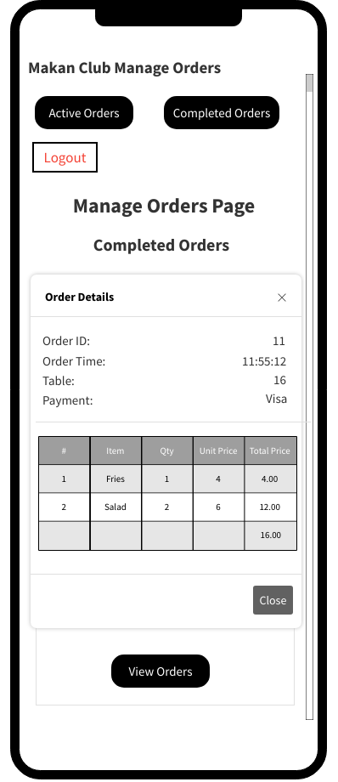

* Logout

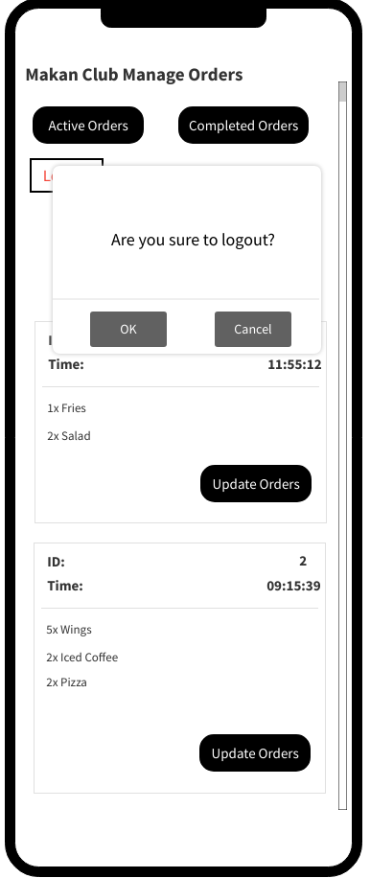

#### 7.3.1.3 Restaurant Manager

Nil

#### 7.3.1.4 Restaurant Owner

* Logout

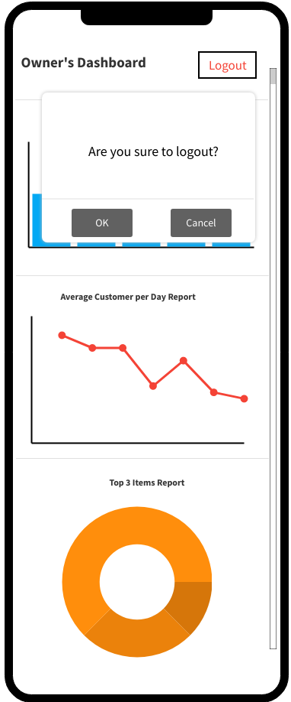

**Interfaces**

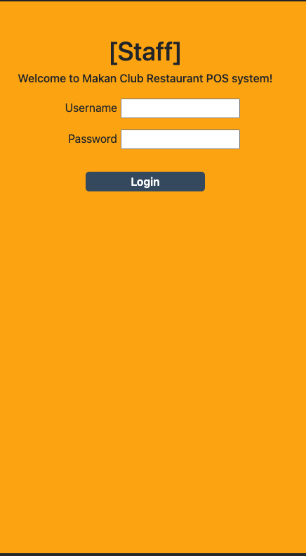

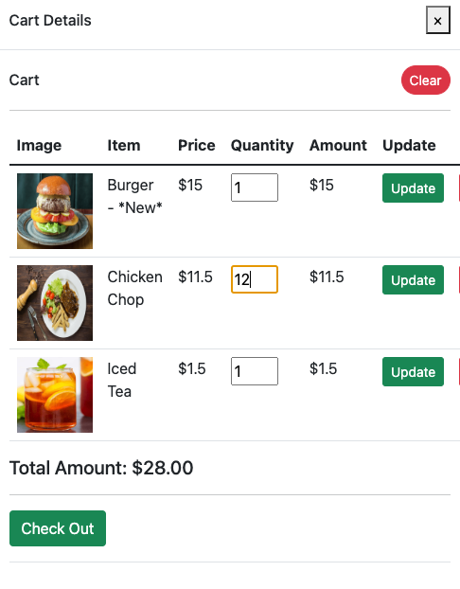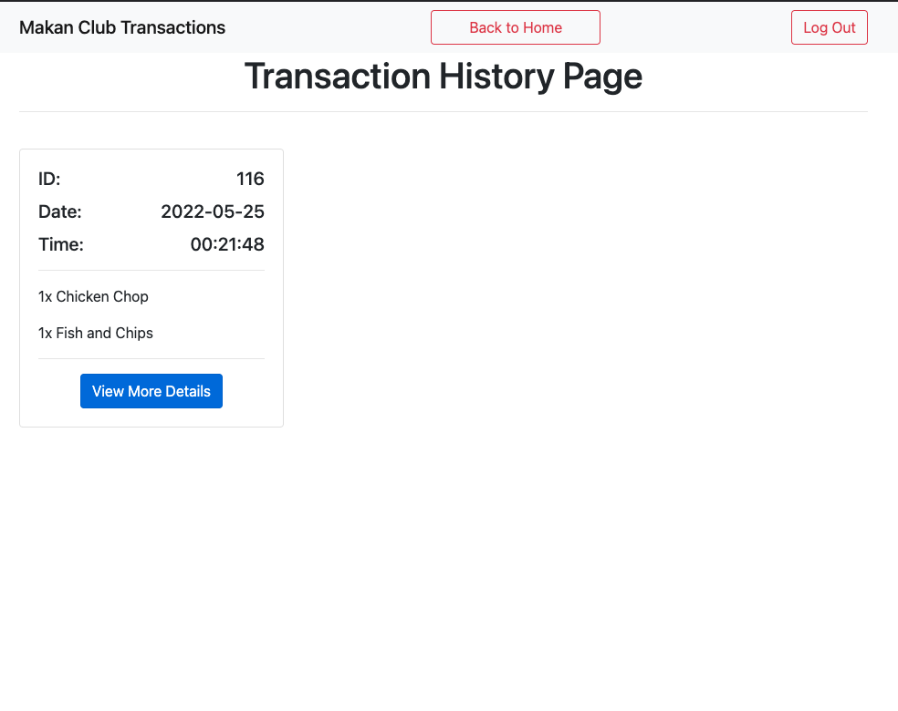

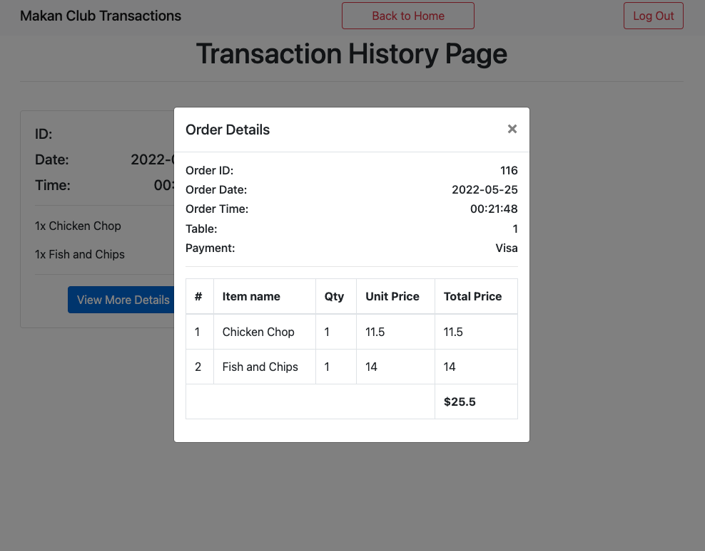

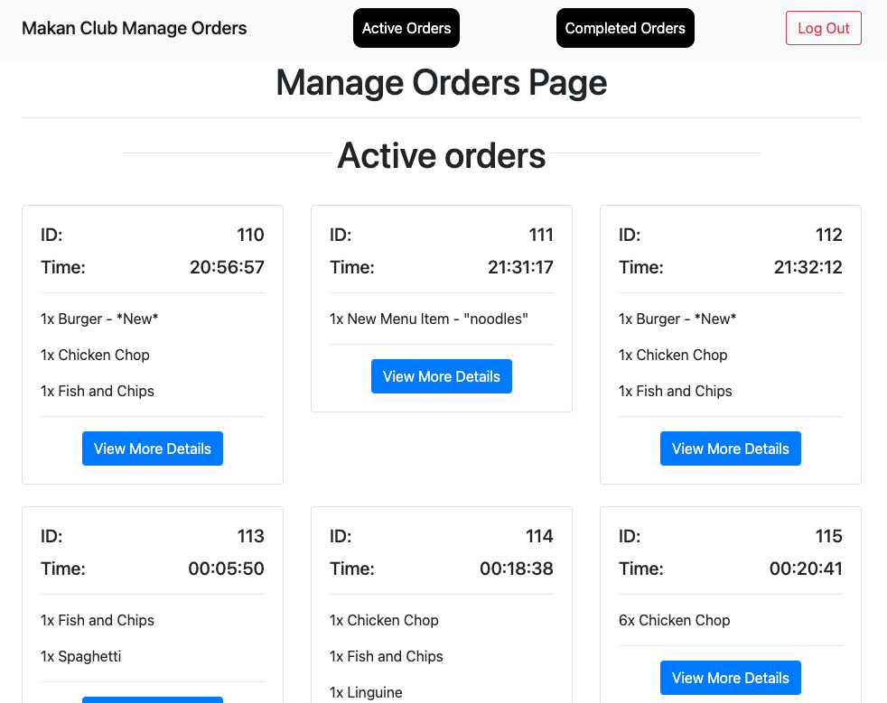

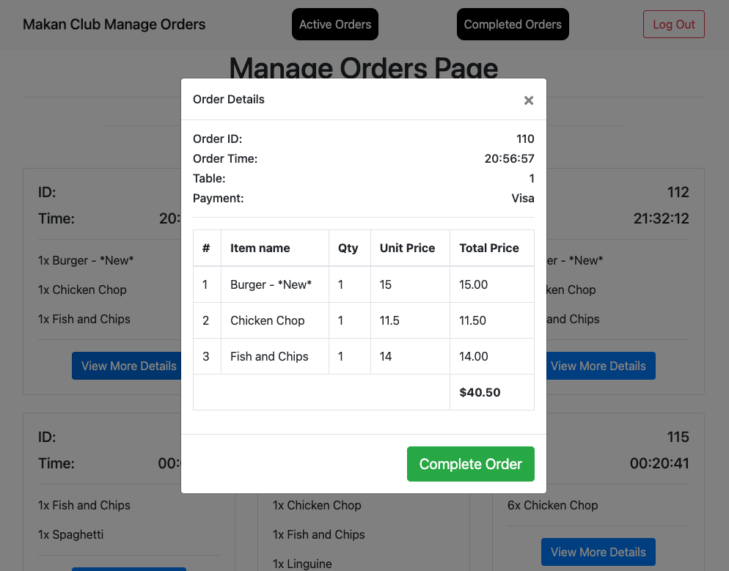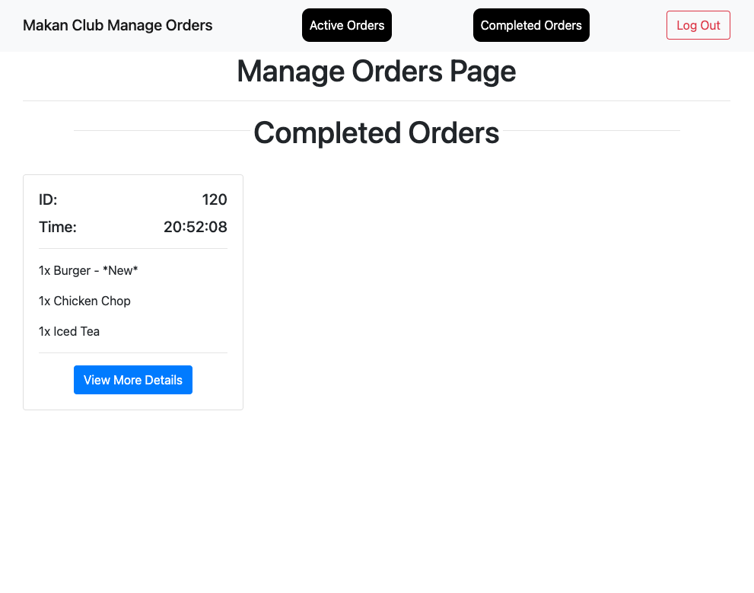

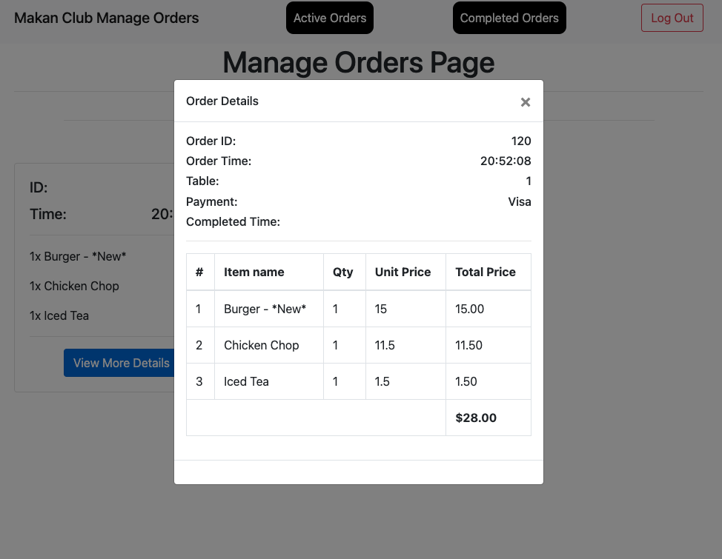

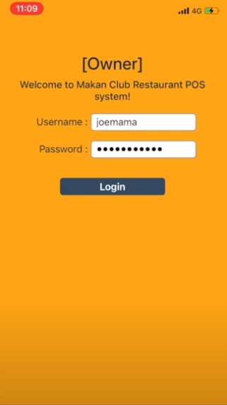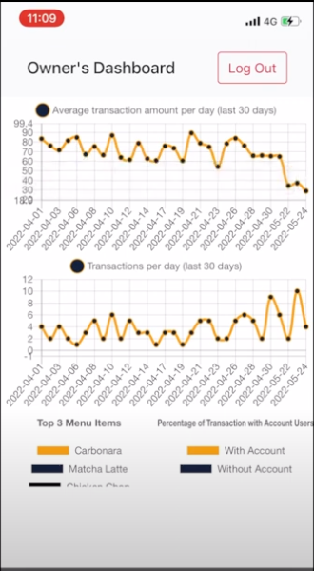

### 7.3.2 Test Cases

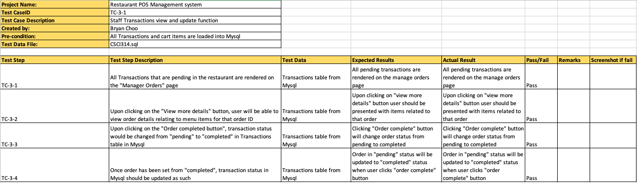

### 7.3.3 Taiga

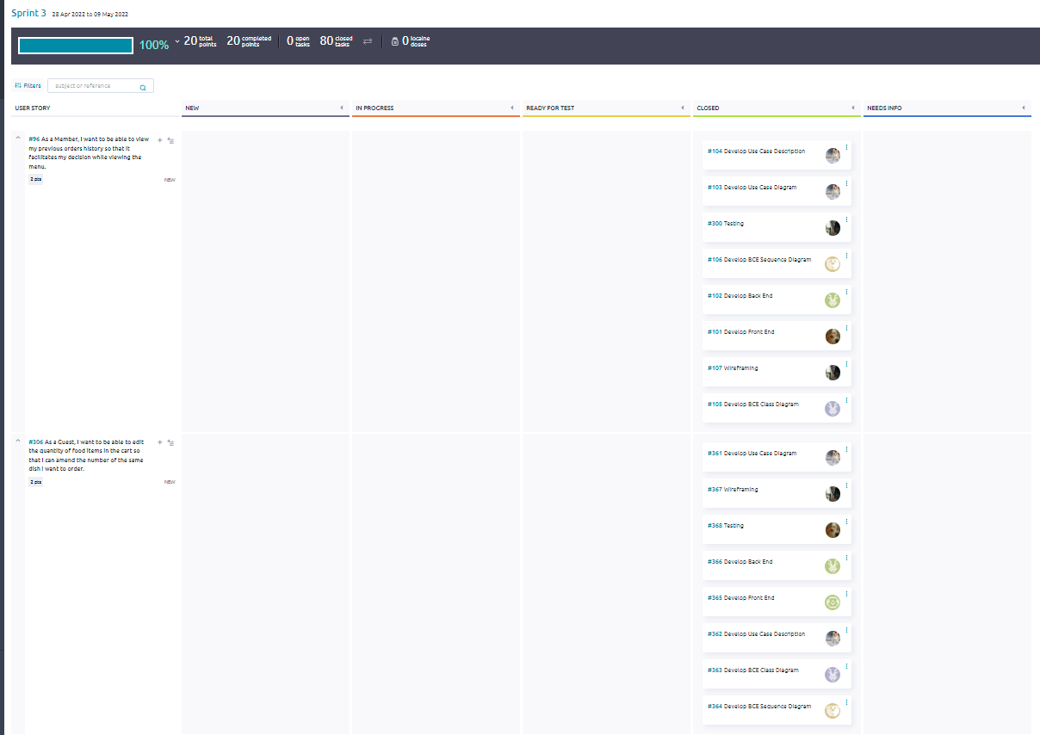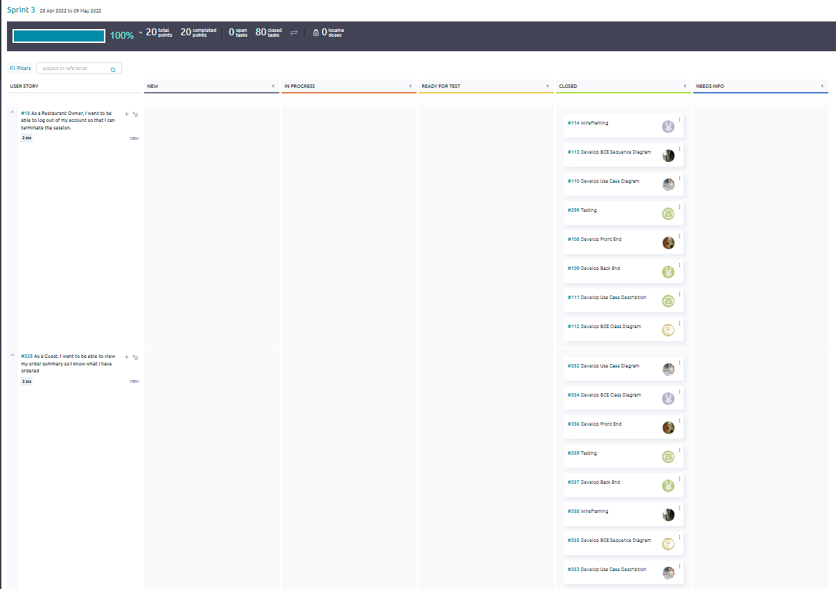

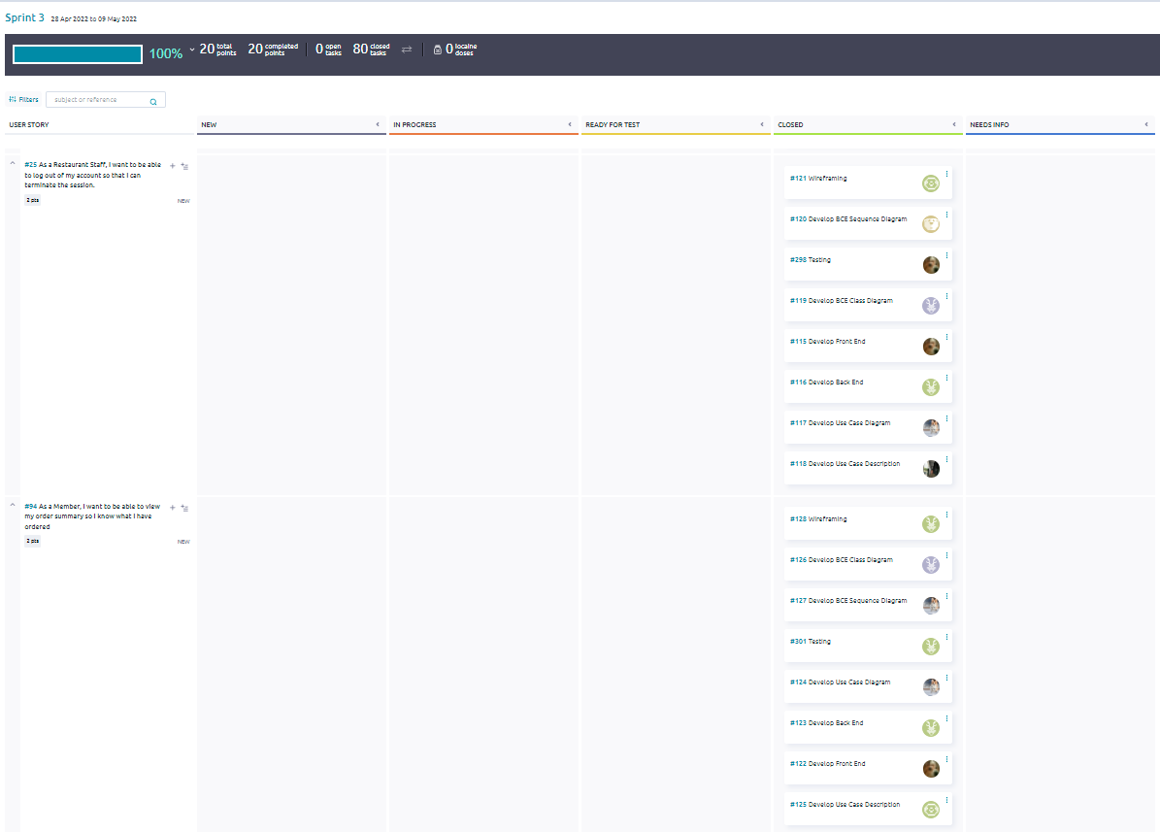

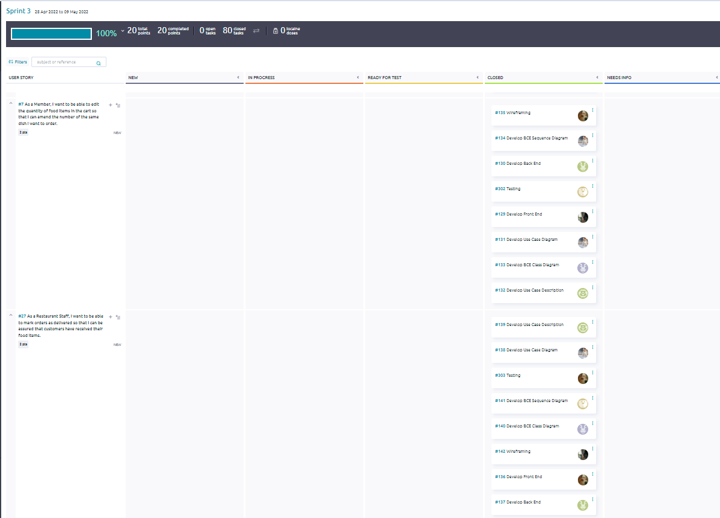

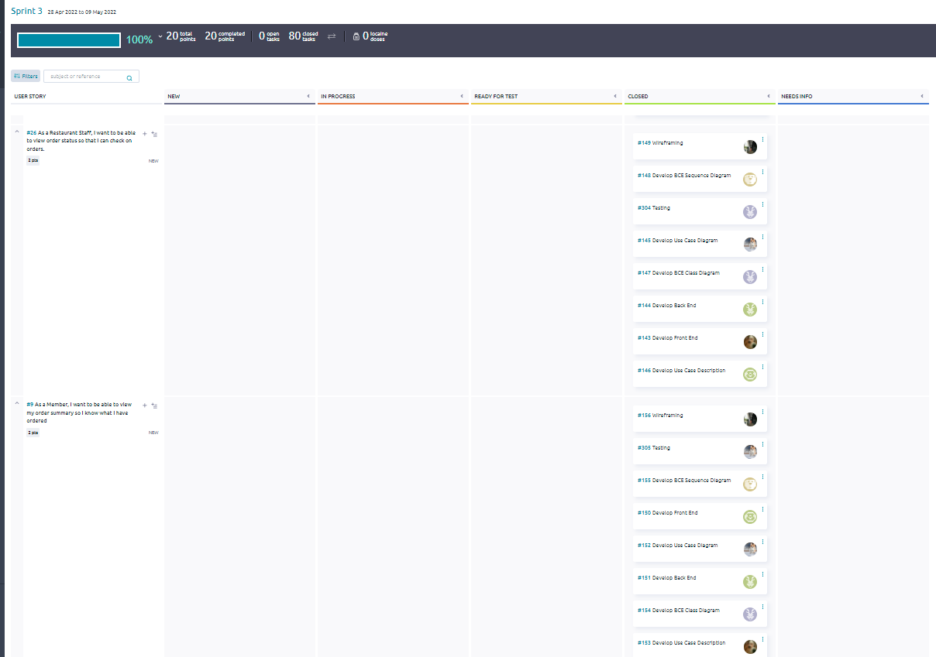

## 7.4 Sprint 4

### 7.4.1 Wireframing

#### 7.4.1.1 Customer

**Guest:**

* Make Payment

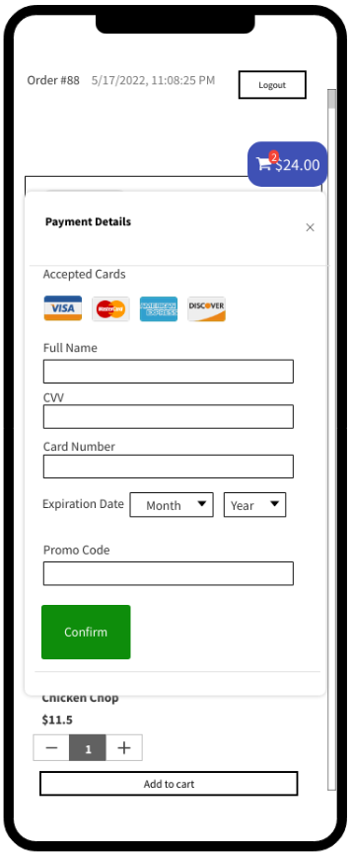

**Member:**

* Make payment

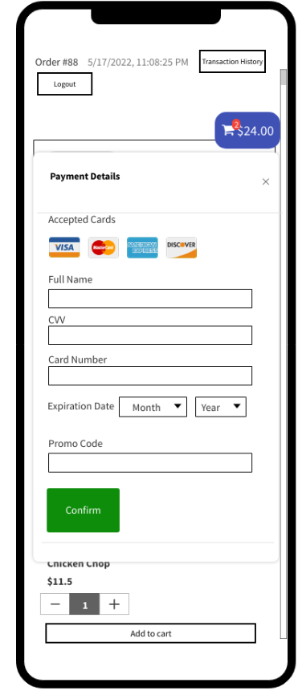

#### 7.4.1.2 Restaurant Staff

Nil

#### 

#### 7.4.1.3 Restaurant Manager

* Edit Food Item

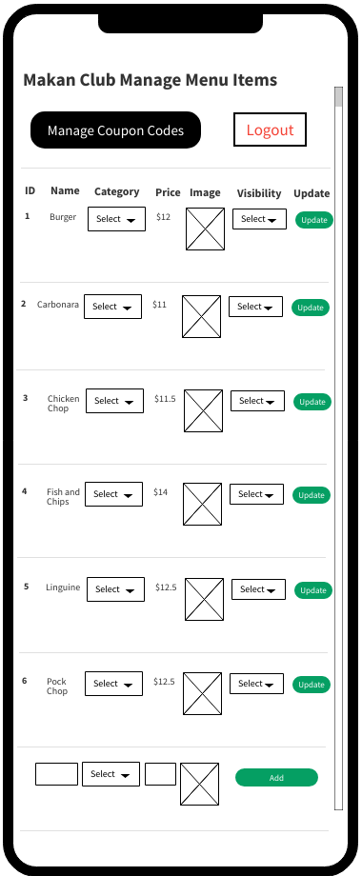

* Add Food Item



* Remove Food Item



#### 

#### 7.4.1.4 Restaurant Owner

* Generate Top 3 Food Item Report

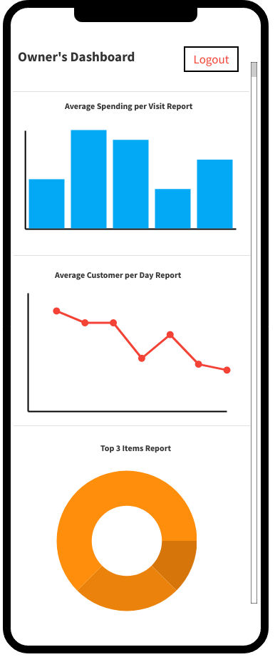

### 

**Interfaces**

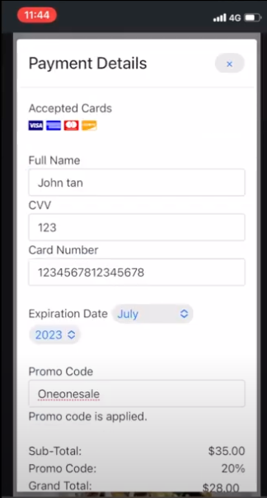

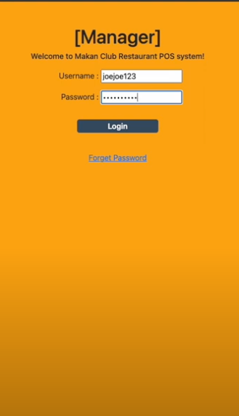

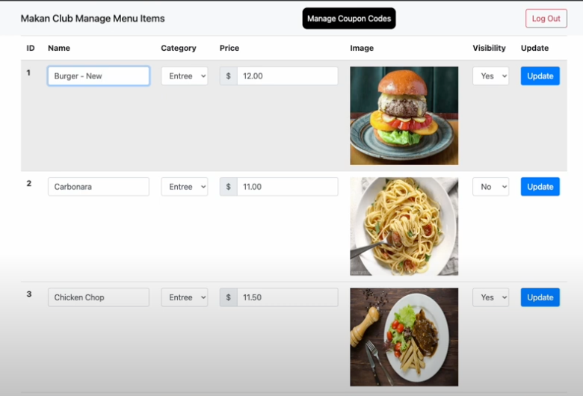

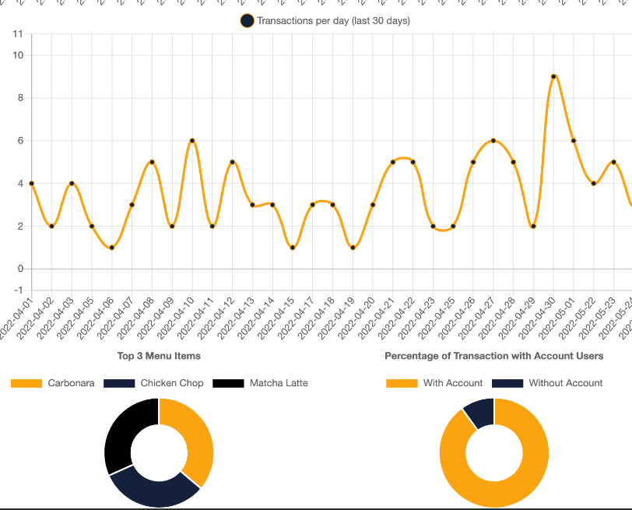

### 7.4.2 Test Cases

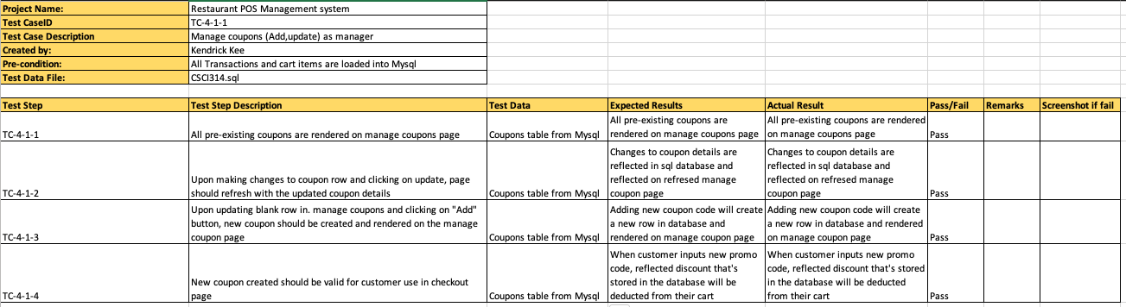

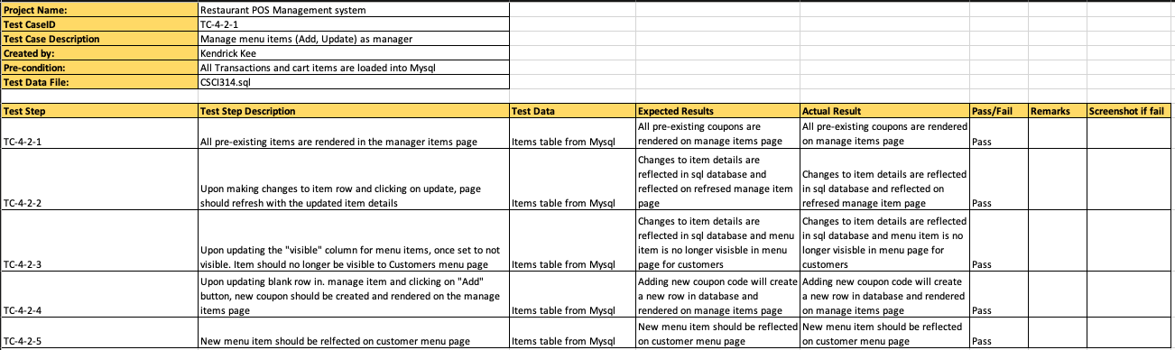

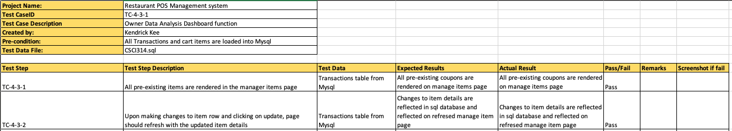

### 7.4.3 Taiga

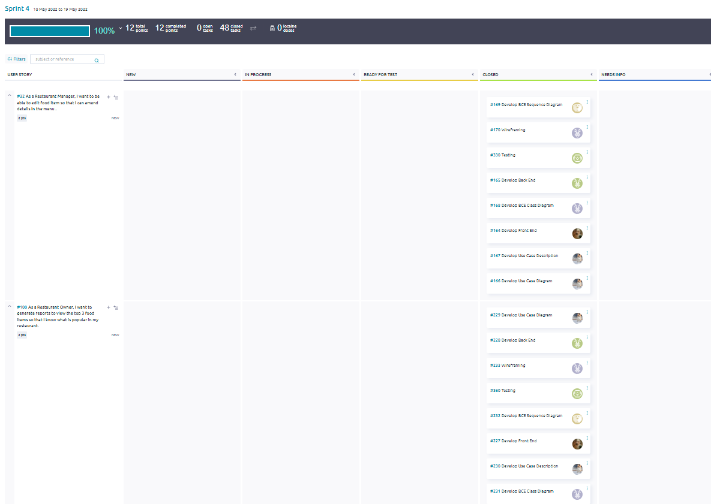

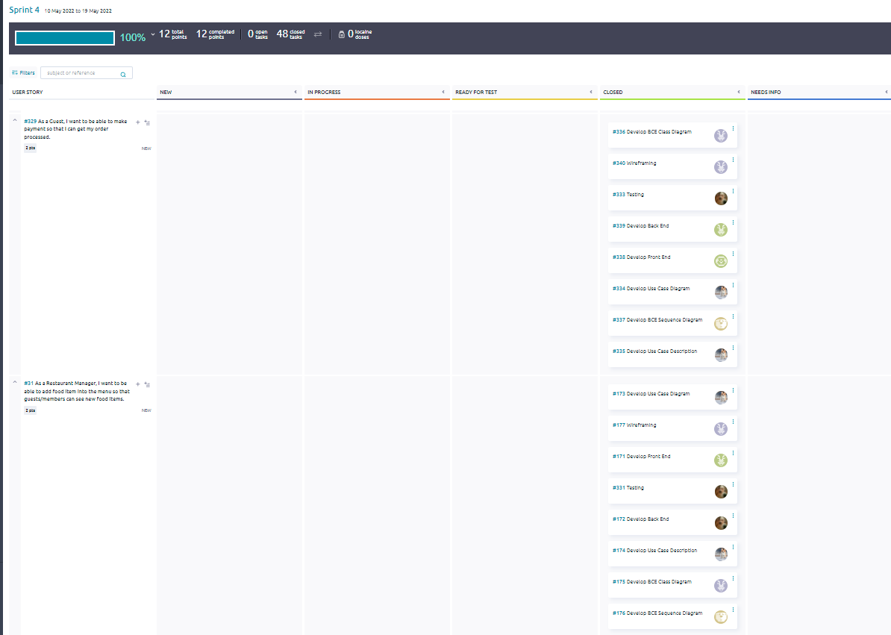

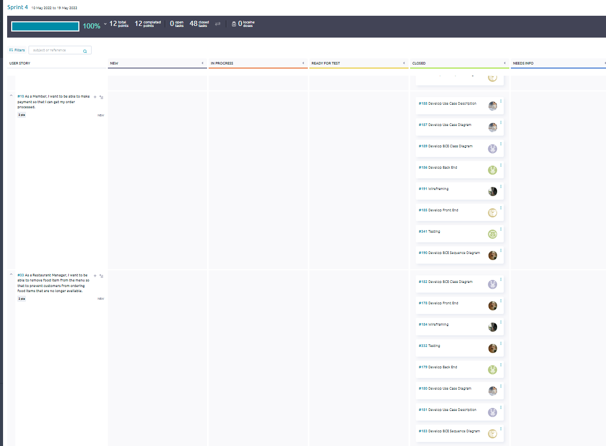

### 

## 7.5 Sprint 5

### 7.5.1 Wireframing

#### 7.5.1 Customer

**Member:**

* Insert Coupon Code

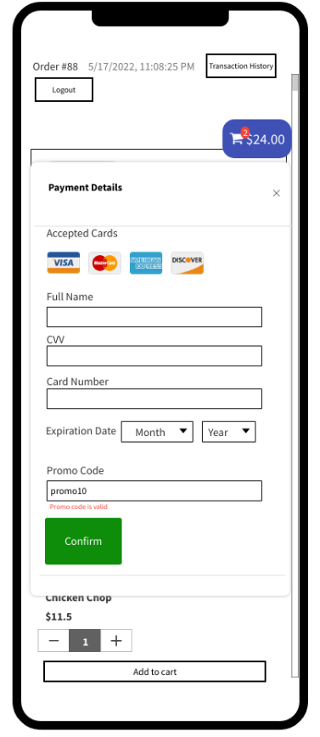

* Remove Coupon Code



#### 7.5.2 Restaurant Staff

Nil

#### 

#### 7.5.3 Restaurant Manager

* Create Coupon Code

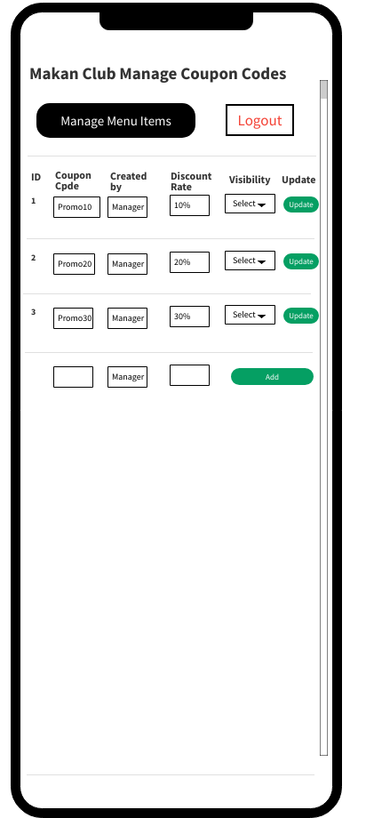

#### 7.5.4 Restaurant Owner

* Generate Average Customer Per Day Report



* Generate Average Spending Per Visit Report



### 

### 

### 

### 

**Interfaces**

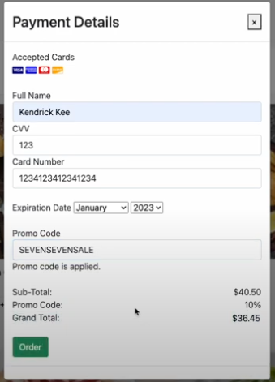

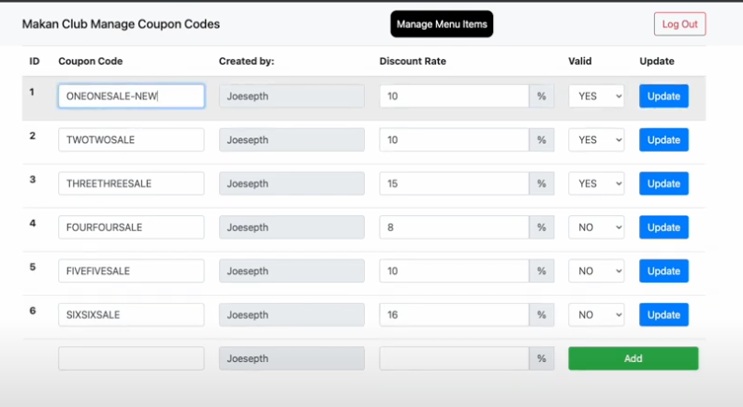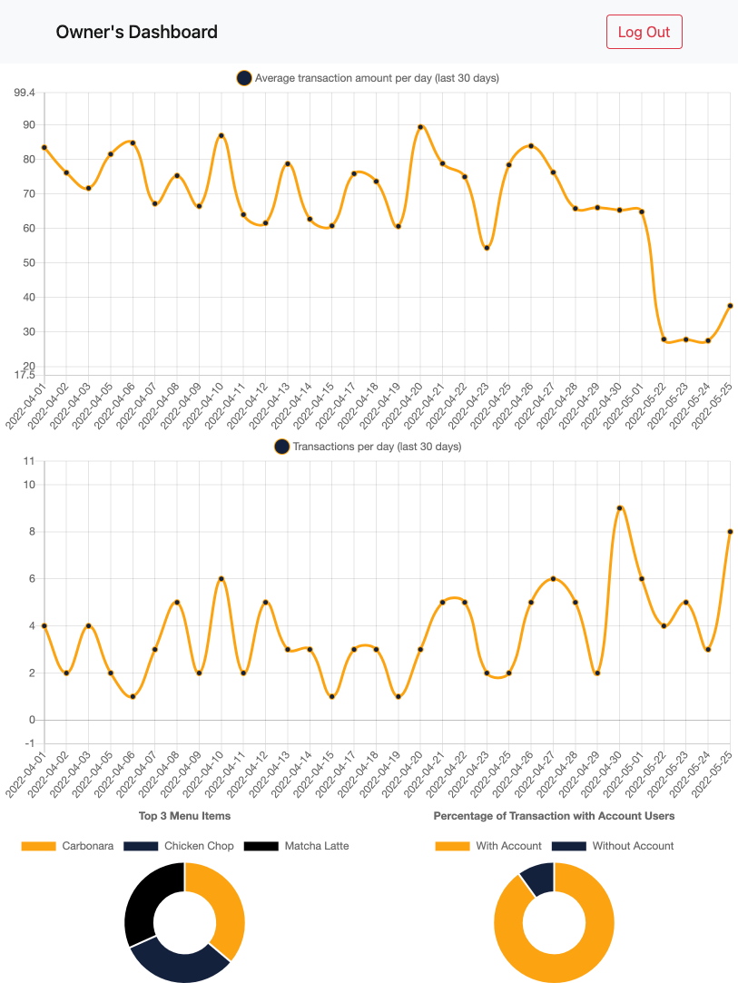

### 7.5.2 Test Cases

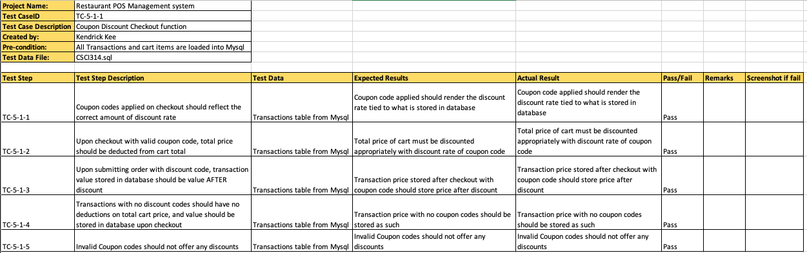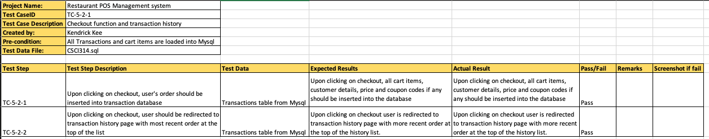

### 

### 7.5.3 Taiga

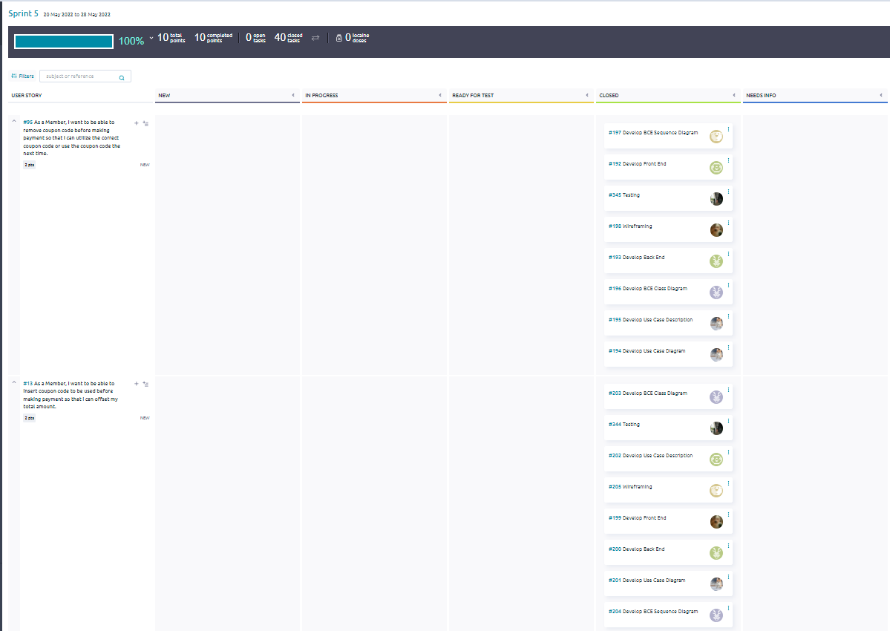

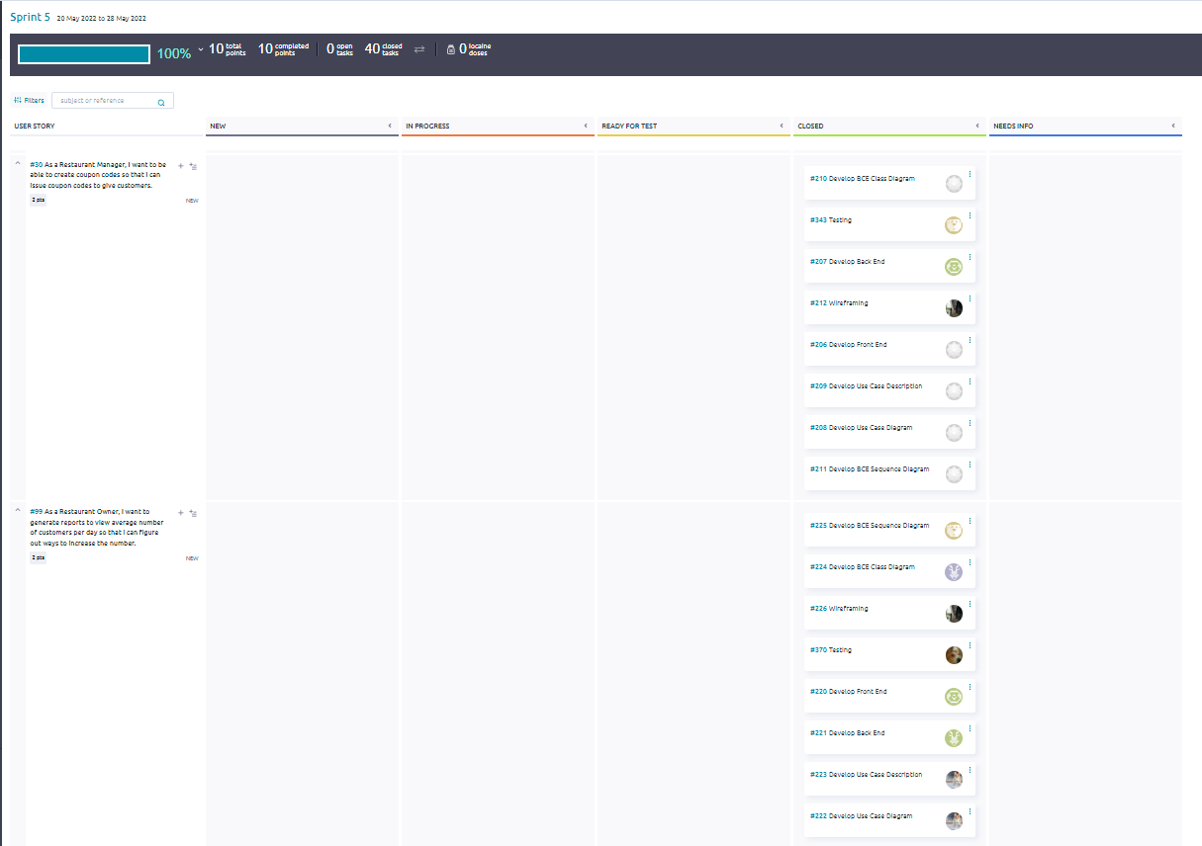

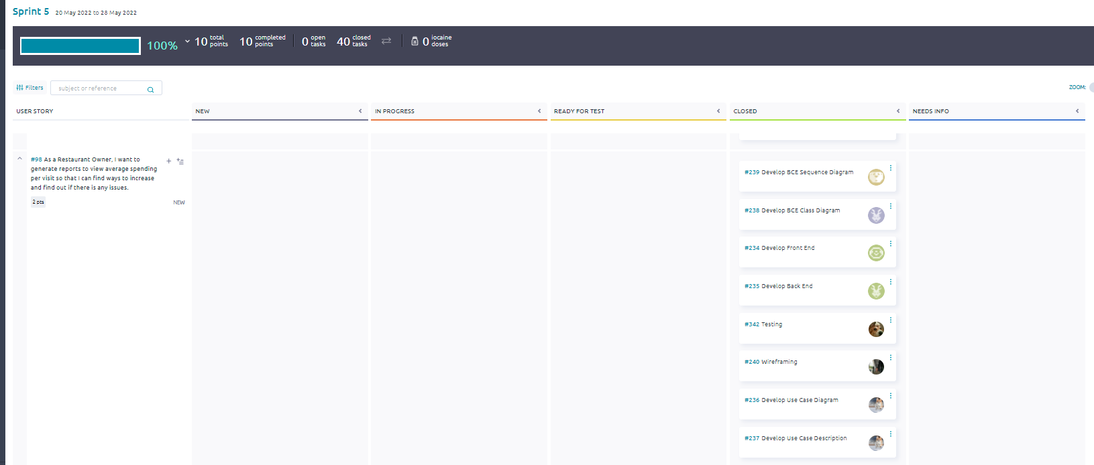

# 8. CI/CD Development

The team has tried developing in terms of Continuous Integration/Continuous Deployment (CI/CD) using the platform, however there were difficulties faced by the team, such as error messages like ‘composer.json not found’ and ‘package does not exist’. The team tried to find solutions online to solve the issue, but the error still persisted.

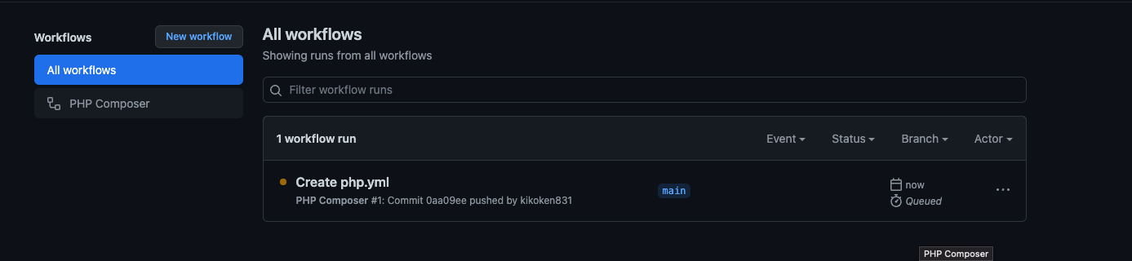

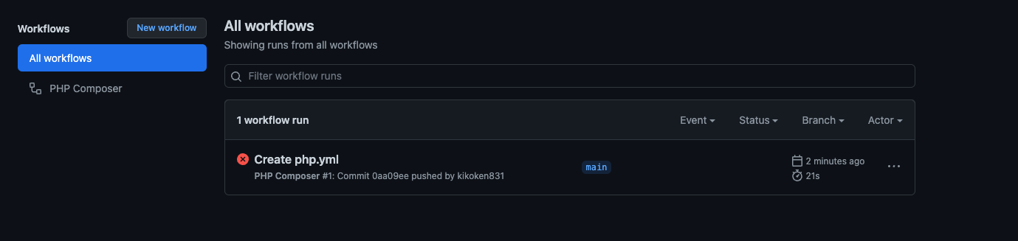

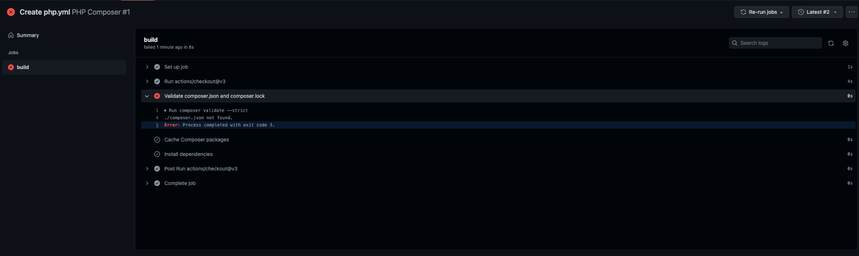

# 9. Ethical Consideration and Discussions

## 9.1 Public

The team shall take full responsibility and be totally committed to the tasks entrusted to the individual and shall follow through for successful implementation and execution. The success of the tasks will be held accountable by the members. Such culture is crucial as it encourages responsibility, self-discipline, and a sense of ownership. In the meanwhile, it also aids to eliminate any surprises and enhances healthier working relationships amongst the team.

## 9.2 Product

The team shall ensure that any decisions with regards to the product, such as maintaining and/or keeping major functions are decided collectively. The team shall also ensure the product is reliable and available, bug-free and its behaviours fall within expectations. The team should ensure that the product meets the highest professional standards. The team shall strive to fully understand the specifications required for the work and be aggressive to ensure the privacy of the data, if any, collected, shall only be used in ways that are authorized.

## 9.3 Profession

The team shall upload integrity and reputation, in terms of professionalism, at all times while working on this project. The team shall be transparent and accurate in the work they do, ensuring that all laws governing their work shall not be broken. In the event that errors occur during the process, the team shall shoulder the responsibility to detect, correct and report such errors in the software and associated documents.

## 9.4 Colleagues

The team shall always uphold teamwork and adhere to open communication. Shall there be any disagreements, the team members shall calmly and openly discuss and come to a mutual understanding and agreement. The team shall uphold fairness and be kind and supportive to each other. The team shall work towards the common goals of providing their ultimate best efforts for this project and ensure that no one is left uncertain. A collective decision will be made as a whole with everyone’s approval before moving on to the next phase of the project. The team shall ensure that the work done is solely their own work and by no means purchased, distributed, or stolen from anyone. The team shall ensure that proper due credits are given.

## 9.5 Client and Employer

The team shall ensure that all information collected is properly stored and shall not be disclosed or accessed by unauthorized personnel. The team shall also ensure that all information collected is strictly confidential and shall not be distributed for any monetary gains or any other purposes. In the event any information collected is shared, consent must be given.

## 9.6 Self

The team shall participate in the lifelong learning approach, whereby the team keeps an open mind to further their knowledge of development throughout the project and improve their ability to produce precise and well-written documentation with accurate information. The team shall also ensure that no unfair treatment is given to anyone because of any irrelevant prejudices and will not influence anyone in the team to take any action that violates a breach of such code.

# 10. Data-driven Development

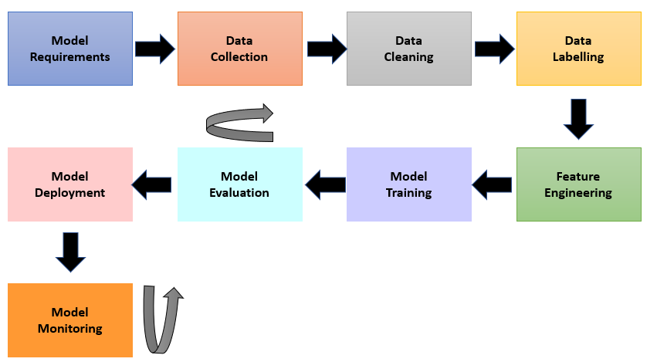

## 10.1 Model Requirements

The feature that would benefit the most from data-driven development would be View Order Summary. By analyzing the data of the popular food items, these can be used by authorized stakeholders for research analysis and marketing purposes.

The biggest beneficiary of the Data-Driven Development would be the business owner and authorized stakeholders to gather insights on popular food items on the menu and assist in the retrieval of least ordered items over a period of time, allowing market analysis to be done to gather the trends of the consumers, understand purchasing behaviours of their customers and in turn facilitate in the creation of new food items to be added to the menu. (Market Basket Analysis)

## 10.2 Data Collection

The Data-Driven Development will make use of the existing records stored in the database, retrieve the food items in transaction records and use it to perform analysis. New order summary data also can be used for generating more accurate observations and updating the existing database, which is allowing for a broader range of data analysis from the updated database.

## 10.3 Data Cleaning

Data used for Data-Driven Development will be periodically stored and replaced, to ensure the data provided is updated, therefore enhancing the accuracy of the observations of trends. Steps such as removing outliers (one beverage item in order summary) is vital to ensure the accurate analysis of the accuracy for the data driven development.

## 10.4 Data Labeling

For this set of data, data labeling will not be required, as the food items have been labeled per their description as individual food items.

## 10.5 Feature Engineering

Feature Engineering typically involves feature selection and feature extraction from the data records so as to gather data that are informative. The set of data that will be input will have to be specially selected so as to enhance the accuracy of the machine learning algorithm and ensure its compatibility. There are many techniques to go about it but feature selection would be more fitting in this case.

In feature splitting, certain features such as date-time can be split into date and time to improve the value of the target to be learned. In this case, date would serve better purpose and contribute more as a feature as compared to date-time.

## 10.6 Model Training

The strategy that will be implemented for model training will consist of learning algorithms that can be supervised and unsupervised, such as random forest, decision tree and Multi-Layer Perceptron Model. To further facilitate and ensure that the data-driven development is concise, performing objectively and ideally that it satisfies the requirements, a test set will also be used.

## 10.7 Model Evaluation

Model Evaluation typically refers to using various different evaluation metrics to understand a learning model’s performance, and in this case, for classification, the accuracy, precision and confusion matrix are measures used.

By comparing the various models’ performance, the business owner will be able to view the correlation between various food items, and statistics such as how frequently certain food items are often paired together. As such, the business owner will be able to iterate data again and make a decision on whether there needs to be a shift in their strategy.

## 10.8 Model Deployment

The model will be deployed based on a combination of application-based which is AI-powered and supported.

## 10.9 Model Monitoring

To go about monitoring the data-driven development implemented and to enhance performance levels, the business owner could fine-tune the functions, so as to get better accuracy and better quality dataset from the database.

# 11. Meeting Minutes



**CSIT314 Meeting Minutes 1**

|  |  |  |
| --- | --- | --- |
| **Date:** 9 April 2022 | **Time:** 11.30PM-1.30AM | **Venue:** Zoom |
| **Attendance** | | |
| **Name** | **Student Number** | **Present/Not Present** |
| Chong Hui Wen | 7311436 | Present |
| Lee Yu Xian | 7233164 | Present |
| Kaycee Tan Wan Ching | 7311540 | Present |
| Li Jin | 6650181 | Present |
| Kendrick Kee | 7366814 | Present |
| Bryan Choo | 7060452 | Present |
| Soh Wei Liang | 7083294 | Present |

**Agenda:**

The Team will decide on the:

* B.C.E (Boundary, Control, Entity) of this project
* The types of Users that will interact with the product
* The types of User data that needs to be collected (database)
* List of complete tasks for each user story (requirements)
  + First draft by 16th April 2022
* Timeline for various stages in the project (Gantt Chart)
  + Developing use case diagrams and descriptions
  + Sequence diagrams
  + Class diagram
  + UI Design and implementation
  + Final Report
* Discuss possible ethical considerations in developing the software system in this project and how to address them
* Style guide of our application (Color palette, logo etc)

The team will setup Taiga and decide:

* CI/CD pipeline
* Whether to integrate Taiga with GitHub

**Progress Report: NA**

**Discussion Summaries:**

Roles Decided:

1. Scrum Master = Kendrick Kee
2. Solutions Architect = Chong Hui Wen, Li Jin
3. Back End Developer = Soh Wei Liang
4. Front End Developer = Kaycee Tan Wan Ching
5. DevOps Developer = Lee Yu Xian
6. Quality Assurance Engineer = Choo Xu Guang Bryan

Agile Methodologies:

* Decided to use Scrum

Software Development Methodology:

* Decided to use B-C-E Framework

DevOps Pipeline:

* To research what are the available options and decide

Database Storage:

* Users
  + Admin
  + Guest
  + Member
* Orders
  + Table #
  + User
  + Item
  + Status
* Menu Items
  + Food Picture URL
  + Price
  + Name of item
  + Quantity
* Cart
* Promotions
  + Name
  + Promotion Period
  + Promocode
  + Value of promo (%)

Use Case:

1. Super User (Developer)
   1. Access to all functionalities
2. Customer (Guest/Member)
   1. Guest
      1. View Menu
      2. Add Food Item to Cart
      3. Quantity
      4. Remarks
      5. View Cart
      6. Edit Cart
      7. Delete Food Item from Cart
      8. Make Payment
      9. Sign up as Member
   2. Member
      1. Login as member
      2. View Menu
      3. Add Food Item to Cart
      4. Quantity
      5. Remarks
      6. View Cart
      7. Edit Cart
      8. Delete Food Item from Cart
      9. Make Payment
3. Restaurant Manager
   1. Has access to functionalities on top of a Restaurant Staff
   2. Add Food Item
   3. Remove Food Item
   4. Edit Price of Food Item
   5. Insert Coupon Codes
   6. Insert promotional food items
   7. Highlight popular food items
4. Restaurant Staff
   1. Login as staff
   2. Verify order has been delivered (Mark as table has received the food item)
5. Restaurant Owner
   1. Statistics such as Average spending per visit
      1. Most popular food item
      2. Frequency of visits
      3. Last visit
      4. Preference for dishes/drinks

Design decisions:

1. Color Palette: <https://coolors.co/palette/000000-14213d-fca311-e5e5e5-ffffff>

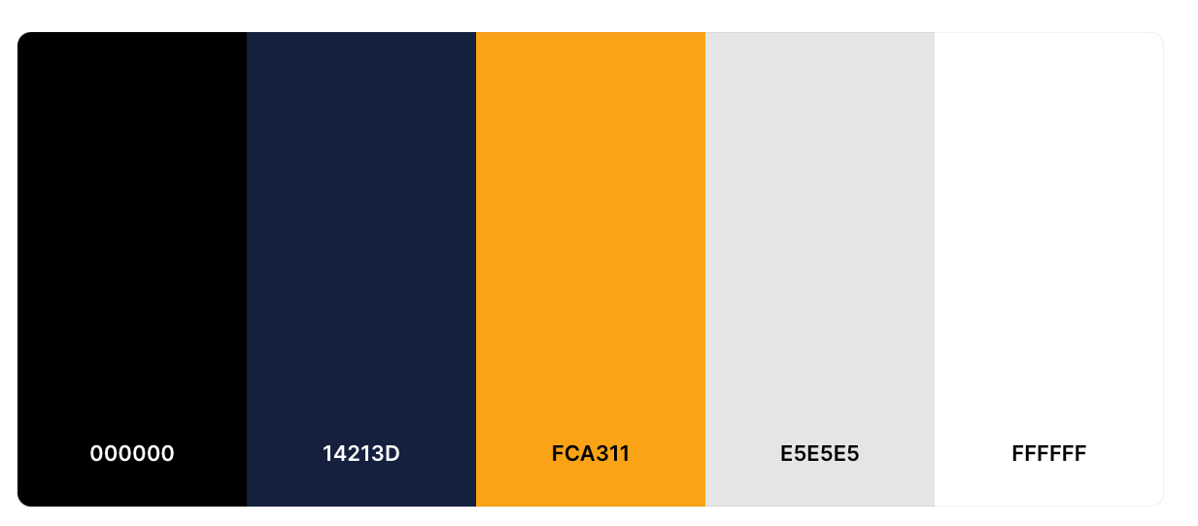

**Agenda for next meeting​​**

1. Decide on functional/non-functional requirements
2. Timeline for various stages in the project (Gantt Chart)
3. 1st draft for Use Case diagram and description (for all users)
4. 1st draft for Class/Sequence Diagram/Gantt Chart
5. Login Page for customer
6. Decide on Technology Stack
   1. PHP/ MYSQL?
   2. Flask?

**Recorded by:** Kendrick Kee  **Date:** 9 April 2022

**Vetted by:** Chong Hui Wen **Date:** 9 April 2022



**CSIT314 Meeting Minutes 2**

|  |  |  |
| --- | --- | --- |
| **Date:** 14 April 2022 | **Time:** 10.30PM-11.30PM | **Venue:** Macdonalds @ West Coast Park |
| **Attendance** | | |
| **Name** | **Student Number** | **Present/Not Present** |
| Chong Hui Wen | 7311436 | Present |
| Lee Yu Xian | 7233164 | Present |
| Kaycee Tan Wan Ching | 7311540 | Present |
| Li Jin | 6650181 | Present |
| Kendrick Kee | 7366814 | Present |
| Bryan Choo | 7060452 | Present |
| Soh Wei Liang | 7083294 | Present |

**Agenda:**

The Team will decide on the:

* functional/non-functional requirements
* Timeline for various stages in the project (Gantt Chart)
* 1st draft for Use Case diagram and description (for all users)
* Login Page for customer
* Market Research for UI
  + A login page for user that allows them to create an account
  + Research on how menu is presented to customers
  + Experience the entire ordering process to better project/improve
    - Spot the areas of improvement and strengths we can reference

**Progress Report:**

1. First draft of use case diagram done
   1. Actors identified
   2. Taiga group project set up
2. Class Diagram 1st draft done

**Discussion Summaries:**

1. Did market research
   1. QR code on table directs user to macdonald app
   2. Location of macdonald is captured
   3. User can browse menu and add to cart
   4. Views cart before checking out
   5. Additional option whereby it integrates with existing payment mode in phone (apple/samsung/google pay) instead of only the traditional keying in of card details
   6. Options given to customer on take away/dine in (self-collect or table service)
   7. Order summary is sent to email
   8. Status bar shown to use
      1. E.g. order received/Food is being prepared
      2. Food is ready for collection/delivery
   9. Optional: Can consider showing # of people in front of you/estimated waiting time
   10. Final receipt (paper) delivered along with food
       1. Should trigger to send invoice to email in view of paperless

**Agenda for next meeting​​**

1. Functional requirements and non-functional requirements to be discussed
2. First look into UI - Login page
3. More use cases to be added for the various actors
4. Work on sequence diagram

**Recorded by:** Chong Huiwen  **Date:** 14 April 2022

**Vetted by:** Kendrick Kee  **Date:** 14 April 2022



**CSIT314 Meeting Minutes 3**

|  |  |  |
| --- | --- | --- |
| **Date:** 23 April 2022 | **Time:** 11.30PM-1.30AM | **Venue:** Zoom |
| **Attendance** | | |
| **Name** | **Student Number** | **Present/Not Present** |
| Chong Hui Wen | 7311436 | Present |
| Lee Yu Xian | 7233164 | Present |
| Kaycee Tan Wan Ching | 7311540 | Present |
| Li Jin | 6650181 | Present |
| Kendrick Kee | 7366814 | Present |
| Bryan Choo | 7060452 | Present |
| Soh Wei Liang | 7083294 | Present |

**Agenda:**

The Team will decide on the:

* Discussion of Sprint 1
* Finalize requirements
* Revisit pointers/feedback given by tutor during class
  + Use case description
  + Use case diagram
  + Sequence diagram
  + Class diagram

**Progress Report:**

1. UI for view menu, add food item into cart, delete food item from cart done.
2. Team has created the sql file for database creation and will insert rows of records (test data).
3. Team is working on other pages for UI (sprint 2)
4. Restaurant Manager - Add/Remove Item in progress

**Discussion Summaries:**

1. To kickstart on test cases
2. To revise the necessary diagrams (Use Case Diagram, Use Case Description, BCE Sequence Diagram, BCE Class Diagram)
3. Team will continue to work on front/back end.

**Agenda for next meeting​​**

1. Review test case results for working functionalities
2. To review Sprint 2 and progress so far

**Recorded by:** Chong Hui Wen **Date:** 23 April 2022

**Vetted by:** Lee Yu Xian **Date:** 23 April 2022



**CSIT314 Meeting Minutes 4**

|  |  |  |
| --- | --- | --- |
| **Date:** 5 May 2022 | **Time:** 11PM-1.30AM | **Venue:** Zoom |
| **Attendance** | | |
| **Name** | **Student Number** | **Present/Not Present** |
| Chong Hui Wen | 7311436 | Present |
| Lee Yu Xian | 7233164 | Present |
| Kaycee Tan Wan Ching | 7311540 | Present |
| Li Jin | 6650181 | Present |
| Kendrick Kee | 7366814 | Present |
| Bryan Choo | 7060452 | Present |
| Soh Wei Liang | 7083294 | Present |

**Agenda:**

The Team will decide/review on the following:

1. Using agile scrum, review progress so far
2. Discuss the difficulties and challenges as a whole so far and how can we improve for sprint 4 and 5
3. Look at the BCE Class and Sequence Diagram

**Progress Report:**

1. Report is 90% done, team will focus on UI and mid/back end.
   1. Team is left with 3 key functions, target to finish by 16th May
   2. Team will combine and test as an integrated application on 16th May
   3. Team will focus on report afterwards
2. Team has completed test cases for a few of the functions that are working
3. Team will focus on the important functions during sprint 3 and sprint 4

**Discussion Summaries:**

1. Team will continue to work on front/back end.
2. Team to target finishing the project by Mid May
3. To update Taiga

**Agenda for next meeting​​**

1. Review Sprint 3 and start on Sprint 4

**Recorded by:** Chong Hui Wen **Date:** 1 May 2022

**Vetted by:** Kendrick Kee **Date:** 1 May 2022



**CSIT314 Meeting Minutes 5**

|  |  |  |
| --- | --- | --- |
| **Date:** 14 May 2022 | **Time:** 8PM-10PM | **Venue:** Zoom |
| **Attendance** | | |
| **Name** | **Student Number** | **Present/Not Present** |
| Chong Hui Wen | 7311436 | Present |
| Lee Yu Xian | 7233164 | Present |
| Kaycee Tan Wan Ching | 7311540 | Present |
| Li Jin | 6650181 | Present |
| Kendrick Kee | 7366814 | Present |
| Bryan Choo | 7060452 | Present |
| Soh Wei Liang | 7083294 | Present |

**Agenda:**

The Team will decide on the following:

1. Date to record video
2. Target date to submit assignment so that the team can study for exams

**Progress Report:**

1. Team is left with checkout page and coupon page
2. To update report with necessary screenshots
   1. Scrum/Taiga
   2. Test Cases (for those already done but not inserted)
   3. Wireframing
   4. UI screenshots from application

**Discussion Summaries:**

1. Review Sprint 4 and kick start sprint 5
2. Polish report
   1. Make sure BCE Class and Sequence Diagram methods matches the classes in the code
3. To test the application as a whole before recording the demo
   1. Team targets to record demo video on 21st May

**Agenda for next meeting​​**

1. Review Final report and application as a team before submission
2. Team targets to submit assignment 2 days in advance (27th May)

**Recorded by:** Kendrick Kee **Date:** 14 May 2022

**Vetted by:** Lee Yu Xian **Date:** 14 May 2022



**CSIT314 Meeting Minutes 6**

|  |  |  |
| --- | --- | --- |
| **Date:** 21 May 2022 | **Time:** 10PM-12AM | **Venue:** Zoom |
| **Attendance** | | |
| **Name** | **Student Number** | **Present/Not Present** |
| Chong Hui Wen | 7311436 | Present |
| Lee Yu Xian | 7233164 | Present |
| Kaycee Tan Wan Ching | 7311540 | Present |
| Li Jin | 6650181 | Present |
| Kendrick Kee | 7366814 | Present |
| Bryan Choo | 7060452 | Present |
| Soh Wei Liang | 7083294 | Present |

**Agenda:**

The Team will decide on the following:

1. Dates of the following
   1. To record video
   2. To finalize and submit report

**Progress Report:**

1. Team has finished the application and has done all necessary tests
2. Team has begun finalizing the report in view of submission deadline
3. Team updated the user stories and included tasks as suggested by the lecturer

**Discussion Summaries:**

1. Team will record the demo video on the 24th of May
   1. Team will edit and complete by 28th May for final submission
2. Team will finalize the report and submit it on 28th of May

**Agenda for next meeting​​:**

N/A

**Recorded by:** Kendrick Kee **Date:** 21 May 2022

**Vetted by:** Chong Huiwen **Date:** 21 May 2022